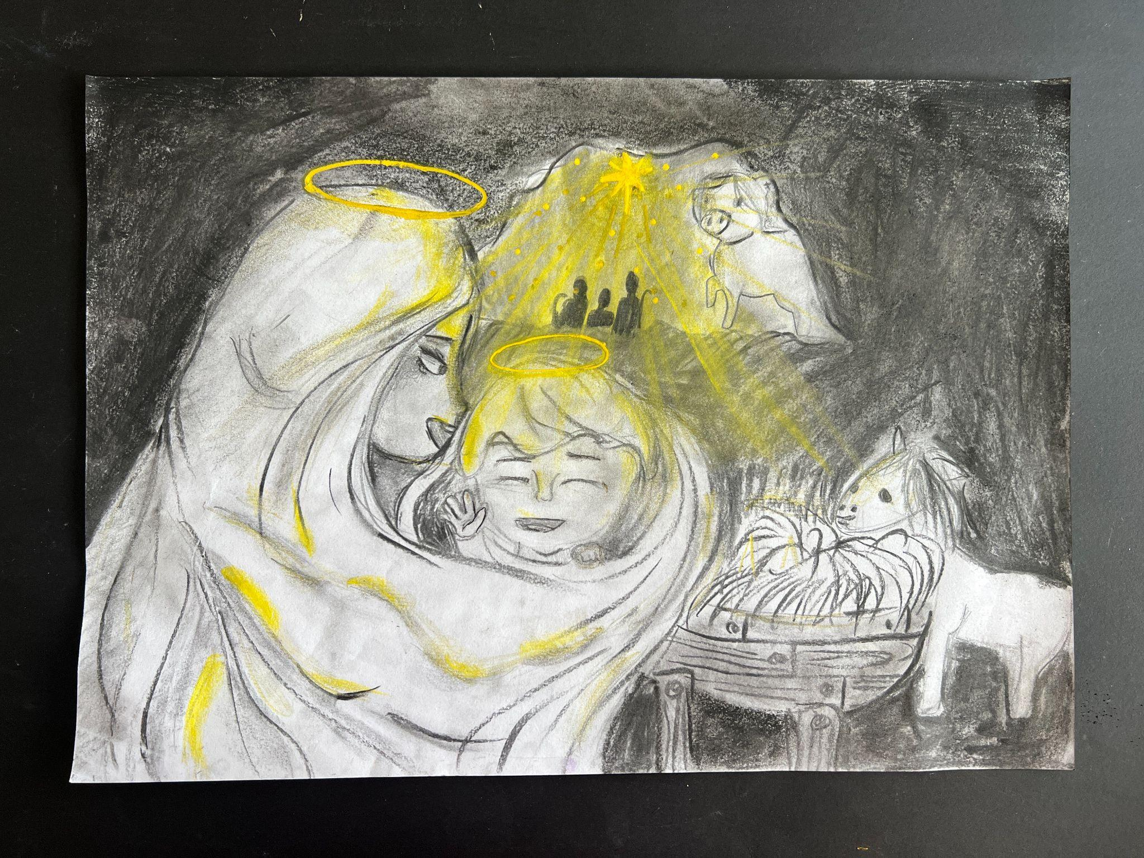
Caylenne Sasminta, Year 5
St. Patrick’s Catholic Primary School Sutherland
Title : The Shining Hope

In my drawing, you'll notice a predominantly monotone composition with a delicate touch of yellow. The inspiration for this artwork stems from the scripture 'The Birth of Jesus and the Visit of the Shepherds, Luke 2:9-14 . The shepherds are positioned just outside the mouth of the cave, right above Jesus' halo. They are bathed in the light of the radiant star.

Initially, my idea was to create a drawing that was mainly monotone but I realised the importance in emphasising the divine light of God. Therefore, I added the colour of light, yellow reflecting on Mary and baby Jesus’s faces and the perspective evolved the presence of various elements, including light shining on the shepherds from the radiant star.

The process of creating this artwork was enjoyable because I had a vivid mental image with minimal details that I had only sparingly paid attention to. I was delighted to translate this complete, original concept from my mind onto paper. I've titled this artwork 'The Shining Hope' to reflect in our darkest moment there is always the light that brings hope when we have faith as Christ is born into this world for us.
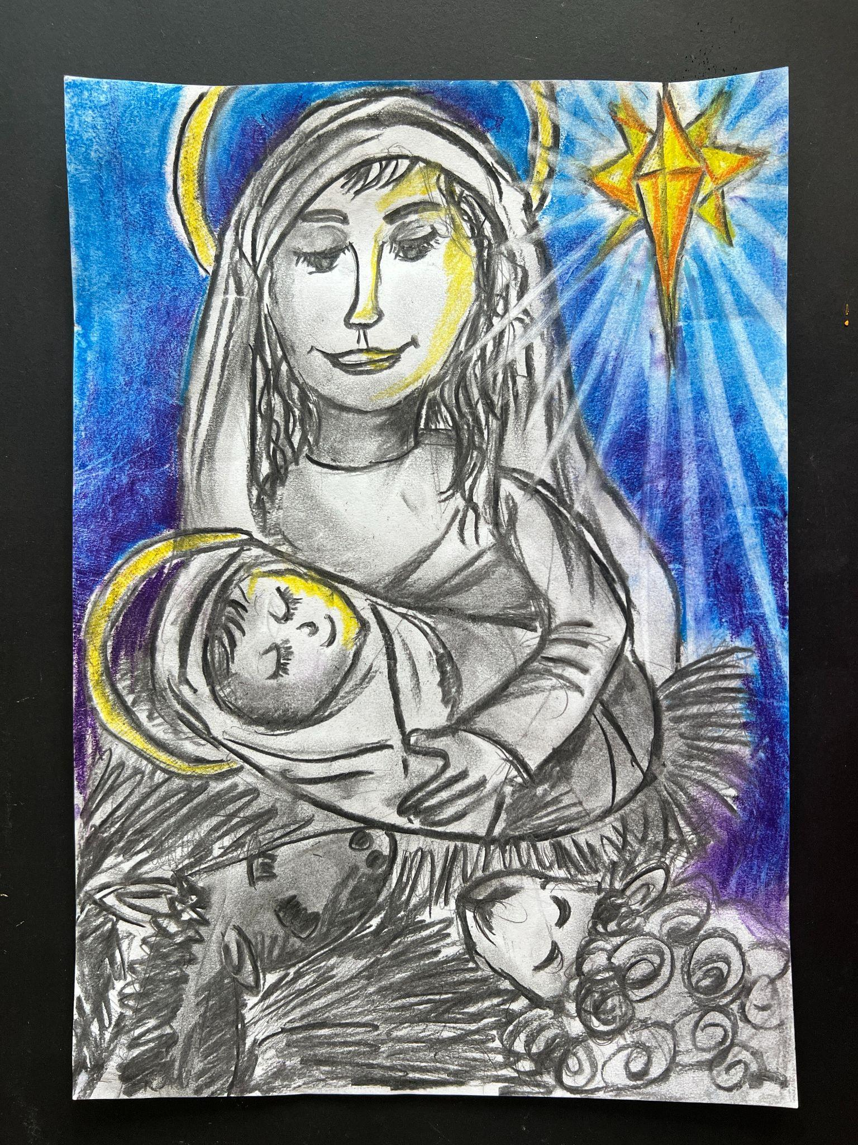 |  | Elsie Brown, Year 5  St. Patrick’s Catholic Primary School Sutherland  Title : The Gleaming Star

I've depicted the scene of Mary after giving birth to baby Jesus, our Messiah, based on the scripture of Jesus's birth and the visit of the shepherds in Luke 2:9-14. Although the shepherds aren’t visible in the picture, they are on their way to see the newborn Jesus.

This scripture resonates with me because it serves as an inspiration to strive for goodness and overcome life's challenges, much like Mary did. In the artwork,
Mary tenderly places her hand on her child, gazing lovingly into Jesus's resting eyes. The background is illuminated by the gleaming star, casting a yellow reflection on their faces.

Jesus lies in a bed of hay, typically used as food for animals, and you can see some animals looking up at Mary and Jesus. I've employed four colours in this painting, each with its own significance. Purple symbolises royalty, a rarity in those times, often associated with kings, queens, and the wealthy. Black represents suffering, reflecting the hardships Mary and Joseph faced in finding shelter, leading them to the humble barn where Jesus was born. Yellow signifies joy, representing Mary's delight in having a child, especially one with God as the father. Lastly, orange symbolises God's deliverance and the passionate praise directed towards His newborn son, Jesus. Creating this artwork made me realise that the true meaning of Christmas is all about the coming of Christ into this world to be like us, so that we can be like Him, be compassionate, be kind and in giving, we receive.
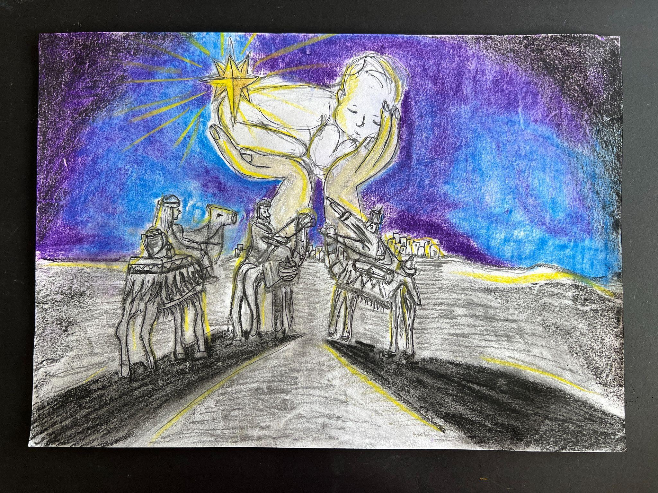
Franklin Gould, Year 5
St. Patrick’s Catholic Primary School Sutherland
Title : The King is born

My artwork depicts the arrival of the three kings delivering the gifts of myrrh, frankincense and gold to the newborn king, our Messiah. The huge golden star illuminates the sky and gives direction to show everyone where Jesus was born. The hands gently holding Jesus in this image are the focal point and represent God delivering his Son to us. He is bathed in the brightness of the beautiful night sky lit up by the radiant star representing hope.

My inspiration comes from the scripture Luke 2:9-14. I was amazed by the faith of the three kings, believing and entrusting the message from God they went on their way, not an easy task to locate the new born child that is to be our Saviour. They followed the star they had seen when it rose and went ahead of them until it stopped over the place where the child was. When they saw the star, they were overjoyed. I learnt from this scripture that we just have to believe and follow what our heart desires to follow God’s will.

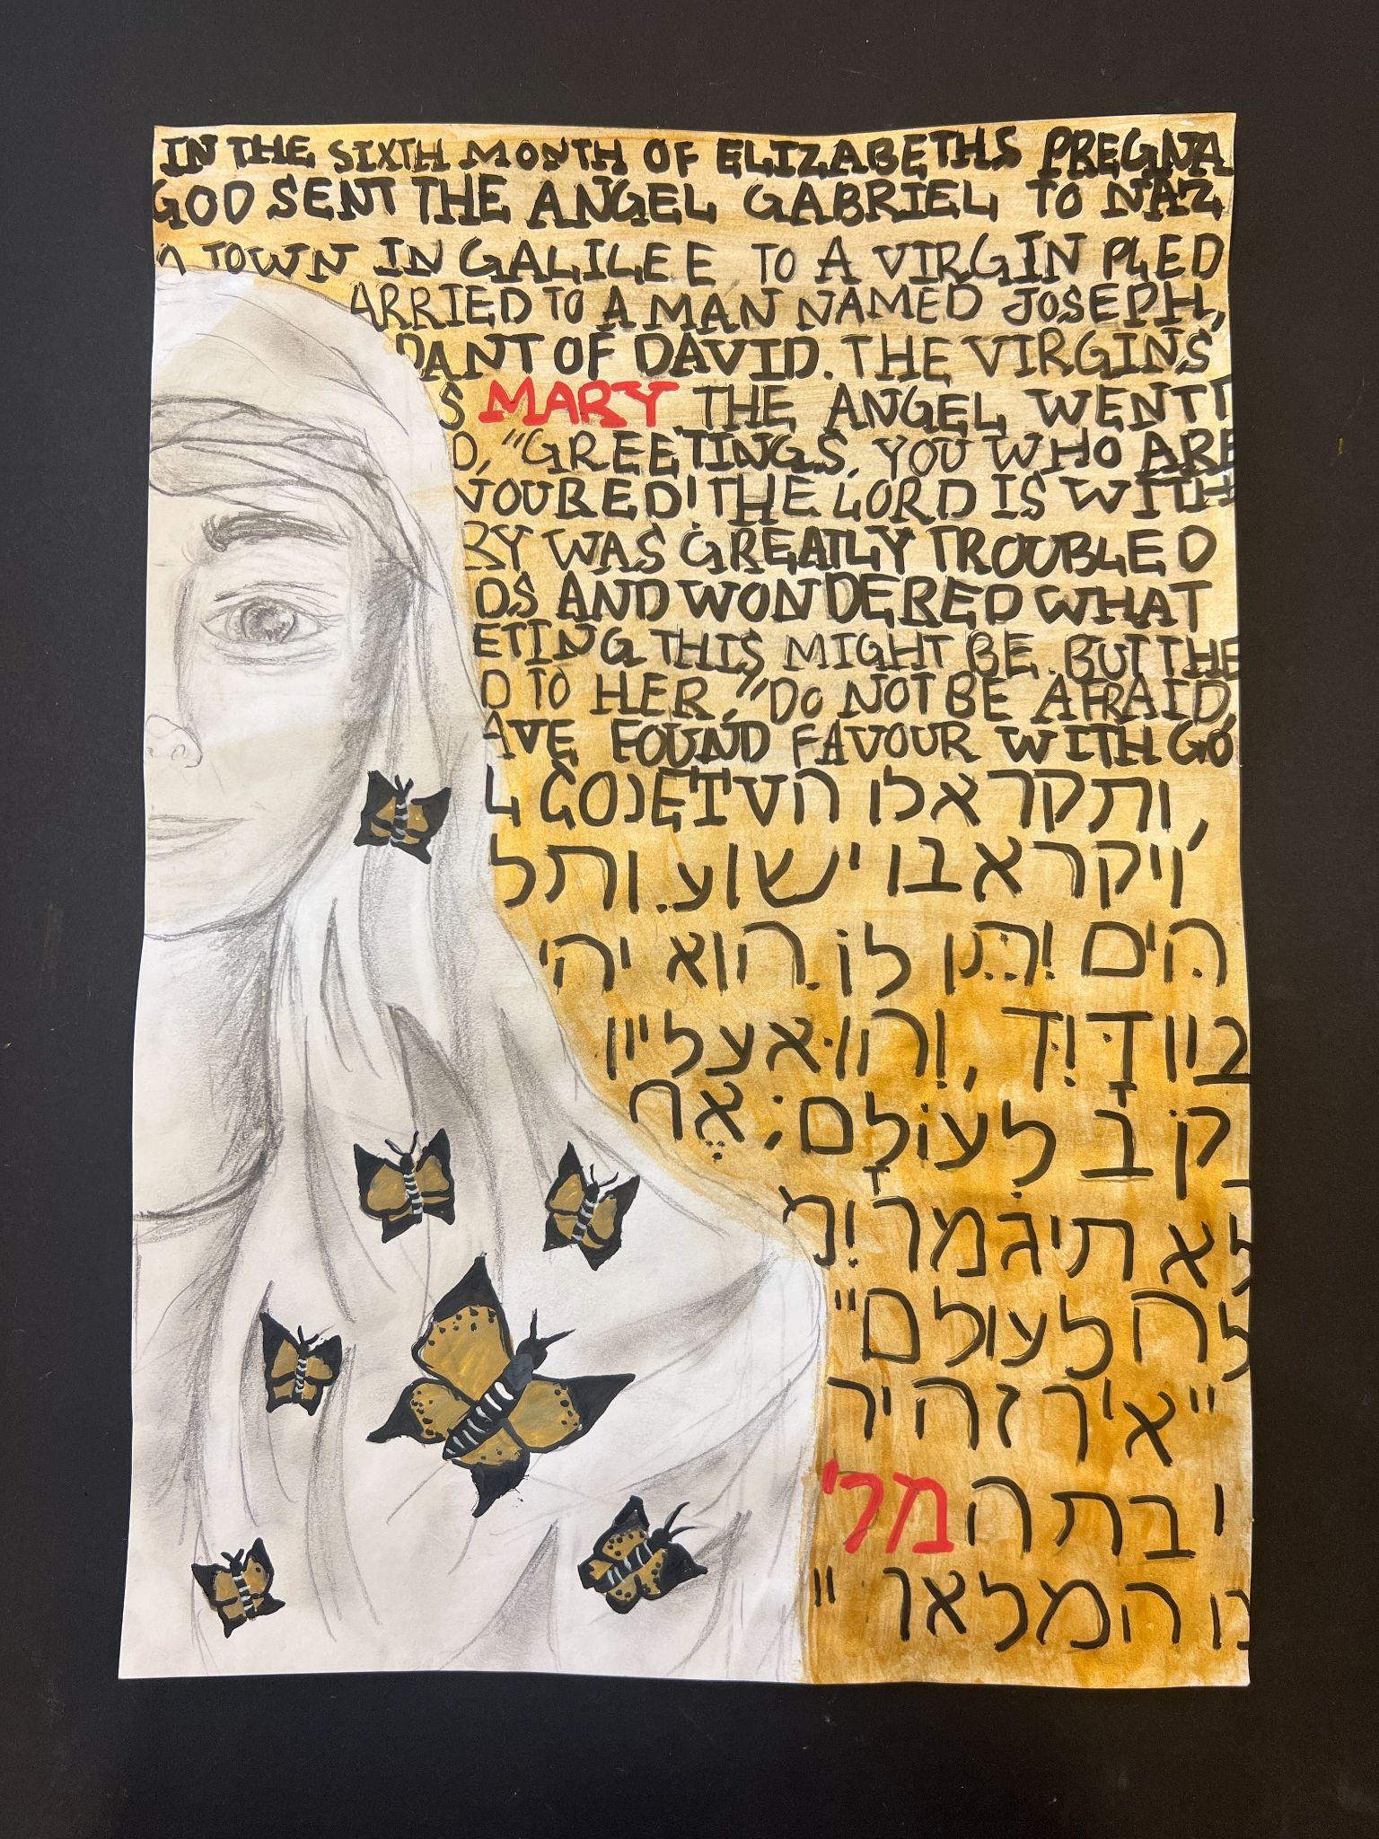 |  | Isla Murray, Year 6  St. Patrick’s Catholic Primary School Sutherland  Title : A New Hope
My artwork is from the scripture Luke 1:26-36 “ The annunciation.” This event is when Angel Gabriel is sent from God to virgin Mary to announce that she will bear Jesus Christ in her womb.

I was inspired by lots of gold since in Mary’s time, it showed kingship or something only someone with a high status could have. It also shows that she is the Queen of heaven and mother of Jesus christ. The butterflies which are also gold represent new life, change, endurance, and hope which Mary is also seen as a lady of hope. The scripture behind Mary is the actual scripture, and in between the scripture it translates from Hebrew which was the language of the time. The reason I left Mary black and white is because it represents a time that is old and a long time ago. It also helps Mary stand out from the gold and background. The black also represents power and elegance. White represents hope, a new beginning, purity, cleanness and innocence. As seen, Mary is looking right into you, or someone significant which is Angel Gabriel. The reason why the name Mary is in red in English and Hebrew is because it shows who the person is in the front and makes it stand out from the rest of the words.

While doing this artwork, I found a lot of connections all throughout the artwork. It showed me that through simplicity, is beauty. I really love it because of the simplicity and uniqueness. From the scripture in the background to the black and white Mary. This all comes to show how important Mary is not just to God and Jesus, but to the whole world and all of Heaven. She shows kindness, purity, honesty and mercy. It also shows how much she is devoted to God. She is an example for all to follow her in her footsteps and lead a life full of mercy, kindness, honesty, purity, care and righteousness.

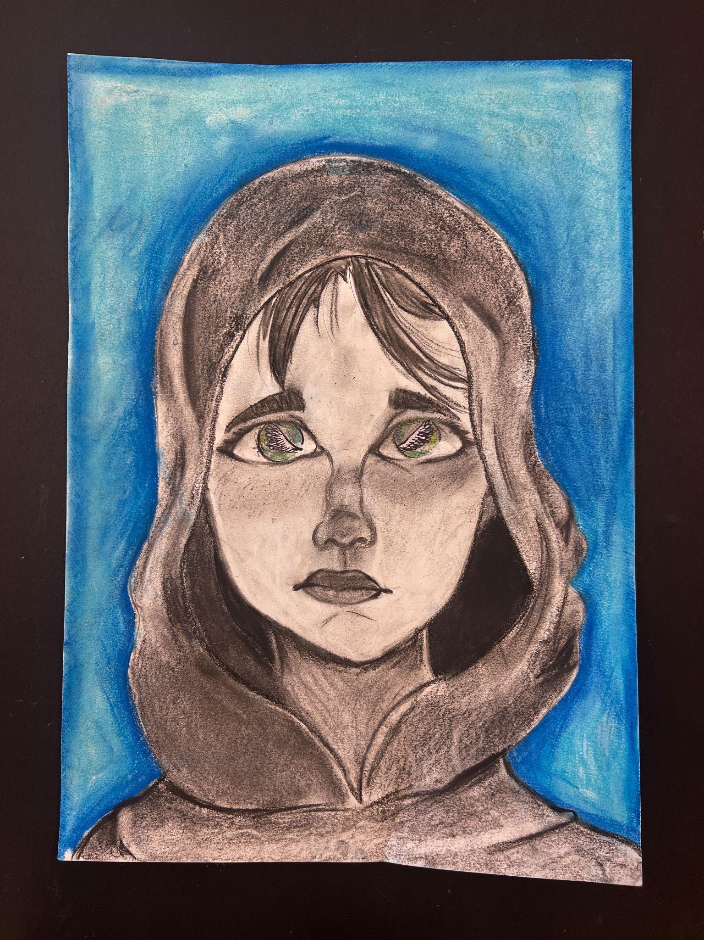 |  | Jessica Hilly, Year 6  St. Patrick’s Catholic Primary School Sutherland  Title : She said “Yes”

I chose to draw the annunciation, as described in Luke 1:26-36. My intention was to emphasise Mary's nervous expression, often overshadowed by her courageous "yes." To convey her fear, I incorporated the colour green into her eyes, a subtle representation of fear and nervousness.

Additionally, I aimed to create a visual contrast by using vibrant colours for the surroundings and a monochromatic scheme for her veil and face, symbolising the hardships she endured from conception to the birth of Jesus.

The angelic wings in her eyes symbolise her recent brave decision to accept the Lord's plan. By making her face noticeably lighter than her veil, I directed the viewer's focus to what truly matters – her expression and the uncertainty of her life but she chose to trust God instead.

This process of art making, makes me realise that no matter how fearful we are if we seek God. We will be fine.

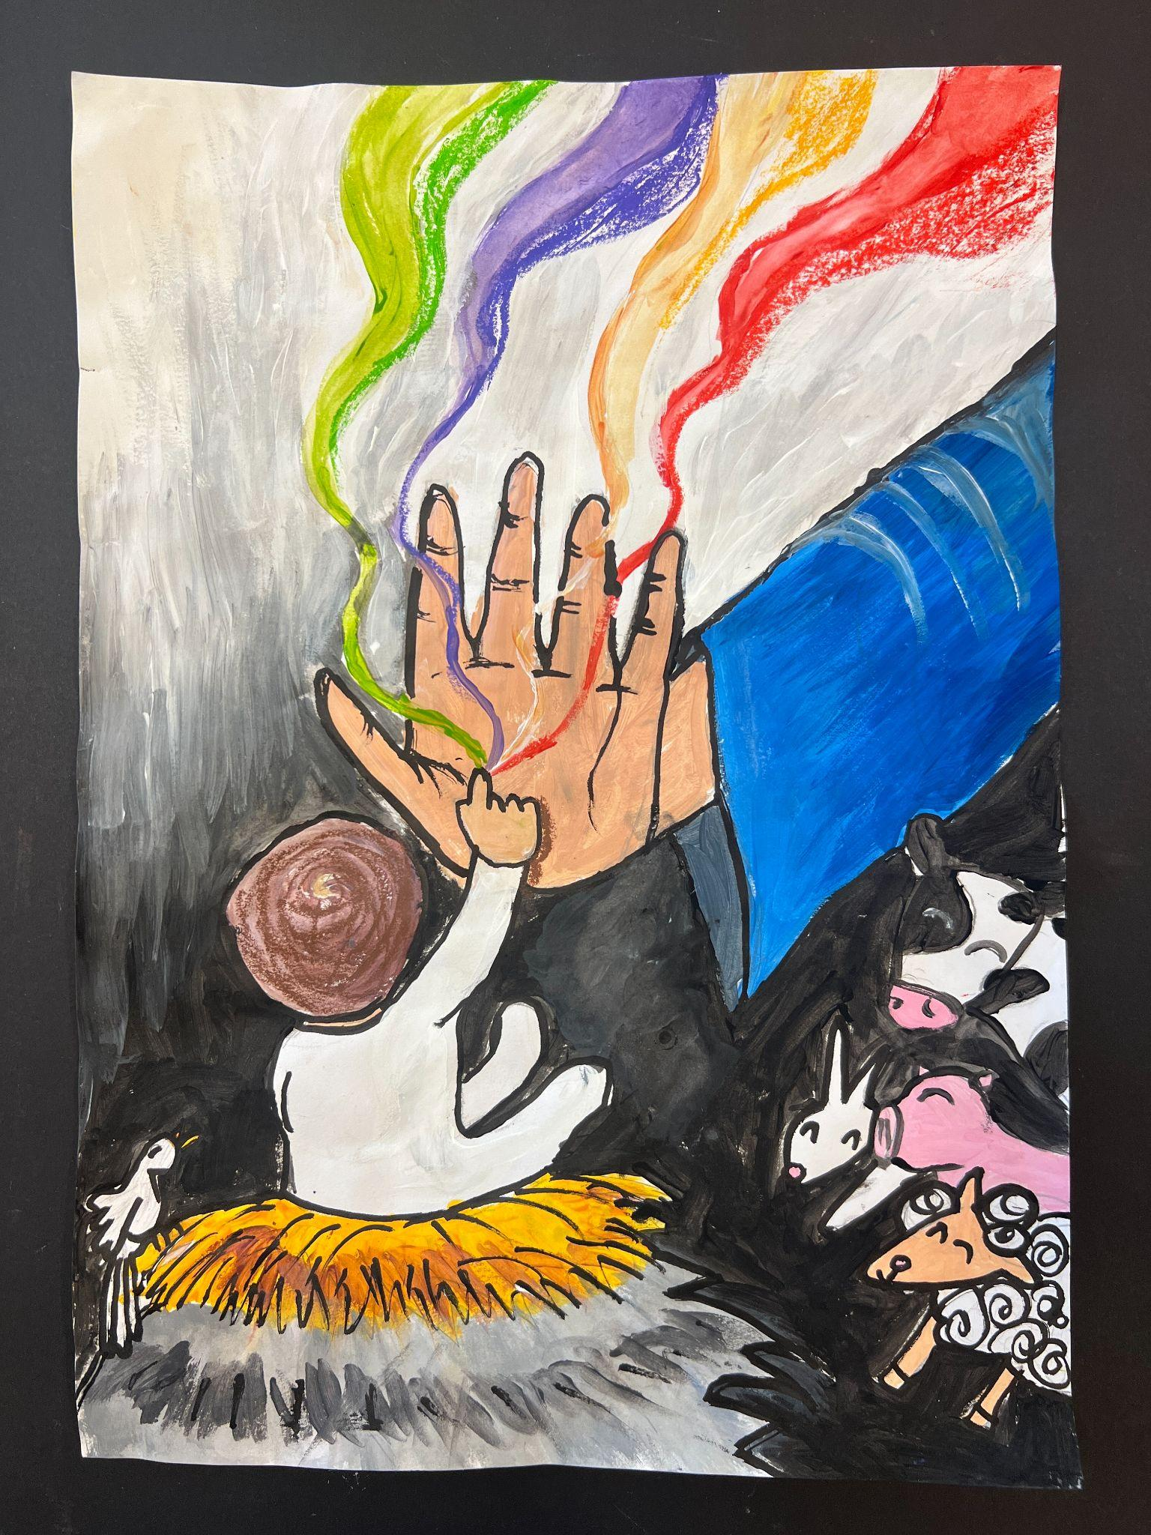 |  | Macy Valabjee, Year 6  St. Patrick’s Catholic Primary School Sutherland  Title : A Touch of Hope

My artwork is inspired by the scripture “The Birth of Jesus” Matthew 1:18-25. In my artwork, you'll notice Mary's outstretched hand, and Baby Jesus gently touches her hand, symbolising a touch of hope. As Jesus makes contact, the world undergoes a transformation from dull grey to vibrant colours, mirroring the hay he's resting on, which was once grey but now bursts with hues.

The colours emanating from Jesus' hands represent different phases of the liturgical year. Green symbolises Ordinary time, purple signifies Lent and Advent, goldy white is associated with Christmas and Easter, and red represents Pentecost. The animals on the right and the dove perched on the haystack all exude joy because the King has been born.

I have this fun image of baby Jesus doing this hi-five gesture with Mary after reading this scripture that shows the partnership between them and God. That reminds me to be prayerful and be faithful to our faith.

