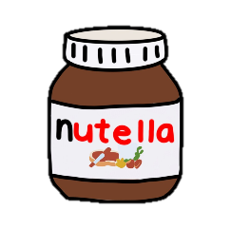
Nutella
Nutella is made from:
- Hazel nuts
- Skim milk powder
- Fat reduced cocoa powder
- Lecithin
- And vanillin
FUN FACT
Nutella usually has about 50 hazel nuts each jar
Nutella was invented by the Ferro family in Italy, during World War II

