Stop the dog poo

Hi I am Ollie L and I am in year 3
We have a big problem here at B.N.P.S. And I believe dogs should be band from B.N.P.S. because students miss class to clean up, dog poo is stinky and dog poo is gross.
Firstly when students step in dog poo they miss out on class. Teachers have to clean the dog poo for so long which is a total waste of time.
For a second reason dog poo is stinky. Imagine dog poo every inch peeww! That would be gross. So please pick up your dog’s poo!
Thirdly dog poo is gross because we sit where dog poo has been yuck. And we step in it so much.
In conclusion B.N.P.S has too much dog poo on the oval. So please pick up your dog`s poo because it stinks, students miss out on class time and dog poo is gross.

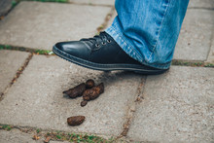
Pick up your dogs poo!!!!

