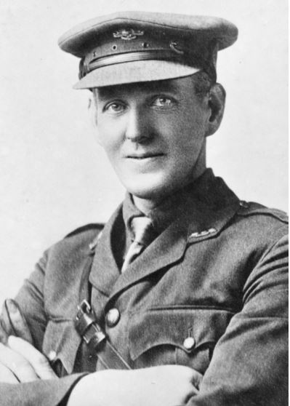
Sergeant Simon Fraser, 3101, 57th Battalion (Jacob)
“My name is Sergeant Simon Fraser and I fought with the 57th Battalion at the Battle of Fromelles. I was a 38-year-old farmer from Byaduk, Victoria, when I decided to join the A.I.F. It was July 13th, 1915, as I remember, when our brave men were fighting Johnny Turk over in Gallipoli. I didn’t get to fight there but I certainly had some adventures in France when I made it to the Western Front. When I got there and saw what a mess was being made, I felt a bit sorry for the French farmers whose land we were blowing up. Anyway, after starting with the 22nd Battalion I was placed in the 57th Battalion. Because I was an old bloke, they promoted me to Sergeant on arrival in France, so I didn’t mind that. Anyway, my first involvement in the war was the big attack at Fromelles. I guess I was lucky in some ways because my battalion, the 57th was ordered to watch the battle and then act as stretcher bearers while our mates in the 60th Battalion went over the top.
When the action stopped on the morning of July 20th, 1916, after a mad night of fighting, it was our job to go out and tend to the injured out there in No-Man’s Land. When we went out, we found a fine haul of wounded and brought them in; but it was not where I heard this fellow calling, so I had another shot for it, and came across a splendid specimen of humanity trying to wriggle into a trench with a big wound in his thigh. He was about 14 stone weight, and I could not lift him on my back; but I managed to get him into an old trench and told him to lie quiet while I got a stretcher. Then another man about 30 yards out sang out ’Don’t forget me, cobber!’ I went in and got four volunteers with stretchers, and we got both men in safely. Next morning at daylight, whilst observing over the parapet, I saw two figures in their shirts and no hats, running about halfway between our lines and the Germans. They were our captains, Cameron and Marshall, hunting for more wounded.”
Sgt Simon Fraser never returned from France. He was killed by an exploding shell at Bullecourt on May 12th, 1917 and his body was never recovered. He is the soldier depicted carrying the wounded ANZAC in the Cobbers statue designed by Peter Corlett.
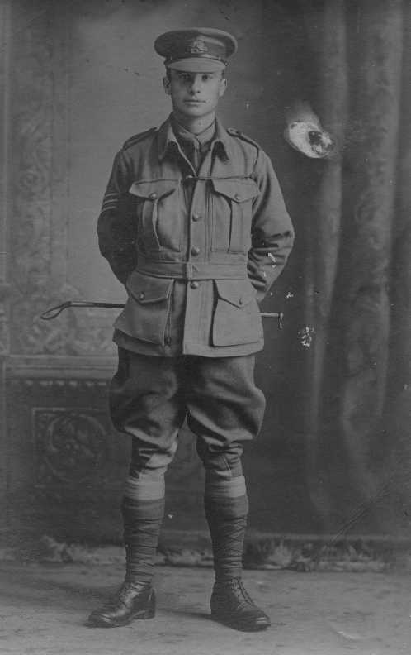
Corporal George Pyne Browne, 3471, 54th Battalion (Nima)
“My name is Corporal George Browne and I fought with the 54th Battalion at the Battle of Fromelles. I was born in Redfern, Sydney in 1888 but my parents settled in Mosman. I joined the A.I.F. at the age of 27 on October 9th, 1915. I had been working as a clerk and boy, I was keen for some adventure!
Soon after my battalion arrived in France in June 1916 we were marched to the Front Line. Soon after that I fought at the Battle of Fromelles and suffered 14 gunshot and shrapnel wounds to my arms, leg and back, all down my right side. I also received a bayonet wound to my face during a little affair with German patrols. I remember that at 20 to 6, 20 minutes before the bombardment was scheduled to finish and we were to leave our trenches, the Germans, who were only 130 yards away from our trenches held up a notice board: “Advance Australia! We are waiting. You are 24 hours late!” You would hardly believe that we had their spies in our trenches without our knowing it! When I was about to charge out into No-Man’s Land I then noticed that the bombs that I had been issued with had no fuses! After I was injured, I found a huge shell hole to hide in. I was there for three days before I was rescued, sharing that hole with a Bavarian soldier who was wounded just like me. I was pulled out of that shell hole by a harness and rope so my mates could avoid the snipers.
The medics marked my medical card as ‘dying’ as my injuries were so horrendous, but I was shipped back to Sydney and slowly recovered. I remained in the army and later served in the 1st Anti-Aircraft Battery in Sydney during WW2.”
Corporal George Pyne Browne died at the age of 86 in 1973.”

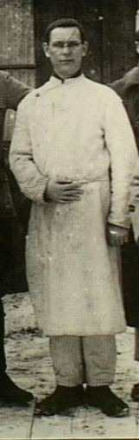
Sergeant Ernest Robert ‘Tosh’ Ridley, 1023, 30th Battalion (Deakin)
“My name is Sergeant Ernest Ridley and I fought with the 30th Battalion at the Battle of Fromelles. I was born in London and had served in the Royal Navy for ten years as a seaman when I decided to join the A.I.F. At the age of 30 I signed up to fight for Australia when I was in port in Melbourne on July 1st, 1915. After travelling to Egypt and training there I arrived in Marseilles aboard HMAT Beltana on 23rd June 1916. My battalion was soon placed at the Front Line where things didn’t go so well for me…
My first and last war experience was at Fromelles, where so many of my friends went west (died). Of my section of eight men who started to carry stores to the troops in the front line, five of us got through and did our bit towards building up some sort of cover in the slimy ditches. Shortly after daybreak we were surrounded. I was badly hit in my right upper arm, shattering the bones, and for a time remained unconscious. When I came to my senses, I was alone and felt very weak from loss of blood. I laid in the shell hole all day and towards evening started to crawl towards what I thought was our front line. I made very little progress, but on the following day as I was nearing a parapet of some kind a German officer hailed me. He said, ‘Have you been out here all this time?’ and I said ‘Yes.’ He was a decent sort and told me that he had been in New Zealand for some years: he gave me a drink and a cigarette and advised me to rest until a prisoners’ escort picked me up. I was taken to Lille, where I spent the night in great pain. On the following day I was taken to a prisoners’ hospital in Douai…I managed to recover and was sent to a prison camp at Ingolstadt where I was put to work and almost starved. I chummed with a 29th Battalion man named Vic Waite and after we could stand our treatment no longer, decided to make a bid for liberty. We got clean away… and we were caught…Vic was sent to Berlin, and I was sent to Bavaria… when I entered Germany, I weighed 11 stone; when I arrived in England after the war, I was down to 6 stone 10 pounds. I left England aboard the hospital ship Czaritza and then in Egypt was transferred to the Dunluce Castle and returned to my new home in Melbourne on 15th May. I was then discharged from the AIF and soon married my sweetheart Meletia Duncan and settled down to civilian life, returning to work as a merchant seaman. I lived until the age of 87, dying in 1973.”

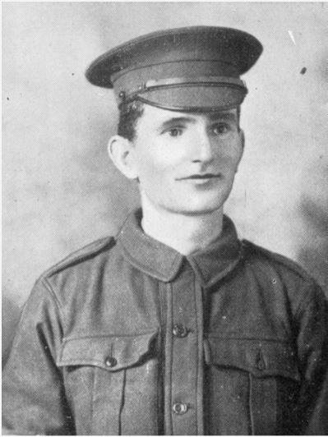
Private Edgar Williams, 4621, 58th Battalion (Neda)
“My name is Private Edgar Williams and I fought with the 58th Battalion at the Battle of Fromelles. I was born in Castlemaine, Victoria in 1884 and as I grew up, I always wanted to become a teacher. In 1900, at the age of sixteen, I became a junior teacher at Long Gully. I then held a series of positions at Eaglehawk, Mundoona North, Narraport and finally at Ouyen Primary School, where I became the Head Teacher or Principal. I was happily teaching in Ouyen when the Great War broke out and I thought it was my duty to sign up and help the lads. I signed up on September 4th, 1915, while our boys were fighting in Gallipoli. In November 1915, I was sent with the 14th Reinforcements on the Troopship Themistocles to join the 5th Division A.I.F that was being assembled in Egypt. In Egypt I initially was placed in the 57th Battalion but on April 5th, 1916, I was transferred to the 58th Battalion. In June we all embarked to where the action was, France. We were immediately thrown into training at Steenbecque for a few days, and then sent straight to the Front Line as there was about to be a big attack on the Germans. This attack was later known as the Battle of Fromelles, but we didn’t know that at the time as we had just arrived.
I was detailed with the responsibility of managing a gas apparatus which I had just learned about in my training. To tell you the truth, I wasn’t comfortable gassing the Germans and I really wasn’t that keen on shooting soldiers, so I volunteered to be a stretcher bearer and transferred to that unit. Because I was a teacher, the A.I.F. offered to enter me in a course of instruction over in England so that I could become an officer, but I declined as I wanted to stay with my mates.
When the big battle began on July 19th, 1916, it was absolute hell. My job really began when it all ended the next morning. You could hear the cries of so many men, Aussies, Poms, but mostly Aussies, out there in the smoking hellhole that was called No-Man’s Land. We stretcher bearers had a tough job: get out of the trenches and rescue as many of our men as possible. It was physically exhausting and very stressful, but we had to do it. How could you not try to save those brave ANZACs who had been cut down by the German machine guns? I worked 60 hours straight navigating massive shell holes and barb wire to bring back our bleeding and dying. The German medics were doing the same thing, but it wasn’t a proper Armistice as we had to put up with snipers taking pot-shots at us. Finally, after my mates insisted that I rest, I agreed to stop, despite me knowing that there were still boys out there after three days still needing our help. I said, ‘We will just get those last two fellas and then I will rest.” So, myself and Pte MacDonnell headed out to carry them back in. We grabbed one poor bloke and put him in the stretcher and told his cobber that we would be back for him shortly. That was when the bullet hit my head, passing through my right eye, and exiting through my skull. Suddenly, I was blind, blood pouring down my face. I sat down and Pte McDonnell put a bandage around my head, but it was useless. I stood up, took off the bandage and wandered off, mumbling…”
Private Edgar Williams died from his head injury at Fromelles and was posthumously awarded the Military Medal for bravery and saving the lives of Australian soldiers who had been cut down on No-Man’s Land on July 19th and 20th July 1916.

