Strong Women Raising Strong, Young Women
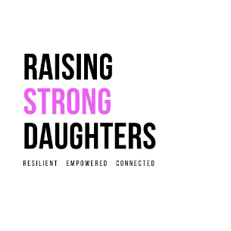
An Event for Mothers and Daughters aged 12-16
This workshop will empower you to:
* Develop and maintain a stronger sense of self
* Create a kinder inner voice
* Handle challenging friendships/Peer Pressure
* Become a critical Social Media user
* Stay one step ahead of the messages of Diet Culture and Society’s unrealistic beauty standards
Parenting young women is hard work. Our girls are facing immense pressures to look and act a certain way, and unfortunately, they are growing up in a world that sees them as bodies first and people second.
This workshop will give both you and your daughter strategies and skills to develop and maintain a more peaceful and harmonious relationship with your mind, body and spirit.

When: Sunday 16th May
Time: 1:30-3:00pm
Where: Black Rock Civic Hall
To book tickets: https://www.trybooking.com/BQRYC
About your Presenter:
Amanda Stokes is a passionate Educator, Author and Presenter with over 15 years’ experience working with young people and adolescents in both the Education and Health Care Sectors. Amanda supports Mothers to raise self-aware and emotionally connected daughters.

To book tickets: https://www.trybooking.com/BQRYC

