Bookings open Wednesday 6 December 2017
Participant name: ______________________________________________________________________
Teenage School Holiday Program Booking Form

- Please sign the box marked ‘parent signature’ for each activity your child wishes to attend.

- Young people with a disability are encouraged to attend the school holiday program however must register with the Recreation Program Team on – 9705 5839 prior to booking.

Date | Activity | PAYMENT | Parent signature | Office use
WEEK 1 BOOKINGS CLOSE WEDNESDAY 10 JANUARY 2018
2/04/18 | Public Holiday | -
3/04/18 | Indoor Sports Centre | DET PLACE
4/04/18 | Bounce | DET PLACE
5/04/18 | Go Karting and Laser Tag | DET PLACE
6/04/18 | Retro Gaming Afternoon  SOLD OUT | SOLD OUT
WEEK 2 BOOKINGS CLOSE WEDNESDAY 17 JANUARY 2018
9/04/18 | Burger Masterclass | DET PLACE
10/04/18 | Healesville Sanctuary | DET PLACE
11/04/18 | Inflatable World | DET PLACE
12/04/18 | Ice Skating | DET PLACE
13/04/18 | Basketball Tournament and Giant Games | DET PLACE

Please tick the location your child will be dropped off at and collected from:
Cranbourne Endeavour Hills Doveton
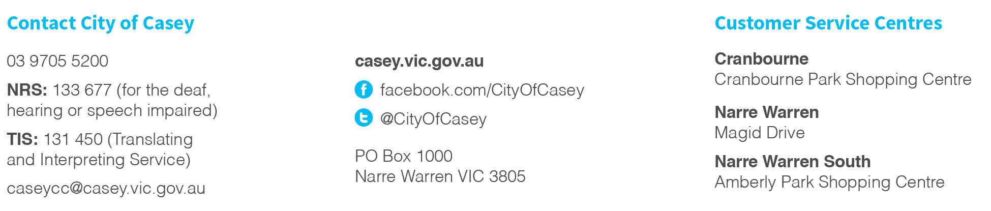
Hampton Park Narre Warren Youth Information Centre

