Career Outreach Opportunities for Families
Finding your right career is about your soul. It is about your identity.
It’s about connecting with where you belong.

7 June A webinar for parents and carers giving advice on how to help your student manage career uncertainty
Wednesday 7 June, 3.30pm
.
The Myfuture team is delivering this webinar to help parents and carers to understand the world of careers that their kids are facing.

In this webinar, Dr Jo Gleeson from Monash University, will talk about how to work with young students who are uncertain about where they see their future, and that is most students.
Register now

May – June Department of Education Career Conversations

The Department of Education gives advice on how to talk about careers with your student.
Register for one or more of the events HERE.
Hear about:
- exploring university and training pathways
- career pathway information for young people with disabilities
- where to find accurate, up-to-date career pathway information
- where the jobs are
- what employers and industry are looking for.

Online  Monday 26 June  5:30 pm to 6:30 pm  Register in Eventbrite | North Metropolitan  Joondalup  Monday 29 May  6:30 pm to 8:00 pm  Register in Eventbrite  Morley  Tuesday 20 June  6:30 pm to 8:00 pm  Register in Eventbrite

22 – 23 July WAAPA ACE your WACE 2.0
Dates: Saturday 22 and Sunday 23 July
Boost your confidence and turbocharge your WACE performance exam or audition!
You’ll perform one of your exam/audition pieces in a fun workshop setting - and WAAPA’s classical music lecturers will give you advice and strategies for enhancing your performance.
Cost: Free. Bookings are essential.

Jobs for the future – Fastest growing jobs
The fastest growing jobs are:
Job | Examples
AI and machine learning | - Tech jobs like coding  - Gathering and analyzing data to make business decisions
Sustainability specialists | - Urban planning and landscaping  - Designing and building homes that use less energy
Business intelligence analyst | - Managers who use data to make business decisions.
Information Security Specialists | - Developing secure IT systems and coding to ensure data security is still growing.
The employers of the biggest number of people are education, agriculture and digital commerce. Growth in those sectors continues.

From Future of Jobs Report 2023
Watch this video for more information.

University Opportunities

5 July UWA Years 10, 11 and 12 On Campus Experience

Why attend this event?
- Take a tour of UWA’s campus including an optional tour of College Row (residential college accommodation).
- Hear about our courses and entry pathways
- Learn about work integrated learning and how you can get career-ready at UWA
- Meet some of our expert lecturers, current students and staff, including some of our student clubs and societies
Find details and register HERE.
Curtin Scholarships 2024
ATAR Achievement Scholarships
(This one is fairly easy to achieve.)
Application forms are not required, students apply by selecting an eligible Curtin course through TISC as their first preference.
The scholarship will reward applicants who achieve an ATAR 3 points higher than their predicted ATAR, based on year 11 studies, and who want to pursue study at Curtin University.
Find details HERE.

Curtin Principal’s Recommendation
The Curtin Principal’s Recommendation Award has been developed by Curtin University to encourage and support students who have chosen to study at Curtin University.
Each West Australian high school principal can nominate two students for this award. Students can be nominated on any of the below criteria:
- Academic merit; or
- Showing most improvement during their high school studies; or
- Potential to achieve at university; or
- Adverse personal circumstances; or
- Financial difficulties
Find details HERE.

Business and Law Top Excellence Scholarship

The Business and Law Top Excellence Scholarship has been developed by Curtin University to reward and assist academically talented student(s) who receive the top ATAR within the Faculty of Business and Law.

Application forms are not required, students apply by selecting a Business and Law undergraduate degree through TISC as their first preference.

Charles Watson Top Excellence Scholarship for Health Sciences
Application forms are not required, students apply by selecting an eligible health sciences undergraduate degree through TISC as their first preference.
Find details HERE.

Curtin Excellence Scholarships
You will automatically be awarded the Curtin Excellence Scholarship if you’re a domestic year 12 student, graduate with an ATAR of 96+*, have an eligible Curtin course as your first preference and accept our main round offer:
- If your ATAR is 96 – 96.99, you’ll receive a one-year scholarship valued at $5,000.
- If your ATAR is 97 or higher, you’ll receive a three-year scholarship valued at $15,000.

Humanities Top Excellence Scholarship
The Humanities Top Excellence Scholarship has been developed by Curtin University to reward and assist academically talented student(s) who receive the top ATAR within the Faculty of Humanities.
Application forms are not required, students apply by selecting a humanities undergraduate degree through TISC as their first preference.
Find details HERE.

John de Laeter Top Excellence Scholarship for Science and Engineering
The John de Laeter Top Excellence Scholarship has been developed by Curtin University to reward and assist academically talented student(s) who receive the top ATAR within the Faculty of Science and Engineering.

Application forms are not required, students apply by selecting a science or engineering undergraduate degree through TISC as their first preference.
Find details HERE.

Women in Engineering Top Excellence Scholarship
The Women in Engineering Top Excellence Scholarship has been developed by Curtin University to reward and assist academically talented female student(s) who receive the top ATAR in an Engineering degree within the Faculty of Science and Engineering.
Application forms are not required, students apply by selecting an engineering undergraduate degree through TISC as their first preference.
Find details HERE.
Curtin provides advice on Applying for a scholarship

Training Opportunities

Register for Apprenticeship Alerts
Woodside and several employers of apprentices in the mining industry advertise and have thrie training managed through Programmed. You can register for apprenticeship alerts HERE.

You can also register on SEEK.

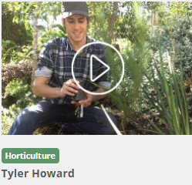
Horticulture Career Site
Kickstart your career in gardening!

Need a little inspiration? Not sure where to start?
We've got a list of common questions and a load of videos from people who've taken their first steps. When you're ready for more and want to find a job that’s right for you, click on the links below to find places to study, a variety of careers, professional organisations and a heap of opportunities.

For more information go HERE.

Traineeship Guide published
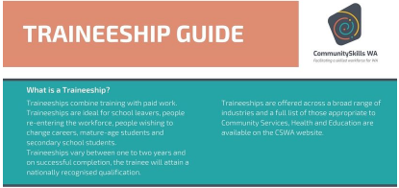
This is a handy guide to traineeships put out by the Community Skills Training Council which oversees traineeships in health, education and community services industries.
You can get a copy HERE.

Senior School Opportunities

4 July Curtin Economics Conference
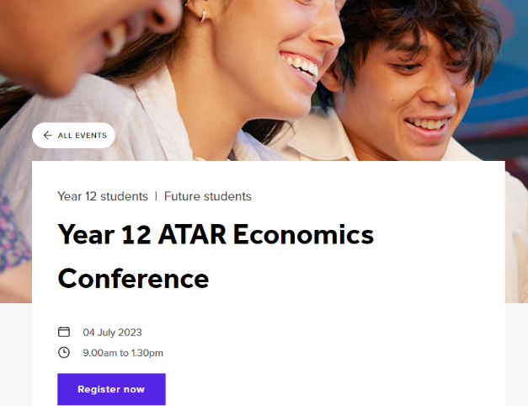
Get ready for the ultimate ATAR economics conference designed to elevate your revision game and prepare you for success! We’re bringing together industry leaders to share their expert insights and knowledge with you.
With a line-up of inspiring speakers, including renowned economist Paul Bloxham (Chief Economist HSBC and Curtin alumni) and special guest Steven Kemp (author of your textbook), you’ll be immersed in a world of economic theory and real-world application.
Find details and get tickets HERE.

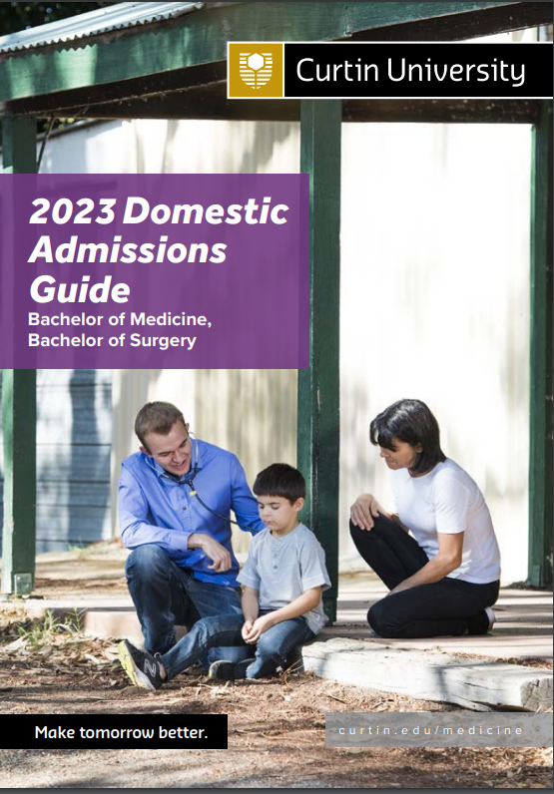
Bachelor of Medicine/Bachelor of Surgery (MBBS) Admissions Guide

Curtin advises to use the 2023 MBBS Admissions Guide as the guide for 2024.

It includes information about the course, key dates and admission criteria.

Curtin has clear and easy to find information about getting into medicine on its website.

Applications Open for Insurance Scholarships for Certificate, Diploma, Degree or Traineeship

The Real Futures Grant is a $5,000 grant awarded to a student studying for a certificate, diploma, degree or traineeship in one of the following fields:
- Healthcare,
- Medicine,
- Business, or
- Finance.
Applicants must write an essay saying why they want to work in their selected field and what difference they hope to make.
You can apply HERE.

Ag CareerStart Scholarships

The AgCareerStart Scholarships open on 14 August.
Successful applicants will be placed with a host farmer on a Gap Year paid work placement.
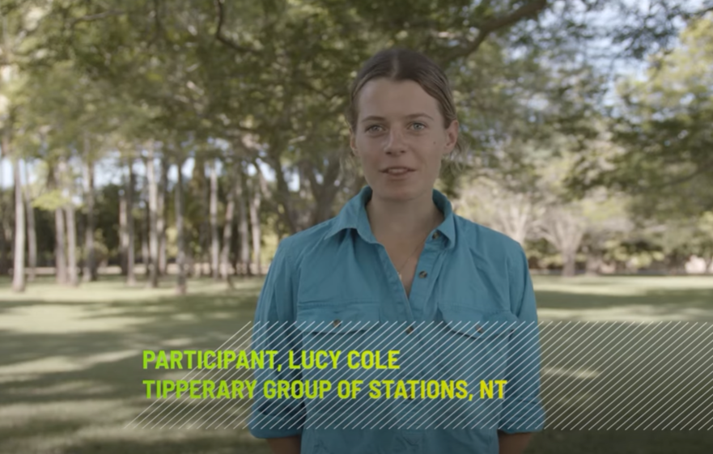
Check out this participants experience.

Register for Scholarship Alerts
Go to the Good Universities Guide and register your preferences for scholarship alerts to that you find out as new scholarships are announced.

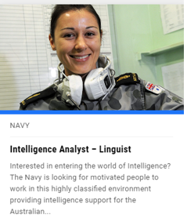
Become an IT expert in the Navy

It you are interested in a career in IT, consider going into the navy. There aren’t many places where IT systems are more vital and advanced.
Defence force systems are the best. They have to be. People’s lives are at risk.

If you are interested in doing a computing degree check out opportunities in the navy HERE.

Projects Abroad
These projects give young people opportunities to grow and learn as they experience other countries. There are lots of different projects. A new one is a Diving and Marine Conservation project in Thailand for 15 – 18-year-olds.
Check it out HERE.
You need to pay to be a volunteer. You can check all of the different projects HERE.

Links to Curtin Guides for 2024
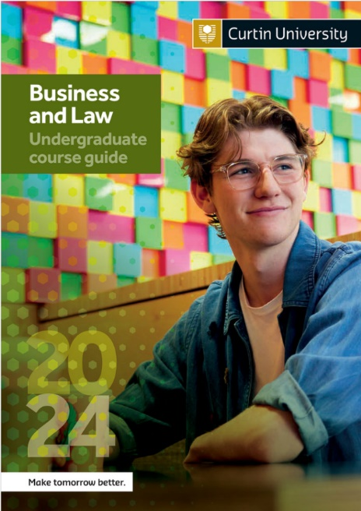
Curtin’s 2024 Course Guides are now available online:

- Business and Law Guide
- Humanities Guide
- Engineering Guide
- Science Guide
- Health Sciences Guide
- Undergraduate Guide

Going to Uni in WA in 2024
This is a booklet I have put together that collates information about universities in Western Australia.
It is designed to help you to decide which uni to go to, what course to do and where to get help to score top results and qualify for scholarships.

You can get it HERE.

ATAR Revision Programs
Curtin University is offering scholarships for students who achieve 3 points over their anticipated ATAR.
Book in for ATAR revision courses run during the mid year break.

Organisation | Details
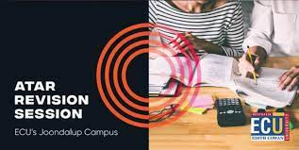 | ECU free revision sessions are delivered on campus and online in September.  Up until 2022, these programs were just for STEM subjects. There was significant demand for ECU to provide a broader range of courses.
 | Master Mind Australia will be running online courses and face to face courses at Guildford Grammar School, Christ Church Grammar School and Methodist Ladies’ College, Hale School, Ashdale Senior College and Quinn’s Baptist College.
Academic Task Force has added a new online service to their extensive range of support. They employ specialist teachers who work with students showing them how to apply what they have learnt at school, how to prepare for their exams and how to maximise their exam performance.
Rossmoyne SHS - Churchlands SHS- Perth Modern School
 | ATARget ATAR Revision, ATAR Exam Preparation and Study Skills programs focus on strengthening students’ understanding of subjects, boosting classroom confidence and improving examination performance.
 | WACE+ ATAR Revision, ATAR Exam Preparation and Study Skills programs focus on strengthening students’ understanding of subjects, boosting classroom confidence and improving examination performance.
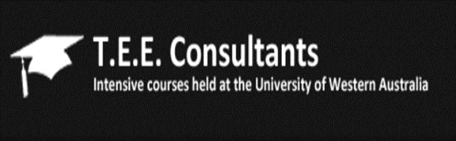 | TEE Consultants deliver intensive courses for year 12 students seeking university.  Courses are run at UWA and Murdoch.
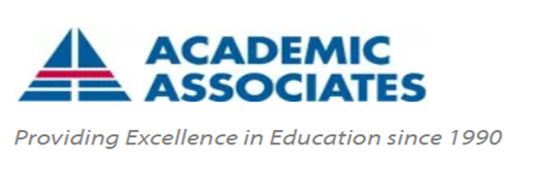 | Academic Associates conducts courses in most WACE subjects. See the latest timetable.  Venues: UWA and Notre Dame University
 |  | InTuition Education Support delivers small group classes in most WACE classes, exam preparation and study skills.
 |  | Revise Online Those who prefer to revise by themselves or those who live in rural and remote areas my like Revise Online. You can find their range of services HERE.
INDIVIDUAL TUTORS
Many semi-retired teachers continue to tutor in their specialty subject.
These teachers have a lifetime of knowledge of their subject, what examiners are looking for and tips for success.
Ask at your school front office to see if they know anyone you can contact.
 |  | Curtin is running an Economics Conference and a Finance and Accounting Conference for ATAR students

Year 11 Opportunities

Curtin Girls + Engineering Tomorrow
Applications are open for Year 11 girls who wish to participate in an intensive out of schools course for 10 sessions, run each fortnight over two school terms. Each session includes a maths tutoring component and an engineering exposure component. Contact Aleesha Davis to find out more.

Applications Open for 2024 National Youth Science Forum
Applications close 31 July
The NYSF program is a 10 day science camp run in Canberra and Brisbane in January for students going into Year 12 who are interested in science, technology, engineering and maths.
The program provides participants with outstanding STEM experiences, opportunities to see a range of careers and you will meet students who could be colleagues throughout your career.

West Australian applicants are encouraged to contact their local Rotary group as Rotary supports this program where possible. You can find out about scholarships HERE.
You can find out about the program HERE.

Year 7 – 10 Opportunities

It takes a Spark! STEM Conference
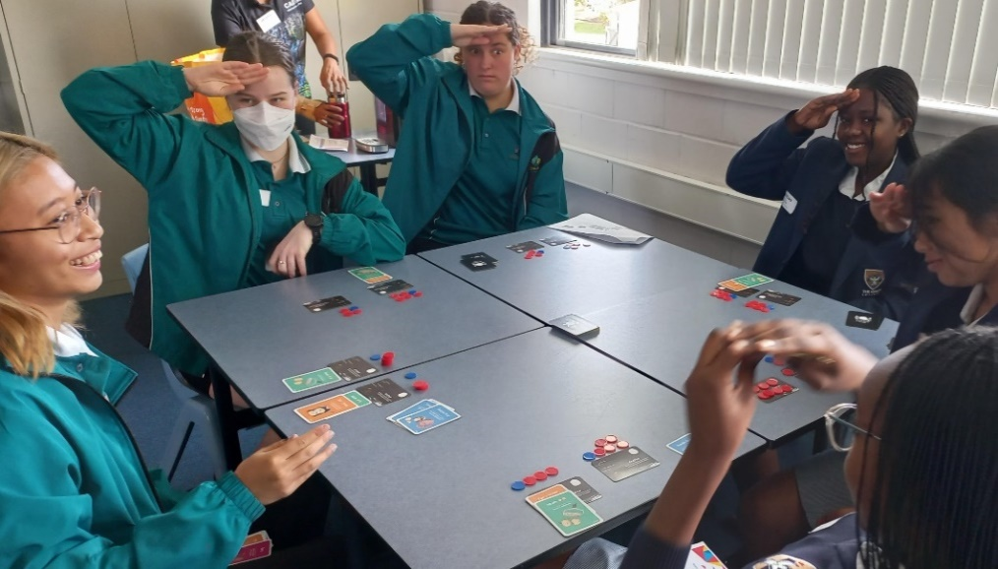
The It Takes a Spark! Conference is on in September. Find details HERE.
This is students at last year’s conference. They are playing a Potato Pirates game that taught them about computational thinking and programming in a frenetic way
You get to talk to experts from universities, TAFE’s and industry about future STEM possibilities.

Year 10 Opportunities

Year 10 Subject Selections for University 2026
If you're in Year 10, the TISC University Admission 2026 (available end Term 2/early Term 3) will help you choose your senior secondary courses, so that you can meet university entry requirements.
Check the undergraduate admissions information that applies to the year in which you'll be commencing your university study.

- The Curtin Year 10 Guide may be useful when making your decisions.
- The University Admissions Centre gives this advice to students in NSW.

Career Conversations – Advice on how to help your student to make career decisions

This series of Career Conversations is available online starting in April, before going to regional centres.

Online events
From 5:30 pm to 6:30 pm.
- 26 June 2023
Goldfields  - 8 June, Esperance  - 13 June, Kalgoorlie | Kimberley  - 2 May, Broome  - 8 August, Kununurra
Mid West  - 22 May, Geraldton  - 27 July, Carnarvon | Pilbara  - 21 June, Karratha  - 22 June, Hedland  - 25 July, Newman  - 10 August, Tom Price
South West  - 27 March, Busselton  - 28 March, Bunbury  - 8 May, Albany | Wheatbelt  - 25 May, Northam  - 31 May, Narrogin

21 June UWA Online Regional Student Information Webinar
Got questions about your journey to UWA as a regional student? Join us at our upcoming online information session on Wednesday 21 June to find out more about courses and pathways, our Broadway UWA scheme, support services and accommodation, and have an opportunity for Q&A with UWA staff.
This event will be live-streamed.
Register HERE.

Ageing and Disability Job Ready Program: Bunbury
An Ageing and Disability Program has just started in Bunbury. If you would like to register for a future program, you can complete a registration form HERE.
communityskills@cswa.org.au.

Community Support Skillset inclued first aid - FREE IN ‘23

The Community Support Skillset skillset is designed to provide both new and existing community services and workers with the knowledge and skills to provide care and support to individuals in a community setting.
For more details go HERE.

City Beach Residential College for Gifted Students

If your student is a candidate for a Gifted and Talented Selective Entry program at one of Perth’s best secondary schools, you might like to check out the support and accommodation provided at City Beach Residential College.
Students from regional areas board at the College. 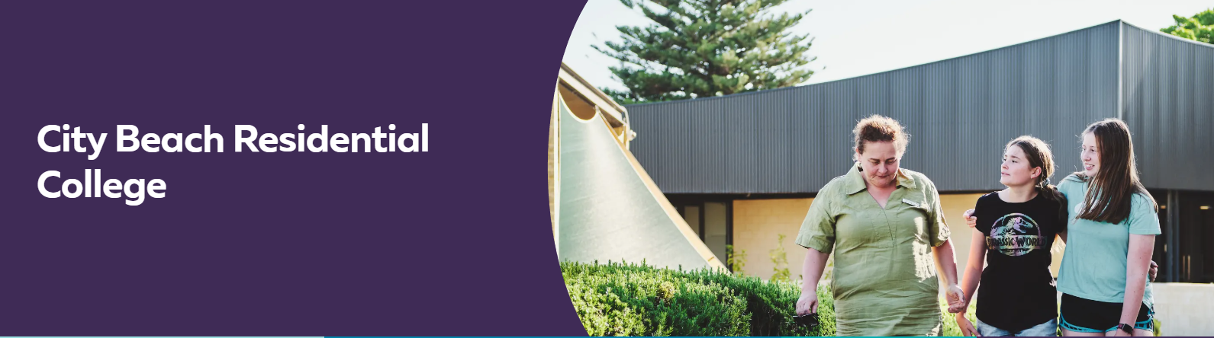
Take a virtual tour of the College and check out the opportunities and support that is provided via this site.

Regional Public Sector Traineeships
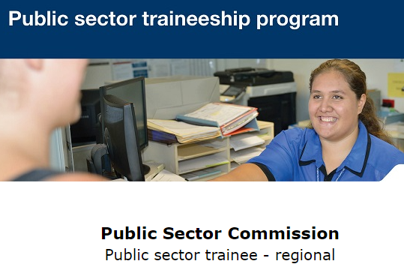
Applications open all year.

The ‘Public sector traineeships in Government (Public Administration)’ – will give you the opportunity to work in a regional WA public sector agency full time for 12 months or part time for 18 months while earning a trainee wage. On successful completion of the traineeship, you will attain a nationally recognised qualification of a Certificate II, III or IV in Government (Public Administration).
For more information go HERE.

Aboriginal and Torres Strait Islander Opportunities

9 – 15 July Curtin Indigenous Australian Engineering School
Week long residential school
The Indigenous Australian Engineering School (IAES) is a week-long residential camp introducing students to engineering studies and careers. Students will do site visits, meet industry representatives and participate in educational activities. The program targets Indigenous students in Year 9, 10, 11 and 12 with an interest and aptitude towards engineering, science and mathematics.
For more information go HERE.

Email Tim Keely to find out more

Have you read the Uluru Statement from the Heart yet?

The Uluru Statement from the Heart is the invitation for Australians to establish a First Nations Voice in the constitution.

The Statement is powerful and moving and beautifully written. Read it HERE.

The referendum on The Voice is a matter of life and death. It aims to put decision making with those who are impacted.

Indigenous Pre-Medicine and Health Sciences Enabling Course

Are you interested in pursuing a career in medicine or health sciences? The Indigenous Pre-Medicine and Health Sciences Enabling course will prepare you for entry into most health sciences courses.
Check out the video HERE.
Find more information HERE.

Services for Aboriginal people enhanced across WA's 19 Jobs and Skills Centres
Jobs and Skills Centres (JSCs) services include specialist services for Aboriginal and Torres Strait Islander people. This service has recently been enhanced through an $8.14 million funding boost.

If you need information or support with any job or career related matters for Aboriginal students, contact your local Jobs and Skills Centre.

Students with Disability Opportunities

2024 Curtin Students
If you have a disability and plan to go to Curtin in 2023, register with Curtin’s AccessABILITY Unit so that staff are aware that you will be attending and of any specific services they need to provide to ensure your best opportunity to succeed.
You can find details HERE.

Genius Armoury Cyber Security for Autistic Students
Genius Armoury offers a range of courses to help introduce neurodiverse individuals to cybersecurity, exploring some of the fundamentals of coding, threats, and exploits, networking, and more. Available to anyone and free to complete, modules only take around 30 minutes to complete.
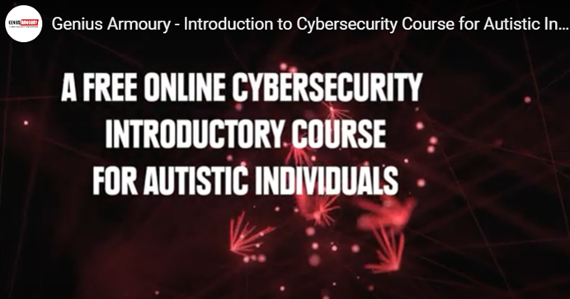
Successful completion of the program may provide eligibility to those located in Western Australia for enrol in a Bachelor of Science course in Cybersecurity at Curtin without an eligible ATAR, through the Portfolio entry system.
Find details HERE.

International Student Opportunities

4 July ECU International Student information session
Join this online information session and ask questions of experts.
6 – 7.30 PM Find more details and register HERE

Study Perth

Study Perth provides support to students who intend to study at school, VET or uni in Perth and to those international students who are already here. You can subscribe to their newsletter HERE.

$1,500 International Student ELICOS Bursary
The Western Australian Government’s International Student ELICOS Bursary provides eligible international students with a one-off support payment of $1,500 towards their ELICOS course fees, when studying in Western Australia.
Find details HERE.

Employment outcomes for international Vocational Education and Training (VET) Students

In mid-2022, 83.0% of international onshore VET students were employed after training, up 7.5 percentage points from the same period in 2021. A total of 81.3% were employed in Australia, which was 8.5 percentage points higher than in the previous year.
Overall, 73.0% of international onshore VET qualification completers had an improved employment status after training, an increase of 8.9 percentage points from 2021.
You can read the report HERE.

You can start to prepare your school or organisation to fully engage with Chat GPT

