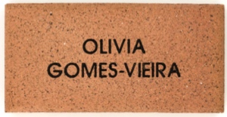
CONTACT DETAILS AND PAYMENT OPTIONS:
Name | Phone | Total Amount
 |  | $
Payment Options:
EFT or CASH in person at school office
OR Direct Deposit
Account Name: Swan Hill North Primary School
BSB: 063 529
ACCOUNT NUMBER: 10043535

Please use your name as a reference

Payment Date: / /
As part of the exciting new building works at our school, we are inviting members of our school & community to take part in a special opportunity to leave a lasting legacy by purchasing commemorative pavers. These pavers will be laid within the outdoor areas and pathways, creating a meaningful space that reflects the support, memories, and spirit of our school community. Families, students, staff, and the local community are all encouraged to participate and become a permanent part of this chapter in our school’s history.

Complete one form per paver and return to Swan Hill North Primary School via:
EMAIL: swanhill.north.ps@education.vic.gov.au
IN PERSON: At the School Office

$35 per PAVER or two for $60
Provides you with a personalised engraved paver to be placed at Swan Hill North Primary School
THE PAVER PROJECT
orders CLOSE FRIDAY 31st July 2026
ENGRAVING DETAILS – MAX 17 CHARACTERS PER LINE
Please print clearly using ALL CAPITAL LETTERS. Max 3 lines per paver.
Each box represents a character (letter, number, punctuation mark or space). No hand drawings.
L 1
L 2
L 3

