**Senior School Assessment Procedures**

At Senior School level students will complete a number of assessment tasks across the year that are aimed at assessing the level of understanding the student has in the current unit of study. These assessment tasks can be administered in a variety of forms, including:

* In class assessments (known as a SAC at VCE level) where the student will complete the entire assessment task within the classroom.
* Combination of in class assessment and out of class assessment (known as a SAT at VCE level) where the students will be able to work on the assessment inside the classroom, as well as take it home to complete additional work.

Students have been provided with an assessment calendar so they are aware of when their assessment will occur. These dates are also published on Compass and this version of the College newsletter.

How does the assessment process occur?

Students will be provided with a ‘notification of assessment task’ form at least two weeks before the assessment task, which will advise students of the date, time, outcomes being assessed and instructions for what to do if they are absent from the assessment task.

Students will then complete the assessment task on the date advised on the ‘notification of assessment task.’ The teacher will collect the assessment task from students on this date and will provide timely feedback to the student including their result, areas the student has performed well, areas that require further focus and strategies for making improvement in the future.

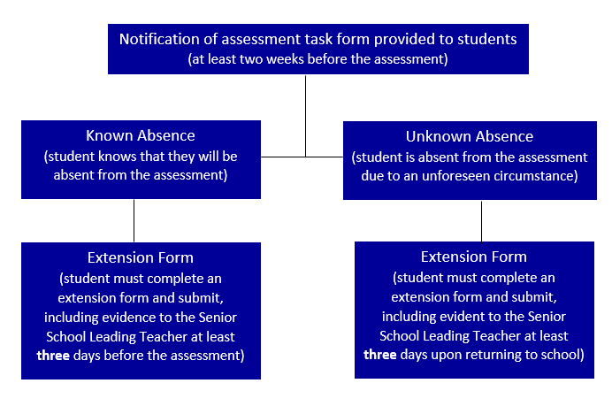What happens if a student is absent on the day of an assessment task?

**Student and teacher will be informed through email by the Senior School Leading Teacher when the extension has been approved.**

What happens if a student misses a deadline?

If a student does not submit a take home assessment by the due date or does not submit the appropriate paperwork for an extension within the required timeframe parents will be notified of a deadline failure.

In this case the student will then be given notification by the classroom teacher of another time they are to complete this task. This task will be marked by the classroom teacher for a satisfactory grade, however **zero** marks will be awarded for the assessment.

What happens if the student does not receive a satisfactory grade?

When a teacher is deciding whether a student has demonstrated a satisfactory understanding of the key knowledge and skills that are being assessed they will look at both the work completed within the classroom during the unit and the assessment task. Students firstly have the opportunity to demonstrate a satisfactory understanding of the key knowledge and skills through the completion and submission of coursework completed during the unit. If a satisfactory has not been received before the assessment task the teacher will rely on this task to assess whether the student’s knowledge and skills are at a satisfactory level.

If a student has not obtained a satisfactory through these two methods they will be required to complete a redemption task. Students will receive a ‘notification of assessment task’ form and will be given approximately one week to prepare for this task. The teacher will decide whether this task is an open book worksheet, another copy of the assessment task or an oral assessment. This redemption task must be supervised by teaching staff to ensure the work is the student’s own. The teacher will use this redemption task to decide whether the student has now received a satisfactory or unsatisfactory. It is important to note that the original mark for the assessment will still stand and this task is only used to gain a satisfactory grade.

Important information about the extension process

**When can I apply for an extension and what evidence will I need?**

* School excursion or camp (no evidence required)
* Specialist appointment (appointment card required)
* Family holiday booked prior to the assessment task being scheduled (completed statutory declaration required)
* Work stress (well-being team support required)

**What are some examples of extensions that will not be granted?**

* Beauty appointments, including hair, make-up or nails
* Driving lessons
* Routine doctor appointments for check-ups
* Breakdown of technology
* Not organised or prepared for the task

**What evidence will I need if I miss an assessment due to an unforeseen circumstance?**

* Illness (medical certificate)
* Other (statutory declaration)

**What if I forget to fill out an extension form before going on work experience or camp? Can I fill it in three days after and submit it?**

No. There is a difference between a known absence and an unknown absence. Students need to be organised as they are given a minimum of two weeks notice before an assessment and therefore have enough time to apply for an extension a minimum of three school days beforehand. An extension submitted after the assessment for a known absence will result in a zero.