Level 5 Homework Matrix
Homework tasks should ideally be completed with adult supervision. The Homework Matrix for each level will be available in the Connect newsletter once a fortnight. Tasks will be completed in student homework books and handed in to the teacher, to be signed, two weeks later on a Friday morning (even weeks). Teachers will sign homework books.

L5/6 – Reading + 8 tasks/fortnight
Reading (compulsory)  Read for: minutes every day.  Record the title of your book and the pages read in your diary. Ask an adult to sign your diary.   | Reading/Summarising:  We learnt that Neerm (Port Phillip Bay) has been a significant gathering place for Indigenous Australians throughout history.  Research some interesting facts about the history of Neerm/Port Phillip Bay and dot point the main facts in your homework book (who, what when where why).  Use your facts to write a summary of what you learnt using full sentences.  Extension:  Draw a map of Neerm/Port Phillip Bay and its important flora and fauna. | Physical Education Challenge  Cross Country Practice  Go for a run at home. Alternate between jogging for 30 seconds and walking for 30 seconds for 5 minutes. Try to maintain a steady pace and rhythm throughout your run. | Gratitude  Pick 3 people you are grateful for  this month. Make sure you explain  why you picked each person.
Spelling/Hand Writing/Vocabulary  This week, we have learnt vocabulary unique to numeracy, literacy and history. Practice the following words daily by: saying them out loud, writing them down neatly and breaking them into their morphemes e.g millimetre = milli +metre and record their meaning e.g 1/1,000th of a metre.  - kilometre  - conscript  - conscription  - perspective  - perimeter  - migrate  - migrating  - immigrate  - decametre  - colonies | Maths  This week, we have learnt how to measure length, and calculate the area and perimeter of shapes.  Practice your skills by choosing the appropriate unit to measure a room in your house, and then calculate its perimeter and area. | Art Challenge  Week 2 - Create an artwork expressing your emotion using colour, line and composition. Consider how artists show mood. | Mindfulness  Lay in a quiet room of the house or  somewhere comfortable outside  e.g. on the grass for a few minutes.  Take a moment to just stop and  listen to all the sounds around you.
Inquiry: Push and Pull Factors  Interview a family member or friend who has moved countries before. Draw up a T-Chart and find out what factors pushed them out of one country and pulled them into another.  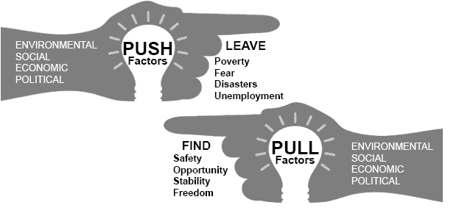 | Maths Skills/Fluency  Practice your 9 times tables.  Challenge: See if you can skip count by  9’s. Go right past 100. | Science Challenge  Look at the colour of your family’s eyes. Are they the same colour or different?  If you have pets, do they have the same coloured eyes or different colours | Emotional Literacy  Create a feelings collage using  magazines, coloured paper or art  supplies. Find pictures  representing different emotions to  create a collage that visually  portrays your feelings.
Maths  Find all the possible factor pairs for;  24, 48, 36  How do you know you’ve found all factor pairs? Prove it! Draw a table or use a system to show how you know. | Online Platforms  - Read a book on Wushka  - Complete tasks on Mathletics  - Play a game on Maths frame  - Listen to a story on Storybox | Mandarin Challenge  Write the time  晚上七点 (wǎnshang qī diǎn)  早上六点半 (zǎoshang liù diǎn bàn)  中午十二点 (zhōngwǔ shí’èr diǎn)  晚上八点一刻 (wǎnshang bā diǎn yí kè) | Empathy  Think about 3 ways in which you  can brighten someone’s day this  week or ways in which you can  cheer someone up if you notice  they’re sad.

