The 7 Types of Rest: A Practical Guide

This guide brings together the core principles of Dalton‑Smith’s 7 Types of Rest.

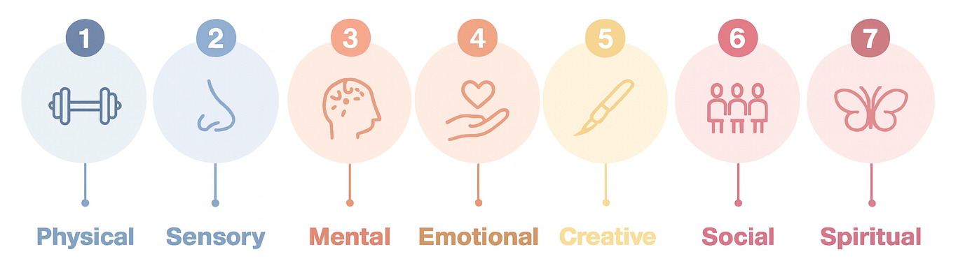

1. Physical Rest

Supporting the body to recover from strain, fatigue, and continuous demand.

- Build regular movement into your day—stretching, walking, mobility, gentle exercise.
- Prioritise oxygen: practise slow breathing or step outside for fresh air.
- Drink water consistently throughout the day.
- Get direct sunlight where possible to boost vitamin D and regulate sleep cycles.
- Choose low‑GI foods for stable energy.
- Alternate between sitting, standing, and moving.
- Rest when your body signals it—don’t override fatigue.

2. Sensory Rest

Reducing sensory overload from screens, noise, visuals, and constant stimulation.

- Limit video calls and simplify backgrounds to reduce visual and cognitive fatigue.
- Reduce exposure to emails, social media, news, and YouTube at set times.
- Switch your phone to night or flight mode during breaks.
- Take intentional breaks from sound—no podcasts, music, audiobooks, or chatter.
- Build micro‑periods of silence into your day.
- Minimise visual clutter in your environment.
- Step outside or choose calm, low‑stimulus spaces.

3. Mental Rest

Easing cognitive demand so the mind can reset.

- Avoid multitasking; its cognitive cost increases errors and drains energy.
- Recognise mental load—decisions, planning, problem‑solving, emotional labour.
- Protect REM sleep by reducing late‑night mental stimulation.
- Write a to‑do list at the end of each day to offload pending tasks.
- Keep a notebook beside the bed to catch runaway thoughts.
- Say no to new commitments when capacity is low.
- Ask for help early rather than late.
- Insert short “mental reset” pauses between tasks.

4. Emotional Rest

Giving yourself permission to feel, process, and decompress instead of absorbing everything around you.

- Acknowledge emotions rather than powering through them.
- Speak honestly with people who feel safe.
- Allow yourself not to take on others’ emotional load.
- Notice when you are over‑empathising or absorbing the mood of a room.
- Set limits on emotionally heavy conversations when you’re depleted.
- Journal or reflect to process emotional weight.

5. Creative Rest

Re‑igniting imagination, innovation, and problem‑solving capacity.

- Create space in your schedule for idea generation—not just output.
- Remember: insights often come when we pause, walk, or take a break.
- Manage notifications and communication channels to protect uninterrupted thinking.
- Spend time in nature, or bring natural elements into your workspace.
- Use mindfulness to reset your thinking environment.
- Engage in creative hobbies without pressure—sketching, music, writing, building.

6. Social Rest

Balancing relationships that energise you with those that drain you.

- Identify your “zappers” (draining) and “sappers” (supportive) and prioritise accordingly.
- Get comfortable with disappointing others when needed.
- Prioritise your own needs instead of defaulting to people‑pleasing.
- Be discerning about how you spend your relational energy—within reason.
- Hold healthy boundaries around availability and emotional labour.
- Seek out interactions that feel grounding and positive.

7. Spiritual Rest

Connecting to meaning, purpose, values, or community.

- Engage with faith, spirituality, or personal belief systems if they resonate with you.
- Connect with communities or causes that give you a sense of purpose.
- Participate in service, contribution, or volunteer work.
- Use reflection, meditation, or gratitude practices to reconnect with values.
- Seek out moments that remind you of belonging.
My Wellbeing Plan

