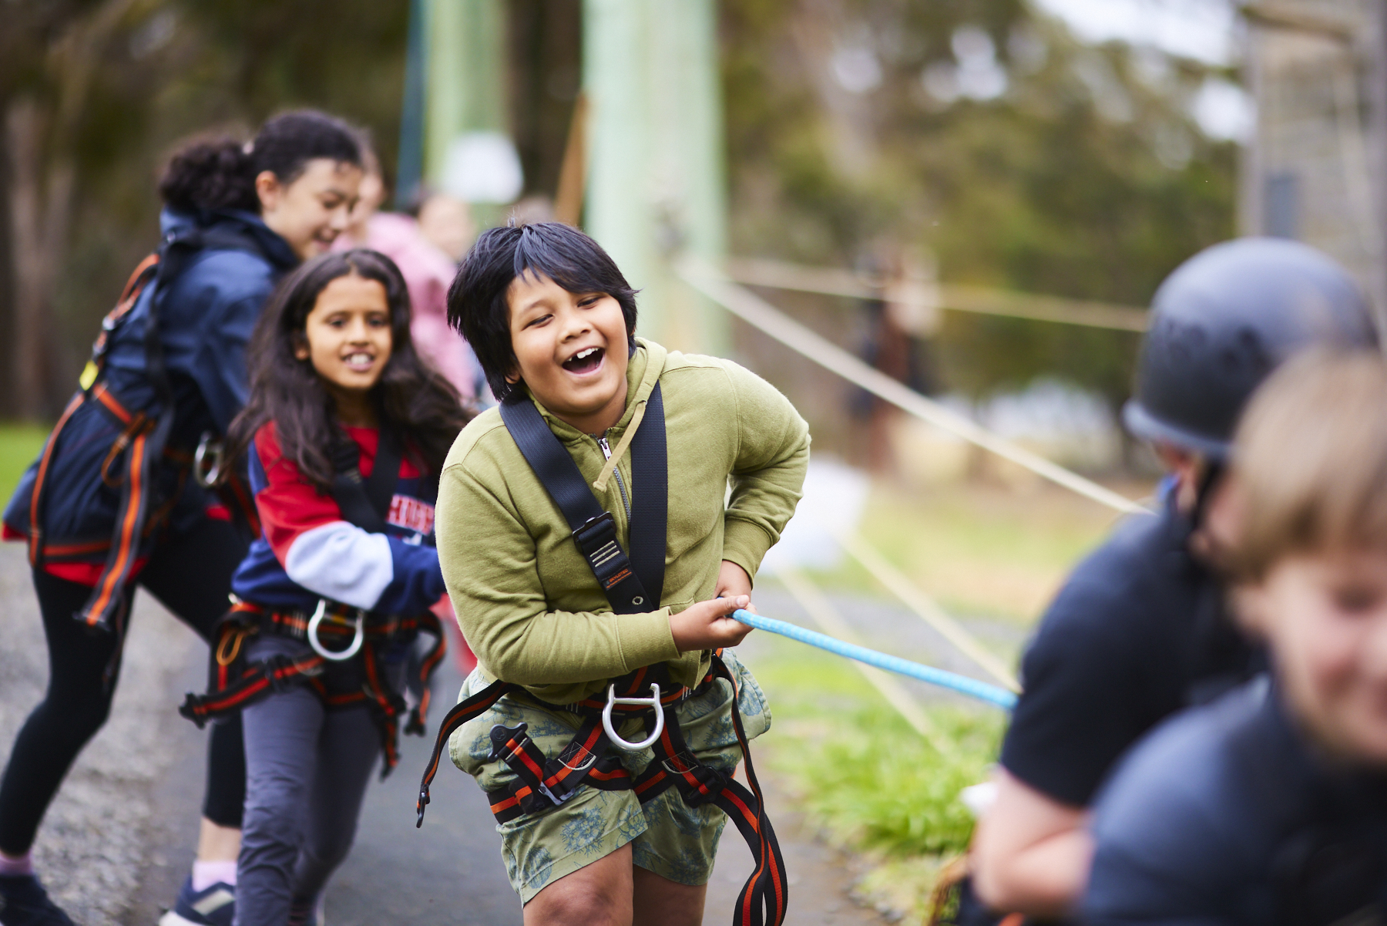
Holiday Camps
Application forM 2024

HOLIDAY CAMP 2024
OVERVIEW
Doxa is a not-for-profit organisation that provides opportunities so that all kids can experience going on camp. We have been running our programs for over 50 years. Our Holiday Camp program offers positive life experiences through a variety of team building activities, personal challenges, and eye-opening moments. We are all about campers having fun while learning and creating special childhood memories.
WHAT IS ON OFFER?
Malmsbury Camp
Our Malmsbury Camp is located in an idyllic bush setting in Central Victoria on the land of the Dja Dja Wurrung people.
There will be a broad range of onsite activities including high ropes, the giant swing, rock climbing, archery, bush adventure activities complemented by native wildlife interactions, swimming & canoeing and other off-site activities.
City Camp
Located in the heart of the CBD on Woiwurrung Wurundjeri Country, our city camp will offer participants the opportunity to discover all the things that our vibrant city has to offer. From seeing Melbourne’s iconic attractions such as the Eureka Skydeck and Melbourne Zoo, visiting the beaches of Melbourne and viewing sport in the sports capital of the world!
Who can attend a Holiday camp?
Our Holiday camp program is for students aged between 10-12 years old who are in year levels 4-6 in 2024.
DATES - Malmsbury & City

Malmsbury Camp
Monday 8th January – Friday 12th January
5 days and 4 overnights

City Camp
Monday 15th January – Friday 19th January
5 days and 4 overnights.

COST
There Is no cost for our holiday camps. Holiday camps are funded by our amazing donors and philanthropic ventures. This includes the cost of accommodation, meals, activities, and transport whilst at camp.
TRANSPORT
City Camp: We will provide bus pick up and drop off to camp from pickup points in Traralgon / Pakenham and Bendigo or families can drop off and pick up their child from the camp.
Malmsbury Camp: We will provide bus pick up and drop off to camp from pickup points in Bendigo and Melbourne or families can drop off and pick up their child from the camp.
the application process
Thank you for your interest in Doxa’s Holiday Camp. Please read, complete, and sign this form and return it to info@doxa.org.au. If you need more information, please contact our team on:
- (03) 9046 8200
How does this work?
Please fill out and return this application form ASAP. We accept applications on a first come first serve basis and the last applications are accepted on Friday 1st December.
Please be advised that submission of this application is not a confirmation of attendance.
Once you’ve sent back this application form, we’ll get in touch with you to advise on the next steps including transport options.
Select camp
Please select 1 of the below options for the 2024 Holiday Camp.
Malmsbury camp
- Monday 8th January – Friday 12th January 2024
City camp
- Monday 15th January – Friday 19th January 2024

Transport options
Malmsbury camp
Doxa facilitated bus transport is available from Southern Cross Station, Melbourne and Bendigo Station.
Parents can drop off & pick up at Malmsbury Camp - 1000 Vaughan Springs Road, Drummond North

My child will travel to Malmsbury Camp via:
- Doxa bus from Southern Cross Station, Melbourne
- Doxa bus from Bendigo Train Station
- Individual drop off & pick up at Malmsbury Camp
City camp
Doxa facilitated bus transport is available from Traralgon / Pakenham Station and Bendigo Station.
Parents can drop off & pick up at City Camp – Medley Hall - 48 Drummond Street, Carlton

My child will travel to City Camp via:
- Doxa bus from Traralgon Station
- Doxa bus from Pakenham Station
- Doxa bus from Bendigo Train Station
- Individual drop off & pick up at City Camp

Camper contact details
First name: Last name:
Date of birth: / / Age: Gender: Male / Female / other
Current Year level: ________________ School Name: ____________________________________
Parent / guardian name: ___________________________________________________
Parent / guardian email:
(Please note the above email address will be used for all communication with you by Doxa)
Parent / guardian mobile phone: (or home phone if no mobile)
Address:
Suburb: Postcode:

School contact details
We would like to contact your child’s school to find out about their previous camp experience so that we can tailor the camping experience to their individual needs.
- I consent OR
- I do not consent.

Teacher/Contact Name:

School phone number:

Emergency contact details:
Same as parent/guardian above Yes No
Name: _______________________________________ Phone No: _________________________________________________

Relationship to camper: ___________________________________________________________________________________

Alternative emergency contact details:
Name: _______________________________________ Phone No: _________________________________________________

Relationship to camper: ___________________________________

Swimming ability:
- Non-swimmer
- Novice (supports oneself in shallow water)
- Intermediate (supports oneself in deep water and can swim a length of the pool)
- Advanced (supports oneself in deep water and can swim many lengths of the pool)

Ambulance cover (if applicable);
Does your child (family) have Ambulance Cover? No Yes

Medical and dietary requirements

- Does your child have any allergies to any food, medication or other? No Yes
Is this an anaphylactic reaction? No Yes Please provide details, including what actions/medication is required:
__________________________________________________________________________________________________________________________________________________________________________________________________________________
- Does your child have any ongoing medical conditions (Asthma, Diabetes, Epilepsy, etc.) No Yes
If yes, please provide details: __________________________________________________________________________________________________________________________________________________________________________________________________________________
- Does your child have any behavioural concerns? No Yes
If yes, please provide details: __________________________________________________________________________________________________________________________________________________________________________________________________________________
- Does your child have regular/ prescribed medication? No Yes
If yes, please provide details: __________________________________________________________________________________________________________________________________________________________________________________________________________________

- Does your child/I have any special dietary requirements (allergies / intolerances)? No Yes
If yes, please provide details: __________________________________________________________________________________________________________________________________________________________________________________________________________________

participation consent form
Our programs are carried out in accordance with Australian Occupational Health & Safety regulations and our qualified staff have training in First Aid, Health & Safety procedures, and Risk Management.
The wellbeing and safety of participants is always important to use. However due to the nature of some of the activities in our programs there is an inherent element of risk involved.
If you have any questions regarding participation, please email: info@doxa.org.au or phone: (03) 9046 8200
Completion of this form is compulsory for your child to participate in all our activities.
General Waiver Agreement and Release
- I acknowledge that there is an inherent risk of personal injury in physical activities that will be undertaken during a Doxa program, and I accept that risk.
- I agree that Doxa will not be held responsible for any future medical complications that may arise later, as a result of an incident.
Medical emergency
- In the case of an emergency, I authorise Doxa staff, where I am unable to be contacted, to arrange for my child to receive medical or surgical treatment as deemed necessary.
- I also consent to undertake any payments or reimburse costs which may be incurred for medical attention, ambulance transport and medication while my child is in Doxa’s care.
Where a child may need to be taken home
- If your child becomes ill or is having major difficulties coping with being at camp, it may be necessary for you to pick them up or arrange for them to come home.
Transport
- I understand that Doxa is not held responsible for any incidents occurring on transportation to and from the Doxa program location.
Personal Information
- I understand that any personal information collected related to my child can only be accessed by authorised Doxa staff, subject to privacy restrictions.
- I consent that such information may be provided to medical professionals where necessary.

By signing below, I agree for __________________________________________ (camper full name) to attend and participate in the activities offered and agree to assume the risks of participating in these activities.
I understand and have read the above information provided by Doxa in relation to the holiday program.

Parent/guardian (full name): ______________________________________________

Parent/guardian (signature): ______________________________________________ Date: ________________________

MEDIA CONSENT FORM

I consent to Doxa holding any photograph or video footage of my child/me throughout the duration of program participation and to use in any promotional material including:
- Marketing collateral (brochures / reports)
- Print and online media (newspapers, magazines, blogs, news sites)
- Social media (Facebook, Instagram, Twitter) and Doxa website, promotional videos
- I acknowledge that no fee or other charge is payable to Doxa for that use and that Doxa owns all copyright in the photograph or video.
- I understand that I can withdraw my consent to future use of any photograph or video by giving Doxa written request at any time.

Please tick one of the following options for media consent:
I consent OR I do not consent

Parent/guardian (full name): ______________________________________________

Parent/guardian (signature): ______________________________________________ Date: ________________________

