**Thai Pumpkin Soup**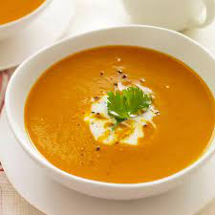

Ingredients

* 2 tablespoons canola oil
* 1 small white onion, chopped
* 2 cloves garlic, minced or 2 teaspoons jar garlic
* 1 tablespoon freshly grated ginger or jar ginger
* 1 stalk of lemongrass, bruised or 1 tablespoon purée lemongrass
* 2 tablespoon Thai red curry paste
* 500g pumpkin (peeled, deseeded and cubed)
* 2 cups vegetable stock
* 1/2 teaspoon salt
* 400g can unsweetened coconut cream
* 2 tablespoons lime juice
* Coriander (optional)

Directions

* In a large pot, heat the oil over moderate heat. Add the onion and sauté for 5 minutes. Add the garlic, ginger, lemongrass and curry paste and cook for 3 minutes. Add the pumpkin and cook, stirring until soft (roughly 10 mins).
* Add stock then season with salt, and bring to a boil. Reduce the heat to low and simmer for 20 minutes. Stir in the coconut milk and lime juice and let cool for 10 minutes.
* Transfer the soup to a blender (or use an immersion blender in the pot) and puree until smooth. If needed, add additional water or stock to reach the desired consistency. Return the mixture to the saucepan. Serve warm and garnish with fresh coriander (if desired).