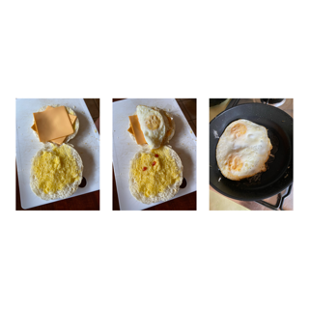
Delicious recipe by Felix
I see yummy bread melted butter eggs and USA cheese
I hear the eggs sizzle
I smell my dinner or lunch or breakfast
I taste good food delicious in my tummy
I feel good and so does the soft bread smooth American cheese and melted warm butter

