
LEVEL NEWSLETTER
2026  Term One  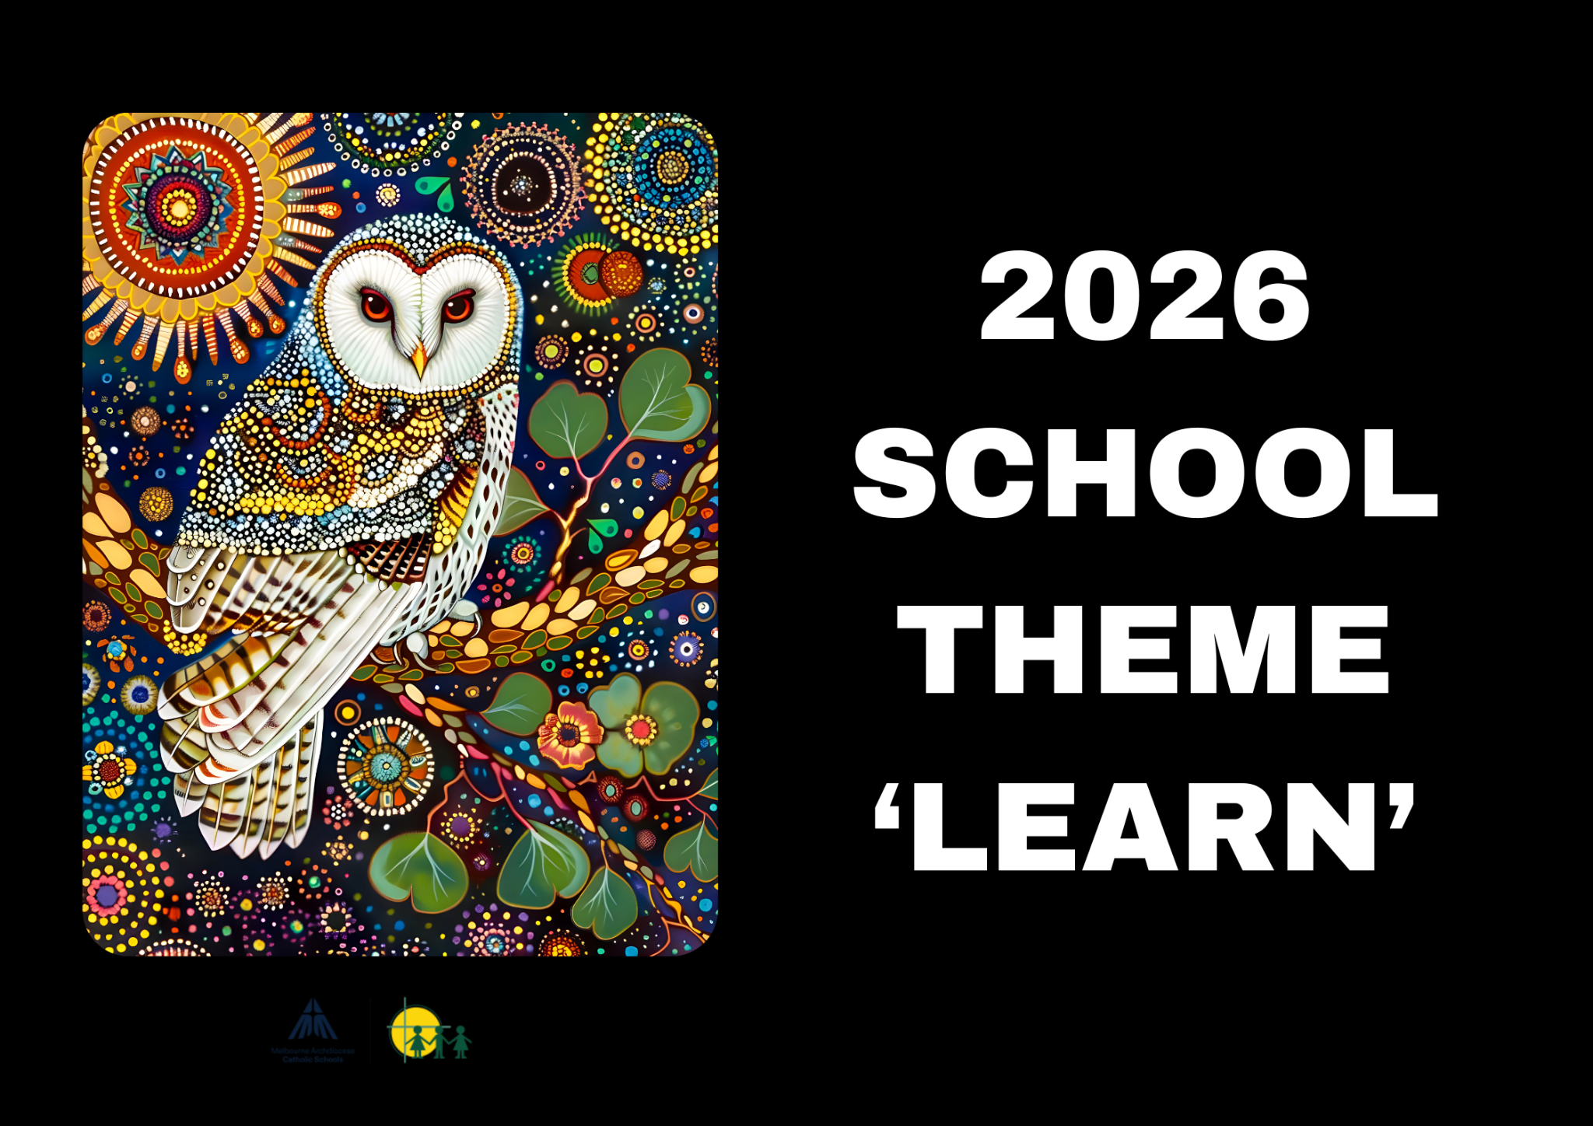 |  |   BIRTHDAYS  January  6th - Alyssa  19th - Alkhvir  26th - Marcelo  26th - Will  27th - Hannah  31st - Neo  February  27th - Joshua  March  18th - Trent  19th - Eden  28th - Harrison  April  12th - Claudia  16th - Ariana  29th - Chloe
Staff Contact |  | Please remember to only email staff between the hours of 8am & 4pm (Mon-Fri)  Cristina Vezzu - cvezzu@hfmw.catholic.edu.au
Specialist Classes | MONDAY
Specialist Classes | TUESDAY | STEM
Specialist Classes | WEDNESDAY | Art
Specialist Classes | THURSDAY | AUSLAN  Performing Arts  PE  3/4 Level Sport
Specialist Classes | FRIDAY
RELIGION   | TOPIC: Prayer, Forgiveness and Lent  This term in Religion, students will be learning about Jesus’ teachings and how they guide us to live in loving, respectful relationships with others. We will explore parables from within the Bible, and how we can learn from them. Through these stories, students will discover how Jesus used parables to teach about the Kingdom of God and what they reveal about God’s love and expectations for us.  A key focus will be Jesus’ commandment to “love one another” and how this shapes our choices and actions each day. Students will learn about the Catholic understanding of right relationships and why personal responsibility is important in maintaining them. They will be encouraged to think about their own choices in light of this teaching and consider how love, kindness, forgiveness, and respect help build strong relationships with God and others.  Throughout the term, prayer, forgiveness, and Lent will be our overarching themes. Students will deepen their understanding of prayer as a way of connecting with God, explore how to forgive and the importance of forgiveness, and learn about the meaning of Lent as a special time of reflection, preparation, and growing closer to God.
SPELLING    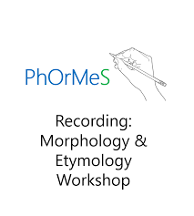 | PhOrMes is a comprehensive spelling program that focuses on phonemic awareness, word patterns, and spelling rules to help students become confident, independent spellers. The program integrates both phonics and morphology, teaching not only how words are spelled but also why they follow certain patterns. In the classroom, students will learn through a variety of activities, including direct instruction, word sorts, and hands-on practice, to reinforce their understanding of spelling concepts. This approach ensures that spelling instruction is engaging, systematic, and supports reading and writing development.  These are the spelling patterns and sounds we will be focussing on this term:  - Ti ci and si codes  - ie vs ei  - Silent letters  - words ending in the /x/ sound
LITERACY  (Reading/Writing)   | Finding Our Heart  This term in Literacy, students will be reading and exploring Finding Our Heart by Thomas Mayo. This powerful text introduces students to the Uluru Statement from the Heart in an honest and meaningful way, helping them develop an understanding of Australia’s history, First Nations voices, and the importance of listening, respect, and shared futures. Through engaging language and illustrations, students will learn how stories can inform, inspire, and invite readers to think deeply about important ideas.  Students will develop their reading, viewing, speaking, and writing skills by identifying the main ideas in a text and responding through discussion, questioning, and written work. They will explore how images and layout features add meaning, learn new vocabulary, and practise expanding and editing sentences for clarity and detail. A focus will also be placed on identifying the author’s perspective and purpose, and understanding whether a text is fiction or non-fiction.  As part of the unit, students will learn how to plan, write, edit, and publish a book report. This will include writing summary paragraphs, personal opinion paragraphs, thesis statements, and concluding statements. Students will also build confidence in oral language through reading aloud and delivering a short spoken presentation, using clear expression and appropriate structure.  Throughout the unit, students will engage with spoken, written, and visual texts, building their comprehension, communication, and critical thinking skills while developing a deeper appreciation of Aboriginal and Torres Strait Islander perspectives and storytelling traditions.
MATHEMATICS  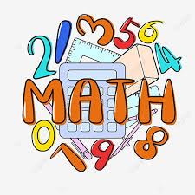 | The mathematical topics that the Year Three’s will be covering this term are:
  Topic | Unit Objective | Key Ideas
  Counting and Place Value | The base ten numeration system is a scheme for recording numbers using digits 0-9, groups of ten, and place value. | Quantity, abstraction principle, one-to-one principle, stable-order principle, cardinality principle, order-irrelevance principle, ordinal principle, conservation of number, subitising, base-10 system, place-value partitioning, comparison
  Addition and Subtraction | Quantities can be combined and separated to form new quantities. | Combining, partitioning, part-part-whole, properties of addition, separation, comparison, properties of subtraction
  Time | Time is used to quantify, measure, or compare the duration of events or the intervals between them. | Attribute, comparison, unit of measure, equivalence, conversion
  Multiplication and Division | Quantities can be shared and grouped into equal groups. | Equal groups, composite units, properties of multiplication, division with a remainder, properties of division
KNOWLEDGE BASED/  INQUIRY   | Unit One - Australia and its Neighbours  By the end of this unit, students will:  - Identify Australia’s geographical neighbours.  - Name some features of each climate type  - Describe natural features of Australia and its neighbours, including how these are impacted by climate (consider how they are similar and different)  - Recognise New Zealand as a close neighbouring country to Australia.  - Recognise that Australia has no southern or western neighbours due to Africa’s geographical distance from Australia.  - Provide examples of natural, managed and constructed features of Australia and New Zealand.  - Describe how natural, managed and constructed features of Australia and New Zealand may be similar or different.  Unit Two - Celebration of Different Cultures  By the end of the unit, students will:  - Understand what a ‘celebration’ is and explore different types of family, religious and cultural celebrations  - Explore and understand Aboriginal and Torres Strait Islander celebrations  - Discover the symbols and emblems of celebrations in Australia  - Identify the National celebration of Australia  - Understand how Anzac Day shaped our Australian culture
BEHAVIOUR CURRICULUM   | Routines  Lining up and sitting down after break times  Calm entrance/exit routine

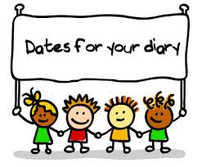 | Term One Important Dates (refer to our Google Calendar as well)  FEBRUARY  Wed 4 Prep Rest Day  Fri 6 Parent Welcome Event  Sun 8 Prep/New Family Welcome Mass (10am)  Mon 9 Children’s Mental Health Week (Wear an outfit that makes you feel confident and comfortable)  Tues 10 Safer Internet Day  P&F Meeting (6:30pm)  Meet the Teacher (Prep-Year 6)  Wed 11 Prep Rest Day  Meet the Teacher (Prep-Year 6)  Thur 12 District Swimming  Fri 13 Whole School Mass (9:15am)  FIRE Carrier Induction (10am)  Tues 17 Shrove Tuesday  Wed 18 Ash Wednesday (12pm Mass)  Prep Rest Day  Fri 20 Interschool Sport (1)  Mini Vinnies Soccer Event  Play Group commences (9:30am)  World Day of Social Justice  Wed 25 SAC Meeting (5:30pm)  Wed 25 Prep Rest Day  Fri 27 Interschool Sport (2)  MARCH  Wed 4 Prep Rest Day  Division Swimming  P&F Meeting (6:30pm)  Thur 5 Twilight Sports Day  Fri 6 School Closure Day (Vision for Engagement)  Sun 8 International Women’s Day (Give To Gain)  Mon 9 Labour Day Public Holiday (School Closed)  Wed 11 NAPLAN commences  Year 4 Reconciliation/Eucharist Info Night  Fri 13 Year 3-6 Athletic Trials  Sun 15 Catholic Education Week (Christ Beside Me-Walking in the Footsteps of St Patrick)  Tues 17 St Patrick’s Day  Wed 18 Open Day (all day) Everyone Welcome  Fri 20 Community Colour Run (Major Fundraiser)  Mass of St Patrick (St Patrick’s Cathedral)  Sat 21 Harmony Day  World Down Syndrome Day  Tues 24 Sacrament of Reconciliation (5pm)  Fri 27 Halogen Young Leaders Day  Summer Sport Gala Day (TBC)  Tues 31 EMR Swimming  APRIL  Thur 2 End of Term 1 (1pm finish)  Holy Thursday  Fri 3 Good Friday  Sun 5 Easter Sunday

