Fish Tacos
[Serves 4]

Ingredients
600g firm white fish fillets [snapper]
Juice and zest of 1 lime
1 tablespoon Cajun spice mix
1 large sprig of fresh coriander finely chopped
2 teaspoons minced garlic
3 tablespoons oil
4 Cups finely shredded dry coleslaw mic
2 spring onions finely sliced
1 sml tin drained sweet corn kernels
1 Sliced avocado
¾ cup sour cream
2-3 tablespoons sriracha sauce
12 small tortillas, warmed to serve
Extra coriander leaves and sliced jalapenos to serve [optional]

Method:
Combine juice and zest of lime, Cajun spice mix, chopped coriander, minced garlic and oil in a snap lock bag. Mix well and then add fish fillets allowing the fish to marinade for 20 minutes but no longer than an hour or the lime juice will begin to ‘cook’ the fish.

Mix the sour cream and sriracha together to make the pink sauce.

In a separate bowl place dry coleslaw mix, spring onions and drained sweet corn. Mix well and dress with half of the pink sauce, set aside.

Heat a non-stick frying pan to a medium heat. Cook fish for 3 minutes on each side until golden and cooked all the way through. Transfer to a plate and flake into large pieces.

To assemble tacos, top the warmed tortillas with coleslaw mix, then fish, sliced avocado and a drizzle of pink sauce. Garnish with fresh coriander and for those that want a little more spice sliced jalapenos.

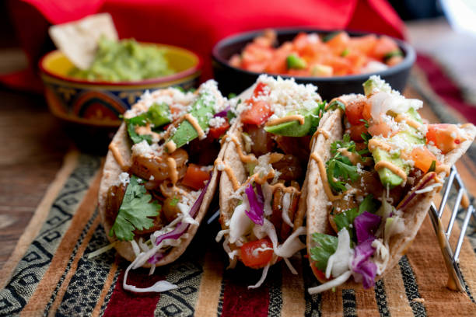
N.B. No time for marinading, a good quality crumbed fish fillet is just as satisfying for this recipe.

