**Boroondara Park Primary School**

**Parent Class Representatives Information Pack**

**Introduction**

We extend our sincerest gratitude for volunteering for the role of Parent Class Representative for your child's class at Boroondara Park Primary School. Your decision to volunteer for this position is instrumental in fostering a strong and close-knit community within our school.

While the class teacher is responsible for the students, as a Parent Class Representative, you hold a vital role within our school community by:

* Providing essential support to class teachers with communication and general support as requested
* Facilitating effective communication between the teachers, parents and the school
* Promoting the core values of the school and supporting the growing school community.

Each year level, ranging from Foundation to Year 6, will have two designated Parent Class Representatives, ensuring that every class benefits from this valuable support system. All Parent Class Representatives are supported by the Parent Class Representative Coordinators.

It is not intended to be an overwhelming task but rather an opportunity to contribute to the quality relationships within the school.

**Selection process**

* Towards the end of the school year communication alerting the school community about the upcoming Parent Class Representative roles will be sent via Compass and existing class WhatsApp groups. Parents will be asked to register their interest in becoming a Parent Class Representative for the following year via a Google Form
* A follow-up notification will be sent early in the school year for those classes who have not had any parents register interest or where another is required
* In the event more than two parents have registered for one class, preference will be given to those parents who are not already on the School Council or other sub-committees
* Where there are more than two Parent Class Representatives for a class, preference will be given to parents who haven’t held the role previously so more people get a chance to participate
* Selected Parent Class Representatives will be notified by the Parent Class Representative Coordinators by mid February and sent the information pack.
* A meeting will be arranged with the Principal and the Community Engagement team to discuss the role and for Parent Class Representatives to meet

**Responsibilities**

* Welcome new families to the class and arrange appropriate introductions with other parents
* Arrange a social activity for the whole class early in the school year, and further events/activities if desired with the class, and perhaps also with the other reps in the year level
* Encourage parents to be involved in their child’s school community e.g. attend school excursions, promote school fund-raising events, help at working bees
* Share information/reminders to your class regarding class and whole school activities
* Arrange end of year “Thank you” gifts to teachers for those parents willing to contribute
* Attend optional Parent Class Representative meetings with the Principal and Community Engagement team once per term
* Be a point of contact for parents to facilitate feedback/ideas/discussion to school sub-committees or Principal as appropriate

**Parent Class Representative Co-ordinators**

The Parent Class Representative Coordinators help recruit Parent Class Representatives each year for each class, collate and disseminate information that needs to be communicated to the school community, and provide ongoing support to the BPPS Parent Class Representatives throughout the year. The coordinators are a key contact for Parent Class Representatives, teachers and principal.

**What do I do first?**

Once you have been confirmed as a Parent Class Representative, there are a few suggestions on what you could do to get started:

* Inform your class teacher and any Parent Class Representative partner that you are in the role. It may be helpful to meet to discuss the specific role you will perform for your class
* When you have been given a copy of the class directory, create a WhatsApp group for your class. This is where all communication with parents will take place. The class directory will list the parents who have consented to be part of the WhatsApp group. Include both parents unless otherwise stated. The Parent Class Representatives should both be administrators of the group as should the Parent Class Representative coordinators.
* Send a message in the WhatsApp group introducing yourself and your Parent Class Representative partner and set some guidelines for the chat.
* Consider organising a class social activity (e.g. a play at the park after school) so that the students and parents get an opportunity to meet and socialise

**WhatsApp conduct**

WhatsApp is the application used for communication with your class. Below are instructions on how to set up a WhatsApp group for your class. Some basic guidance for the chat includes:

* Communication by all group members must be respectful and courteous; no profane, insulting, harassing, aggressive or otherwise offensive language will be tolerated
* The group must act in the best interests and welfare of students, families, staff members and the school
* The chat is not the place to discuss issues or to single out children/families
* Any inappropriate behaviour should be communicated to the Parent Class Representative coordinators or principal.

**Setting up a WhatsApp group**

Firstly, create a new contact for each parent on the class directory in your phone. You can then follow the steps below.

**How to create a WhatsApp group on**[**iPhone**](https://www.businessinsider.com/category/iphone)

1. Download and install WhatsApp on your iPhone.

2. Tap the "Chats Option" tab in the bottom menu bar.

3. Tap "New Group" in the top-right. Allow WhatsApp to access your contacts.

* If you allow WhatsApp to access your contacts you'll be able to see which of your contacts are already on WhatsApp and which ones you can invite to join.

4. Tap the empty circle next to the names of the people that you'd like to add to the group.

5. Once you've added everyone to the group, tap "Next."

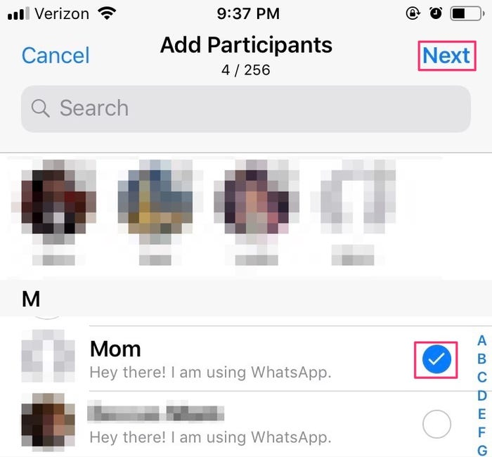

Select who you'd like to add to the group, then tap "Next."

6. Name your group following this format, ‘**Class name’ Class Parent group ‘Year’ (ie. 5CE Class Parent group 2023)** then tap "Create."

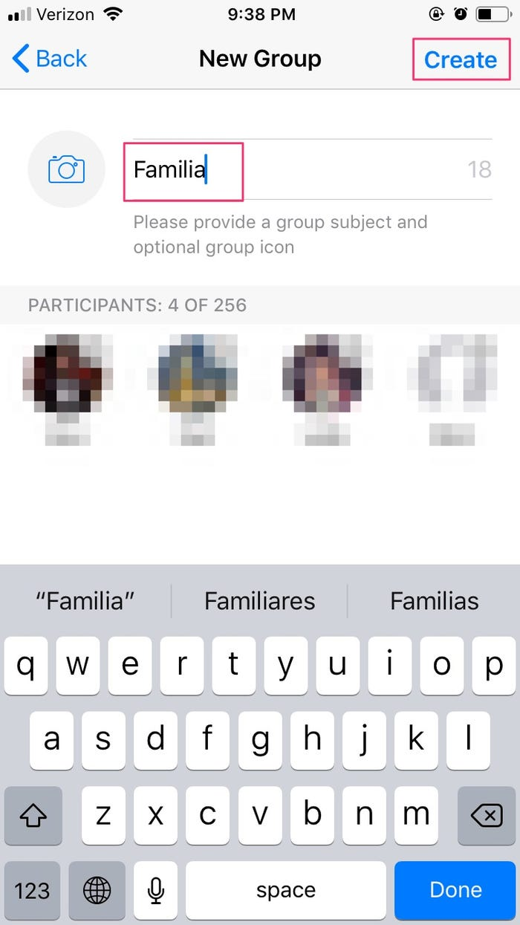

**How to create a WhatsApp group on Android**

1. Download WhatsApp on your Android device.

2. Open WhatsApp and tap "Chats" in the middle of the top menu bar.

3. Tap the three vertical dots in the top-right corner to open a dropdown menu.

4. Tap "New Group."

5. Allow WhatsApp to access your contacts. Go through your contacts and tap on the names that you want to add to your group.

If you allow WhatsApp to access your contacts you'll be able to see which of your contacts are already on WhatsApp and which ones you can invite to join.

6. Tap "OK" in the top-right corner to confirm your group list.

7. Type in a group name.

8. You can now add a picture and customize your group in other ways, if you wish to do so.

9. Tap the check mark to finish setting up your group.