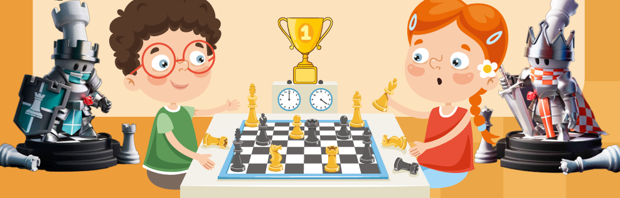

Why do children love this program?
- There is a chess tournament held each day. Trophies and prizes to be won
- It is a great way to make new friends and share passion for chess
- We play many other board games and outdoor games
- Chess lessons. Learn tricks and traps to beat your dad!
- Lightning Chess, Transfer Chess, Rifle Chess, Snowball Chess, chess Simuls

VENUE: | Elwood & St Kilda Neighbourhood Learning Centre
ADDRESS: | 87 Tennyson St, Elwood
DATE/S: | 7th, 8th, 14th, 15th July - (Mondays, Tuesdays)

COST: $80 for one day and $75 for any additional days
$65 for one half day and $60 for any additional half days

- Full day sessions run from 9am-5pm, Half Day sessions run from 9am-1pm and 1pm-5pm
- Please note that we do not open before 9am or after 5pm.
- Children who attend full day sessions must provide their own lunch and snacks. Drinks will be provided.

Enquiries and bookings: email felix@chessfanatics.com.au or call Felix on 0451965385

   

Please return to: Felix Chandler, Chess Fanatics

Name: ___________________Age: _______School: ____________________________________
Phone#(s): _____________________________Email: ____________________________________
My child will attend on: ___________________________________________________________
Payment By:  Cash / *Direct Debit ⁭ Total $____________________________

ACC. Name: Chess Fanatics
BSB: 063-162
Account No: 1086 7252

