LOCATION AND CONTACT

LEGAL ADVICE
Eastern Community Legal Centre Suite 3/27 Bank St Box Hill 3128 BH: 9285 4822
First Appointment Free

Victoria Legal Aid
Tel: 9259 5444 Ringwood Office Tel:9269 0120 Telephone info 9-5pm

EMERGENCY HOUSING
Community Housing Ltd
26-28 Prospect St Box Hill 3128
BH : 9856 0050
Crisis Accommodation after Hours: 1800 825955

BOX HILL CIS
1/27 Bank Street, Box Hill 3128 (Wheelchair Accessible)
Tel: (03) 92854801 (opening hours only) Email: help@boxhillcis.org.au www.boxhillcis.org.au

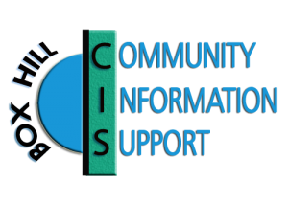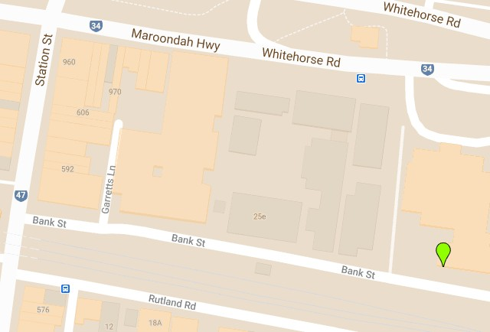FINANCIAL COUNSELLING / BUDGETTING
Free Debt Counselling – Tel: 1300 227 000 Anglicare Financial Counselling
7-11 Shipley St Box Hill 3128
BH : 9896 6322

OTHER EMERGENCY RELIEF AGENCIES
St Vincent De Paul: 1300 305 330
Salvation Army: 17 Nelson Rd Box Hill 3128 BH : 98902993
OPENING HOURS

Closed public holidays

Monday 11:00am - 3:00pm
Tuesday CLOSED
Wednesday 9:30am -12:30pm
Thursday CLOSED
Friday 11:00am - 3:00pm
Saturday CLOSED
Sunday CLOSED

1/27 Bank Street, Box Hill 3128 (03) 92854801
help@boxhillcis.org.au boxhillcis.org.au facebook.com/boxhillcis

BOX HILL CIS
COMMUNITY INFORMATION & SUPPORT

We provide services which aim to help individuals and families deal with a wide range of life situations. Our trained, multicultural group of volunteer Community Support Workers conduct one to one discussions, respecting the privacy of clients and the confidentiality of all client information.

We respect all cultural, religious, gender, ages, abilities and are welcoming to all.

Our services are:
- Free
- Independent
- Client focused
Box Hill Community Information & Support is a not for profit incorporated voluntary agency founded in 1967 to meet a need in the community for financial assistance and community support

We are funded by:
- Federal Government
- City of Whitehorse
- Local groups, private donations and trusts

We work in partnership with other relief agencies in Whitehorse to reduce duplication of assistance.

WE ASSIST CLIENTS LIVING IN THE CITY OF WHITEHORSE NORTH OF CANTERBURY ROAD
OUR SERVICES

EMERGENCY RELIEF
Available to residents of Whitehorse residing north of Canterbury Road on low incomes (typically those on Centrelink payments and asylum seekers), to relieve financial stress.
This may take the form of:
- Food Vouchers
- Assist with chemist, utility and phone accounts
- Phone cards & Telstra Assistance Certificates
- Transport assistance (petrol & Myki credits)

Clients may also access our supplies of packaged, frozen and refrigerated foods, bread, fresh fruit and vegetables when available.

ADVOCACY AND NEGOTIATION
We can provide advocacy assistance in dealing with utility and phone companies to avoid disconnections and to negotiate affordable payment plans

INFORMATION AND REFERRAL
We provide information and referrals to a wide range of free local community services available to Whitehorse residents with the expertise to best assist individual
needs including: legal advice, financial counselling, emergency housing, health, tenancy rights, no interest loans and counselling.

Located Nearby

The Salvation Army Doorways Program provides Emergency Relief on Tuesdays and Thursdays 9:30- 2:30. Assistance is provided to people living in the City of Whitehorse, appointments are necessary.
1010 Whitehorse Rd Box Hill 9897 9000

INTERPRETERS AVAILABLE
EMERGENCY NUMBERS
Police /Fire/Ambulance: 000
Box Hill Police: 8892 3200
Box Hill Hospital: 1300 342 255
Lifeline : 13 11 14
Mensline: 1300 789 978
Child Protection DHS after Hours: 131278 Safe Steps Family Violence Response (24 hours):
1800 015 188
Alcohol and drug crisis line: 1800 033 108
Poisons Information : 131 126
COVID19 Helpline: 1800 020 080
Gamblers Help: 1800 858 858

HELPFUL CONTACTS

Carrington Health
Level 2, 43 Carrington Rd Box Hill 3128
BH: 9890 2220

Koonung Community Mental Health Clinic 1st Floor, 43 Carrington Rd Box Hill 3128 Tel: 9843 5800 BH ( 9am-5pm)
Tel: 1300 721 927 Triage (new referrals) AH

