**Welcome, Christ Our Light Parish!**

As St Agnes Parish, Highett and Our Lady of the Assumption Parish, Cheltenham prepare to welcome our new Parish, the Care for our Common Home Group says, “Welcome, Jesus, Christ Our Light, you are the Light of the World!” (John 1:9).

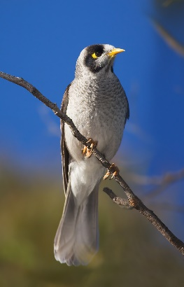**Jesus and our Common Home**

We care for the Earth because it is our common home, our precious “blue planet”. But there is another reason. The Earth and all there is, was made through Jesus, the Word of God. Not only that, but He “became flesh and lived amongst us” (John 1:1-3,14). Consider what an astounding statement that is!

Noisy miner, eastern and SE Australia

Jesus told us how much God the Father knows and cares for all creation: “Can you not buy five sparrows for two pennies? And yet not one is forgotten in God's sight” (Luke 12:6)

Let us thank Jesus and the Father for this glorious Creation, and may we treat every living and non-living thing with the greatest thanksgiving and respect.

**Season of Creation 2024 “To Hope and Act with Creation”**

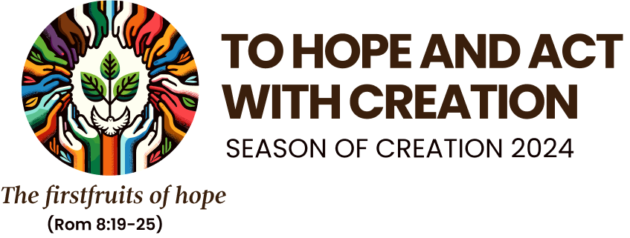From 1 September to 4 October (Feast of St Francis of Assisi) we will celebrate the Season of Creation once again. This year’s theme will be “To Hope and Act with Creation”, taken from the St Paul’s epistle to the Romans (8:19-25). We are looking forward to working with our new Christ Our Light Parish and teachers and staff of St Agnes and Our Lady of the Assumption Parish Primary Schools to celebrate the Season, as the days lengthen and grow warmer.

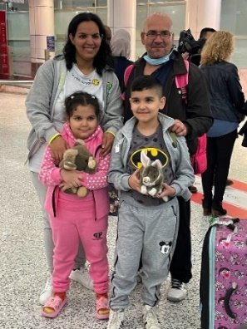**CRISP – sponsoring a refugee family**

Several Care for our Common Home Group members have joined with parishioners from St Mary of the Cross Parish, Mordialloc and Aspendale to sponsor a refugee family from overseas later this year, under a new Commonwealth government program, CRISP. In coming weeks we will be seeking tax deductible donations to help settle the family in our area. We hope you will be able to help us. We will be in touch.

**AI and cryptocurrency**

A family settled under the CRISP program (stock photo)

Artificial intelligence (AI) offers great benefits through increases in knowledge and efficiency, accelerating research and automating tasks that humans can’t or don’t want to do.

In his address to the G7 Summit in June, Pope Francis noted the benefits of AI, but he also noted the dangers, particularly when AI is enabled to make autonomous decisions, for example in the use of medical equipment, military weapons, etc.

AI, cryptocurrency and other energy-intensive information technologies need huge volumes of fresh water to cool their data centres. Their demand for energy and water is expected to increase rapidly at the same time as the world strives to achieve net zero carbon emissions by 2050, and as fresh water becomes scarcer in parts of the world due to climate change.

As Christians responsible for caring for our Earth and its people, we must be ready to support positive uses of AI and other information technologies, and ready to oppose wasteful and potentially harmful uses. (*Earthbeat* and *Vatican News* newsletters).

**Prayer**

*Lord Jesus, shine on us today.*

*May we reflect You in our words and actions,*

*And may the world come to know*

*That You are Christ Our Light, Light of the world.*