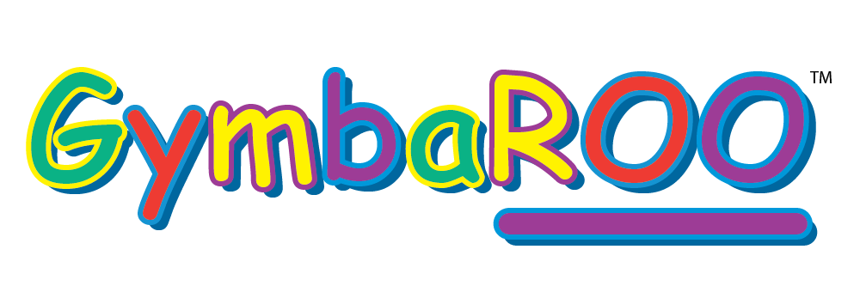
Ongoing Employment Opportunity – Immediately start （required during school terms）

We currently have 2 positions available as ‘equipment setters’ - setting up and pulling down children play activity equipment at Gymbaroo Glen Waverley.
Monday afternoon (3.30pm start) – duration approx. 1¼
Thursday / Friday afternoon (class finishes at 2.45pm so access any time after that.) – duration approx. 1 - 1¼ - but must be finished by 4.30pm
Gymbaroo runs during the school terms only, so there is no work during the school holidays.
The successful applicants will work as a team and must be available Monday and Thursday/Friday every week. On the job training will be provided. They must be reliable and committed to doing the job with attention to detail as we cannot be left on a Tuesday morning when classes commence with no equipment set up.
Due to the amount of lifting and the height of some of the equipment, we prefer someone who is average to tall in stature.
Looking forward to hearing from you via email/text if you are interested in applying.
If you need any additional info, please don’t hesitate to contact me
thank you!
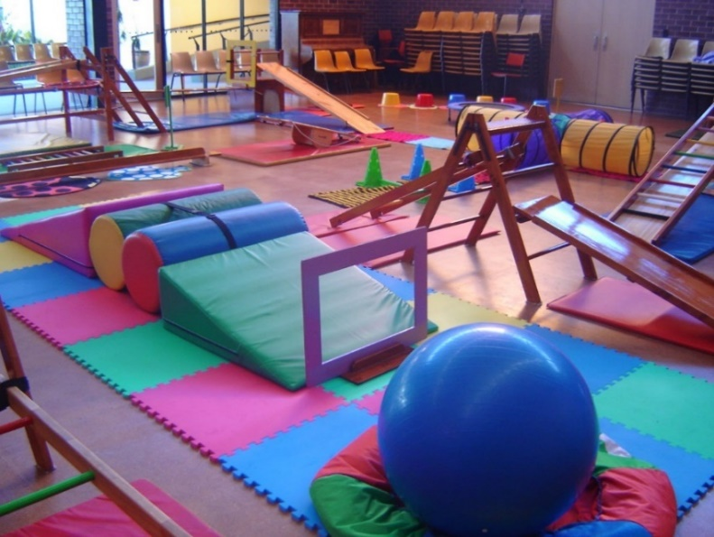
Carrie 0411 088 533
glenwaverley@gymbaroo.com.au
800 Waverley Road, Glen Waverley

