Get Caught Reading @ ASC!
Reading also improves our minds!

Did you
know?
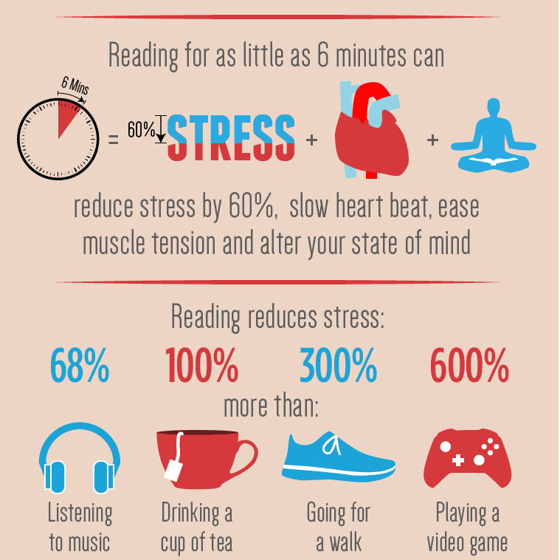

About Get Caught Reading @ ASC!
- All of Year 7 (Year 8 will start this term) read for twenty minutes every day
- Year 7 have been given a Book Level by their English teacher so that books they select are at the right level for them
- They will complete quizzes using a program called Accelerated Reader
- Each student will be given an individual points target for the term
- They will be invited to celebrate meeting or exceeding their points targets towards the end of this term

What can we do?
- Encourage your student to read – not just your year 7 student!
- Guide your student to the following places for books: http://armidale.eplatform.co/ (ASC Library, which has a wide variety of ebooks available). Students can also access this through Oliver, on their student portal
https://www.armidaleregional.nsw.gov.au/community/arts-and- culture/libraries (Armidale town library - free membership)

Enjoy Getting Caught Reading!

