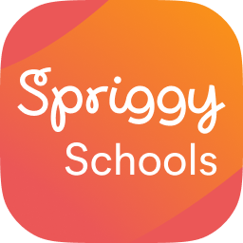
Place your lunch orders online with
Spriggy Schools

Lakeside College PTFA are excited to announce the introduction of a new online lunch ordering system called Spriggy Schools.

Spriggy Schools will make lunch orders more convenient for both families and the PTFA volunteers.

Steps to get started:

- Go to www.spriggyschools.com.au to register and download the app.

- Add a profile for each of your children, making sure you select SCHOOLNAME and your child’s class.

- Start placing lunch orders! You can place orders up to 2 weeks in advance.

If you have any questions, please contact Spriggy Schools via their chat function on their website at https://app.spriggyschools.com.au/login

Spriggy Schools is backed by Spriggy.com.au, a digital pocket money app designed to help parents improve the financial literacy skills of their children.

