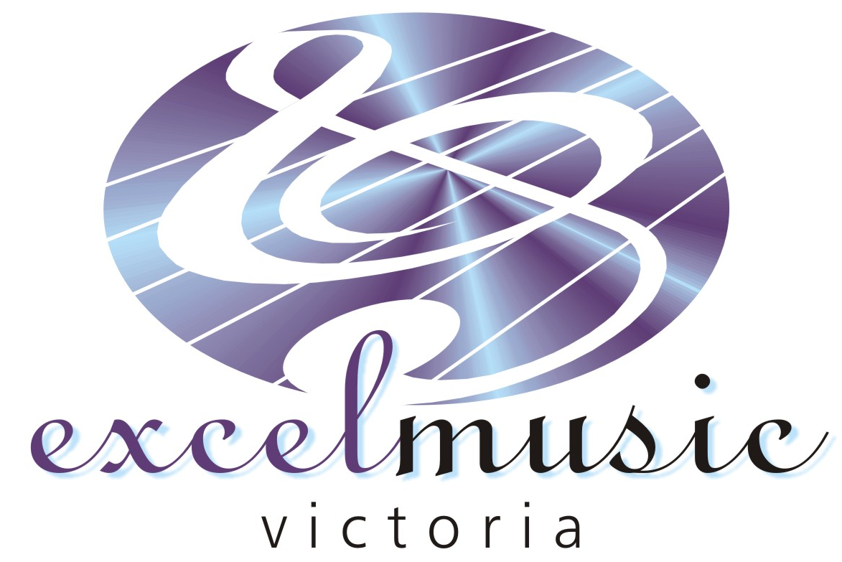

PO Box 5319
Studfield Victoria, 3152
Ph: (03) 9801 8991
Fax: (03) 9801 8992
www.excelmusic.com.au
email: music@excelmusic.com.au
ABN – 31 021 359 264

EXPRESSION OF INTEREST FOR
KEYBOARD, GUITAR AND DRUM LESSONS

Dear Parents/Guardians,

We are very excited to announce that we will be offering group and individual keyboard, guitar and drum lessons at Holy Saviour Primary School this term.

Music is a wonderful activity which can benefit other core areas of learning. Our specialized teachers provide students with a supportive and fun learning environment.

In order to anticipate enrollment numbers, we ask that you complete the below form and return it to the school office as soon as possible.

The music lessons will be facilitated by Excel Music and will be held for 30 minutes every week during school time. Maximum class size is 4 students per lesson. Lessons are charged at $14.00 (incl. GST) per group lesson. Alternatively, we also offer private lessons at a cost of $25.00.

If you require more information regarding our music lessons, please do not hesitate to contact Excel Music on 9801 8991.

Yours Faithfully,

Kim Wong and Amanda Iliov
Excel Music Directors

EXPRESSION OF INTEREST FORM

Please complete this form and return it to the school office as soon as possible. Please also indicate if you would prefer your child to participate in group or individual lessons.

I would like to enroll my child in group / individual guitar lessons

I would like to enroll my child in group / individual keyboard lessons

I would like to enroll my child in group / individual drum lessons

Child’s Name/s: ……………….………………………………...……………………………..

Child’s Grade: ………………………………. Instrument: ……………………………………

Guardian’s Name: ………………………….………………………………………………………

Home Phone Number: …………..……...…… Mobile Phone Number: …………………………

