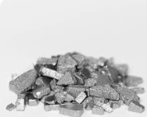
Iron
Iron is a mineral that the body need for growth. Your body uses iron hemoglobin for protection in red blood cells that carry oxygen. It is mainly heme which bines oxygen. In the lung’s oxygen is exchanged for carbon dioxide.
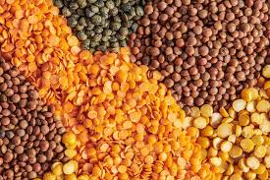
A lack of iron is called iron – deficiency anemia which affects 20 million people yearly.
The foods that are highest in iron are:
. Tofu
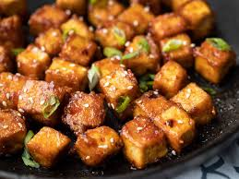
. Beans
. tomato products
. Dried beans
. Dried peas
. Lentils

In conclusion Iron is very important for your body’s growth and it helps with producing oxygen in your body.

