

**13/12/2024**

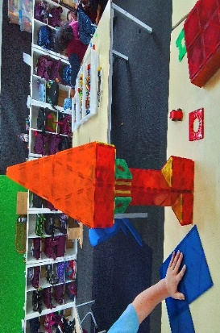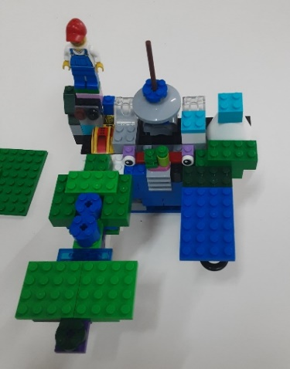[](https://pp.campaustralia.com.au/)

We would like to wish a very Merry Christmas and Happy New Year to all our children and families. All the best for the future to our 12 grade 6 students that graduate to Secondary School in 2025.

We will be starting at 1.30pm on Thursday 19th December to cater for early school finish.

Our Rocketeers program will start on Monday 6th January 2025 and finish on the 28th January.

We will be running Student Free Day programs on Friday the 20th December and Wednesday 29th January. These days need to be booked via the parent portal.

Our normal term 1 sessions will begin on Thursday 30th January with before school care. Thank you

* Big Art
* Cooking Experience
* Sand Art

**Activities coming up**

Join in the fun of Outside School Hours Care activities and experiences with your OSHC and Rocketeers.

**Make a booking**

Book now

**Oatlands Primary School OSHC**