[](https://pp.campaustralia.com.au/)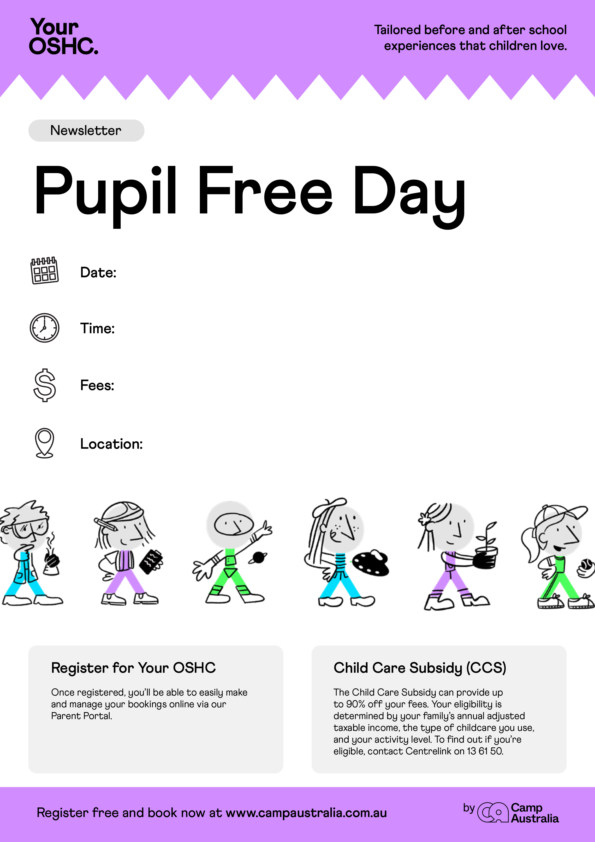

Registar on line at :www.campaustralia.com.au

6-30 am to 630pm

Monday 06/11/2023

Out of School Hours Room