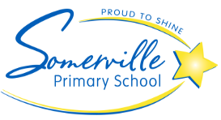
BYOD iPad Program 2022
11/10/21

Dear Year 4 & 5 Parents and Carers,

After overwhelming success from 2019-2021 we wish to inform you that Somerville Primary School will be continuing the 1:1 iPad program, therefore your child will be required to bring an iPad to school in 2022.

As such we will be sending home a number of supporting documents to ensure that you have all of the appropriate information about the BYOD program at Somerville Primary School.

We will be sharing information about why we are running a BYOD program, what iPads can be used, how the iPads are to be used and stored in the classroom, consequences of misuse, student and parent responsibilities and much much more.

Could you please complete the slip below and return it to the office prior to the end of the year.

I look forward to hearing back from you all.

Kind Regards

Shane Gagiero
Digital Technologies Leader
----------------------------------------------------------------------------------------------------------------

Parent Name_____________________ Student Name______________________

I will be purchasing an iPad for my child in 2022 ⃣ YES ⃣ NO

