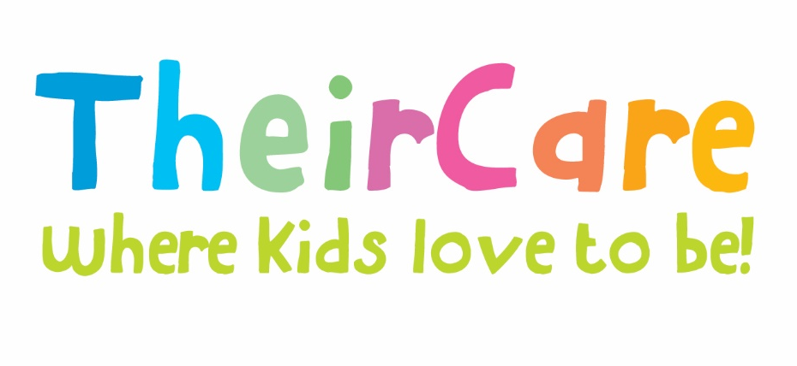

Newsletter Term 2 Week 9 2022

St Marys Primary School St Kilda

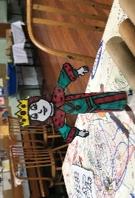
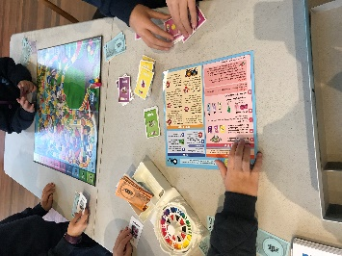
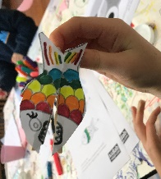
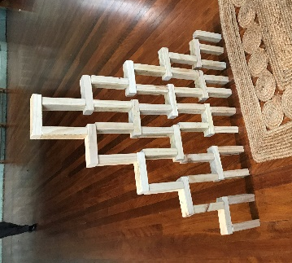
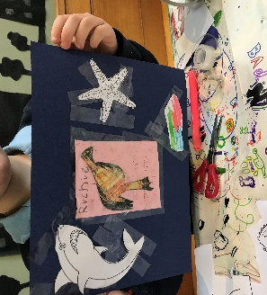
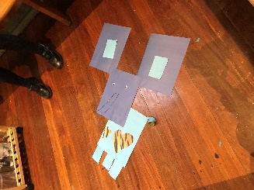
Dive into the Ocean – Week 7
We ‘Dive into the Ocean’ during this week to celebrate the World Ocean Day with craft activities related to sea life, group games and sport activities to keep us warm during winter. We received some toy donations from families and our children got engaged with the new games brought such as Rummy-O and Harry Potter Cards. Also, we learned how to do several designs of paper planes using a book donated focused on it and did competition about the best design depend on how far the paper plane fly. So, origami, board games such as Rummy-O; construction with Lego, blocks, and train tracks game; making animals with paper such as the elephant; collage with sea animal, fish clothe pegs creations, kites making, were part of the activities developed during service time.
Kings & Queens – Week 8
’Kings & Queens’ was the topic of week 8 making feel our children as part of the Royal Family, teaching them how to make crowns and tiaras; princes, kings and queens puppets with paper roll, pop sticks and paper; and castles with Lego.
Regarding sport, soccer continued to be the most popular game due to the Soccer season and some kids have expressed that they are in soccer teams, and they utilised OSCH time to practice. As other physical activities, we played tag, running races, Lava monsters, ‘Stealing the ball’, ‘poison ball’ and playing with balls showing our skills.

Once Upon a Time…!
Winter Holiday Program

We would like to invite our children to join us in the Winter Holiday Program with amazing activities, special visitors, and excursions.
Bookings are now open and can be made online using the parent booking portal, or parents can call 1300 072 410 for support.

Photo Gallery

Contact Service | Contact Head Office | Times
Phone: 0475 577 404 | Phone: 1300 072 410 | Before School: 7:00am – 8:45am
Email: stmarysstkilda@theircare.com.au | Email: info@theircare.com.au | After School: 3:30pm – 6:00pm

