

Silverbeet and Mushroom Pasta
Sauce
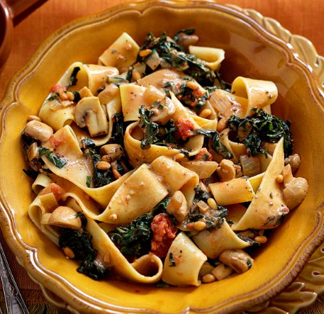
Source – womensweeklyfood.com.au
Harvest – onion, mushroom, silverbeet, garlic, tomato, basil
Vocab Words – passata, softened, wilts, garnish
Skills – chop, slice, fry
Equipment:  - Metric measuring millilitres and spoons  - Measuring scales  - Chopping boards and grips  - Blue scraps bowls  - Knives  - Frying pan and wooden spoon  - Serving Items – bowls and spoons | Ingredients:  - 1 tablespoon olive oil  - 1 onion, chopped  - 400 gram mushrooms, sliced  - 1 bunch silverbeet, stems removed, leaves finely sliced  - 4 cloves garlic, finely chopped  - 800 gm can diced tomatoes or jar of passata  - 1 cup basil  - 300ml cream  - 100gm Parmesan cheese, finely  - Handful of flat-leaved parsley, finely chopped, to garnish
What to do:
- Wash all garden ingredients and prepare all ingredients based on instructions in the ‘Ingredients’ list.
- Heat oil in a large frying pan on medium. Cook onion for 5 minutes, until softened.
- Add mushroom and cook for 3-4 minutes, until just softened.
- Add silverbeet and garlic and cook for 2-3 minutes, until silverbeet wilts. Add tomato and basil and season well. Cover and cook for 5 minutes, until silverbeet is tender.
- Stir in cream. Add pasta or gnocchi and toss to combine.
- Sprinkle with parmesan and garnish with parsley and serve.
Notes:

