Working from home safely and productively

1. Purpose
The purpose of this guide is to provide some practical advice and tips to staff when working at home to support their physical and mental wellbeing.

2. Guidelines
Working at home is more than just having a good ergonomic workstation set-up, it is also the work practices which can influence and impact our health, safety and wellbeing.
Here are some tips for consideration to support our health, safety and wellbeing when working from home.

2.1 Keep a regular schedule
Maintaining a familiar routine or schedule, as much as possible, is important and helps not just your work schedule but also your sleeping routine.  Getting good rest is important, ensure you eat well and find ways and time to exercise and keep active at home.  The current circumstances mean you may need to adjust your regular routine and schedule.  Don't forget to include frequent breaks for recharging in your schedule. |   

2.2 Schedule in regular social connections
Ensure each day you're catching up and connecting with others about non-work topics, just as you would at work.  This may not be able to be in person but you can share a cup of tea with a colleague or a friend or groups of people via a video call (Zoom, Skype, Facetime, Microsoft teams), or just pick up the phone and have a chat.  Don't just rely upon only typing emails and texting.  While it is very important that we all strictly follow the physical distancing requirements, it is important to maintain social connections through the many other ways available to us all. | 

2.3 Set up a dedicated work area
Make sure you have a dedicated area where you do work.  Treat this as your office for now and take regular breaks.  This is important for helping you draw a line between work and home and allowing you to "switch off" at the end of the workday.  If it is not feasible for you to have a designated workspace for your circumstances, consciously set up and pack up your workspace to mark the start and finish of your workday.  Set up your work area and workspace in a way that is comfortable for you, this may include opening windows, an area away from other members of your family/household, putting on background music, setting temperature controls to your preferred room temperature. | 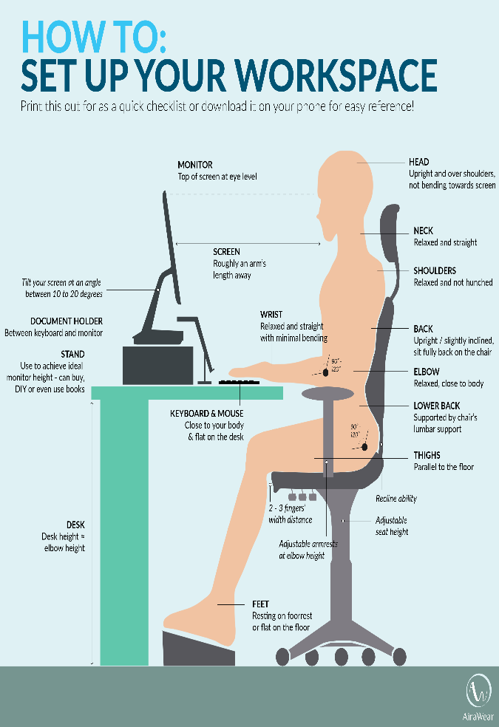

2.4 Write a To Do List
Create a to do list.  Identify the most important tasks for each day and lock these into your calendar for when you are likely to be at your best.  Communicate with and discuss/agree these with your Principal during regular check-ins to ensure that no priorities for your work area have changed.  You only want to use your best brain for your best work. For example, if you are a morning person, undertake your hardest, most important tasks in the morning and leave your administrative and process driven work for the afternoon. | 

2.5 Take breaks, exercise and stay active
To maintain your physical and mental wellbeing at work, a small "posture break" every 20 - 30 minutes is recommended.  Periodically, get up and move around your home.  Take a few steps around the house or have a quick stretch regularly to keep your body healthy and your brain active.  Walking, stretching, or whatever works best and is suitable for you to reduce or alleviate stress and increase endorphins.  This is not only good for your physical health, but also your mental health. |     

2.6 Learn the facts, seek information from reliable sources to avoid misinformation
Constant media coverage can keep you in a heightened state of anxiety - try to limit related media exposure and focus on factual information from reliable, trustworthy sources of information. | 

2.7 Practice self-care
Everybody practices self-care differently, but no matter what this looks like for you, it is important to look after yourself.  Engage in activities that benefit your well-being, bring you joy and distract you from existing challenges.  This could include making time for activities and hobbies, communicating and keeping contact with family, friends and colleagues and keeping up a healthy lifestyle including being active, eating well and getting quality sleep. |     

