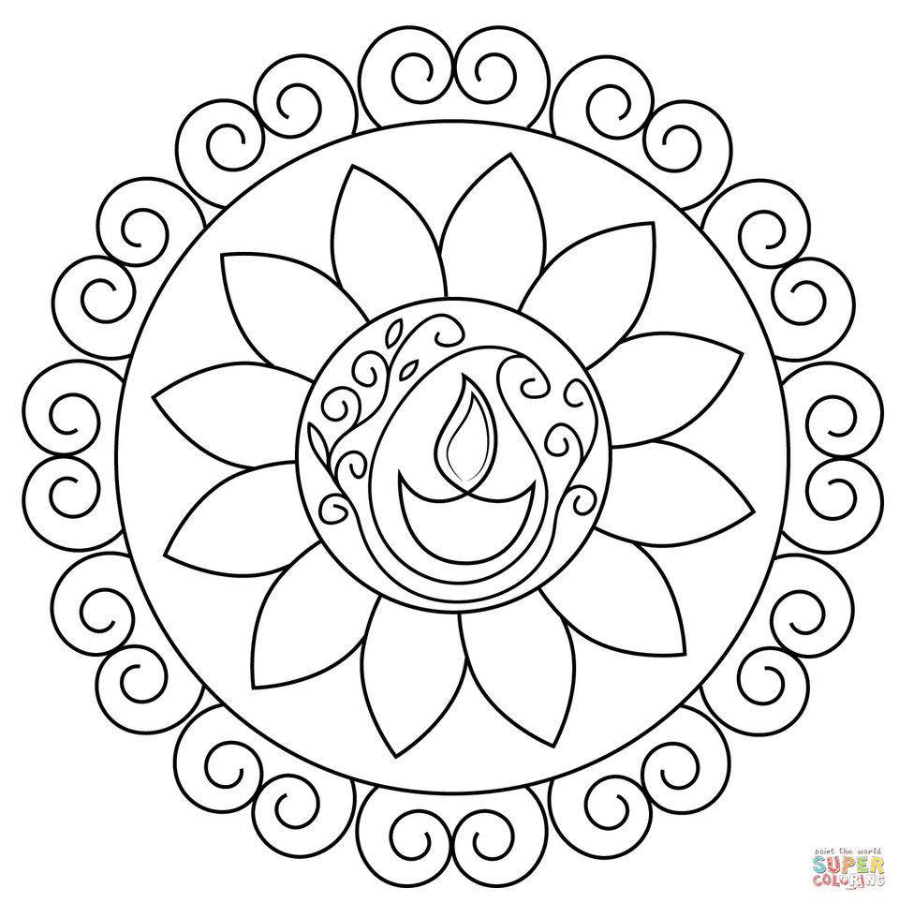

Name_________________________________________
Year ______________ Class _____________________

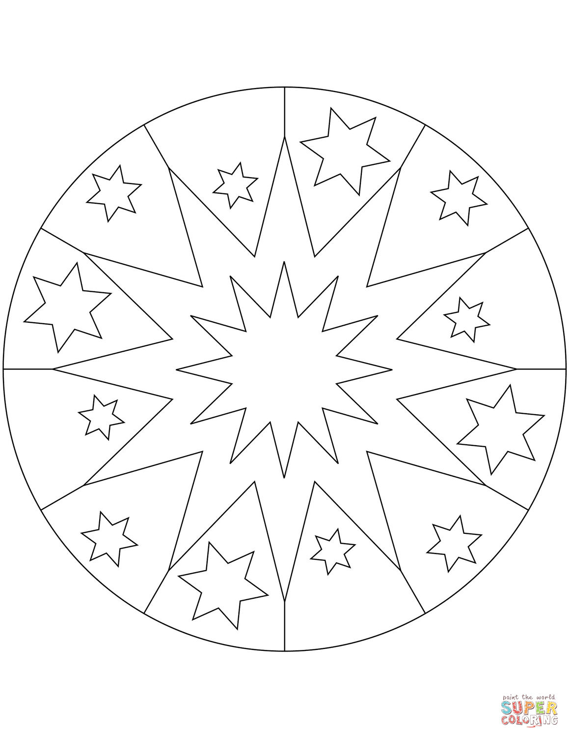

Name_________________________________________
Year ______________ Class _____________________

