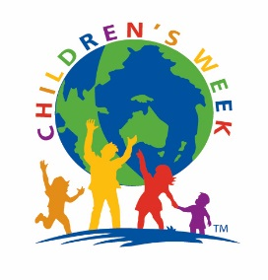
Celebrate Children’s Week 2023
Theme: Children the right to relax, play and take part in activities they enjoy. Article 31 UNCRC

Friday 20th October to Sunday 29th October

What is Children’s Week?
Children’s Week is an opportunity for the community to engage in a variety of activities that facilitate, support and encourage children and their families to play, learn and grow together.
Get Involved in 2023
Organise an event/activity during Children’s Week to ‘celebrate children’ – use the theme. Visit website for suggestions. You can advertise in the Children’s Week Program by registering your event. Forms available from the website www.childrensweek.org.au or email: mberlemon@hotmail.com
Website
Visit www.sachildrensweek.org.au to find more about what is in store for Children’s Week in 2023. Details will include the central program of events.
Apply for a grant
Small activity grants are offered to assist you to organise your activity for Children’s Week.
Applications due 12th August
Application form can be downloaded from the website or email: mberlemon@hotmail.com
Awards
Recognising children, young people and members of the community who make a difference for children. We are especially interested in discovering the quiet achievers and those who have not been previously recognised.
Children’s Week Awards recognise outstanding contributions to the needs, interests and welfare of children in the following categories:
Children’s Week Awards
- Youth Award
- Adult Award
Special Children’s Week Award
Play Award
Nominations due Friday 19th August 2023
Minister for Education Awards
To recognise outstanding achievement for children in any endeavour either as an individual or a class
Nominations due Friday 22nd September
For forms and guidelines visit www.sachildrensweek.org.au or email mberlemon@hotmail.com
Children’s Week SA is proudly sponsored by

