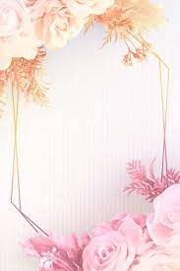


I am Mila
I am strong, brave and calm,
I wonder why people fight,
I hear change and worry,
I see society evolving and growing,
I want a class of friends.
I am strong, brave and calm.

I pretend to have no feelings when I really do,
I feel empathy for orphans,
I hold my emotions close and share them with no one,
I worry about my family,
I cry when I’m stressed or tired.
I am strong, brave and calm.

I understand most of my emotions,
I say I’m ok when I’m not,
I dream my worry’s,
I try my best,
I hope to live in a world of peace,
I am strong brave, calm and right where I’m meant to be

