

3 February 2021

Dear Parent or Friend,

The next meeting of the Nossal Parents and Friends Association (PFA) is Wednesday March 3 at 7.00 pm in the Jean Russell Centre.

The first part of the meeting will be the AGM chaired by the Principal where all positions will be declared vacant and new office bearers elected. Only registered members of the PFA are entitled to nominate or vote – but anyone who is present and fills in a registration form on the night is eligible so please encourage others to attend and participate.

As people are often reluctant to put themselves forward on the night – or to nominate others – I encourage you to nominate yourself or another PFA member by **completing the attached form and emailing it back to me by noon on Wednesday March 3.** We will also call for nominations on the night.

We will confirm the nominee willingness to accept at the meeting and if required will vote via secret ballot on the night. If you are unable to attend and wish to nominate – you can do so in writing (via attached form) and will be included in the ballot, but you must be present to vote (no proxy votes)

**I call for nominations for the following positions......**

* **President – Chairs and runs the meetings**
* **Secretary – takes minutes and manages correspondence and the attendance register**
* **Treasurer – liaises with Business Manager to present and oversee PFA budget and expenditure**

These are the minimum required roles under the Constitution and other positions will be declared at the AGM following the election for these three positions. (we generally have others backing up these positions and the school provides administrative support)

**Please consider nominating yourself or another person and encourage as many people as possible to attend the AGM so we can ensure that our PFA remains so vibrant, supportive and effective.**

Please feel free to forward this to non-members and invite them to attend and/or nominate.

Contact me directly if you have any questions about this.

Regards,

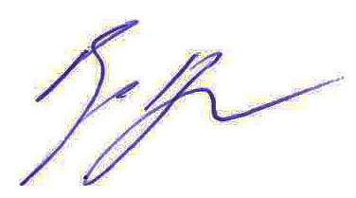

Roger Page

Principal

***Principal***

**Nossal High School**

Sir Gustav Nossal Boulevard

Federation University

100 Clyde Road

Berwick  Vic  3806

Phone: 03 8762 4600

Mobile: 0408121847

[www.nossalhs.vic.edu.au](http://www.nossalhs.vic.edu.au/)

Roger Page

Principal