**About George Ivanoff**

[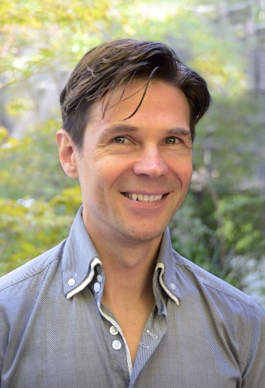](http://georgeivanoff.com.au/wp-content/uploads/2011/04/ivanoff_promo_02_sm.jpg)

Writing about oneself is a rather difficult thing to do. I always find myself wondering what to say. Hmm… well… my favourite film is *E.T.: The Extra-Terrestrial*; I think that *Doctor Who* is, without doubt, the greatest television series ever made; and Pet Shop Boys are the most talented pop duo ever to walk the face of this earth.

Perhaps it would be better to have an official bio? Oh, wait — I do. Here it is…

George Ivanoff — Short Bio

George Ivanoff is a Melbourne author who’s written more than 100 books for kids and teens, including the *Gamers*trilogy, the interactive *You Choose*series, the *RFDS Adventures*, and his latest series, *OTHER WORLDS*; as well as a ton of school readers and educational books. George’s books and stories have been shortlisted for numerous awards and he’s even won a few of them. George drinks too much coffee, eats too much chocolate and watches too much *Doctor Who*. He has one wife, two children and an uncontrollable imagination.

George Ivanoff — Full Bio

George Ivanoff is an author. He lives in the suburbs of Melbourne, Australia.

He has written over 100 books for children and teenagers, including fiction and non-fiction. He has written school readers, library reference books, chapter books, novelettes, novels and even a short story collection. He has books on both the Victorian Premier’s and the NSW Premier’s Reading Challenge booklists.

George’s latest series of books is *OTHER WORDS*. With this series George has ventured into the realms of science fiction and fantasy, two of his favourite genres, in order to tell stories about ordinary kids facing extraordinary circumstances. There are 4 books so far.

George’s has written 13 books in his interactive *You Choose* series. *You Choose: The Treasure of Dead Man’s Cove* won the 2015 YABBA in the “Fiction for Younger Readers” category; and *You Choose: Alien Invasion From Beyond the Stars*got an Honour Award in the KOALAs in 2016 and 2017.

His teen science fiction novel, *Gamers’ Quest*(2009), won a Chronos Award for speculative fiction. The sequel, *Gamers’ Challenge*(2011), was shortlisted for the same award. And the final book in the Gamers trilogy, *Gamers’ Rebellion*(2013), also won a Chronos Award.

George has also written a series of adventure books for kids — *RFDS Adventures*. The four books in this series were published in 2016.

George also writes short stories and articles for adults as well as kids. Of all these, he is most proud to have had the opportunity to write a *Doctor Who* story for the *Short Trips: Defining Patterns* anthology (Big Finish, UK, 2008).

Occasionally, George has been known to moonlight as an actor. He has had small roles in numerous productions including the television series *Neighbours* and the feature films [*Frozen Butterflies*](http://www.imdb.com/title/tt1340656/)and [William Kelly’s War](http://www.imdb.com/title/tt4149656/?ref_=nm_flmg_act_1). He recently guest starred in an episode of the audio series [*Night Terrace*](https://nightterrace.com/).

George eats too much chocolate, drinks too much coffee and watches too much *Doctor Who*. He will sometimes indulge in a nice bottle of wine or a single malt Scotch.

He has one wife, two children, two cats and several chickens. And he is very content!