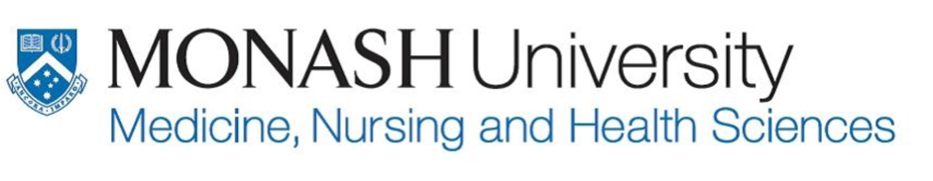

21st October 2020
Eczema School
______________

Know your skin
Prevent hospital admission from eczema
______________

Learn about new treatments in eczema
______________

ECZEMA SCHOOL ONLINE WEBINAR
Online webinar from 6 pm to 7:15 pm
21st October 2020
Come and learn more about eczema!
Two of our leading experts will share their knowledge on:
Update in eczema. What are the new treatments available?
Topical steroid safety
This is also a great opportunity for you to share your own experiences and ask our experts questions.

CONTACT: EASTERNHEALTHECZEMASCHOOL@GMAIL.COM
REGISTER VIA: https://monash.zoom.us/webinar/register/WN_SEZ_spvqRYSGqZ3dUwuC0w/webinar/register/WN_SEZ_spvqRYSGqZ3dUwuC0w

Speakers:
A/Prof John Su
General and Paediatric Dermatologist
Head of Dermatology Department, Eastern Health

Dr Louis Chan
Eastern Health Dermatology Research Fellow

