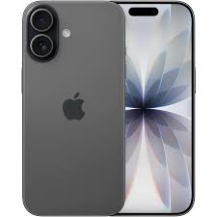
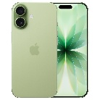
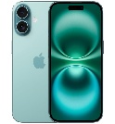

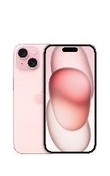
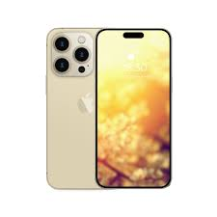
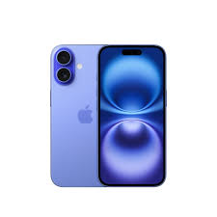
All kids should have mobile phones
Today I am going to tell you why all kids should have mobile phones. Keep in mind I am a 10 year old so I DEFINITLEY agree with this argument.
First of all I think phones are a good way for home education because of sites like 99math, Blooket, nitro type and coolmathgames just kidding coolmathgames is just a games website, but anyways back to the topic. Another app/site is Youtube kids as it has many channels that are educational such as National geographic, numberblocks and alpha blocks.
Another reason that I think phones are good for children is because of social and online games such as Roblox and Minecraft and more. And don’t get me started on 80 year olds on Roblox because they have made age restrictions for the roblox chat meaning that older people cannot chat to kids unless they are a trusted connections (friends,family ect ect). And Minecraft is another story, Minecraft is an educational video game that you can buy on the app store,you can play it with friends or use realms to socialize with people.
I also think phones are good because if your child is in danger and has no phone your kid most likely wont know what to do if you haven’t taught them self defence, where as if you gave your child a phone they could call the cops or yourself to help them and that would most likely the bad person off . a mobile phone could also be helpful if they were lost because they could use the GPS system to get home, they could also use child friendly bank systems such as spriggy, Westpac or Commbank so they could pay for activitys or a taxi home if lost.
Another reason is they could have on-the-go easy access from Google , safari and other search engines.there are also many child – friendly sites (google earth, fact monster & CoolKidFacts) that can help with homework, school research projects and more.
These are the reasons I think that Iphones for kids are good

