
Bird Profile No. 1
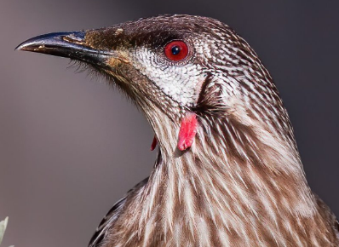
black-curved beak

red eye

red wattle

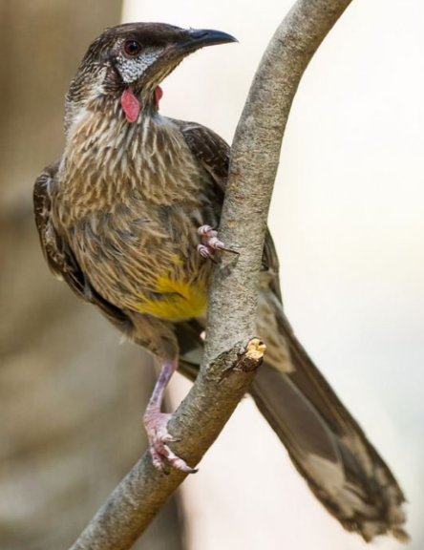
Common Name | Red Wattlebird
Scientific name | Anthochaera carunculata
Description: What I look like. | Grey-brown feathers on the body, with white streaks and yellow on the belly. Pale face with a fleshy reddish wattle on the side of the neck. A red eye and black curved beak. Long tail with a white-tip.
Distribution: Where I occur | 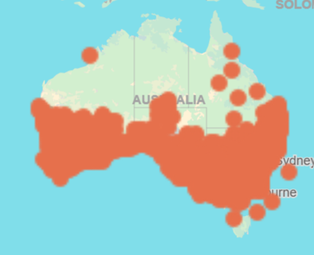
Habitat: Where I live. | Forests, woodlands and gardens,
Diet: What I eat. | Nectar, some insects from foliage or caught in mid-air, berries and honeydew
Breeding: | July to December  Nests - small bowl shaped made of twigs and grass, usually 3 to 10 metres above the ground with two to 3 small oval-shaped eggs
Call: What I sound like. | Many different calls including coughs, a harsh ‘yac a yac’ and a loud ‘chok’ https://birdlife.org.au/bird-profiles/red-wattlebird/#

