Anne Frank

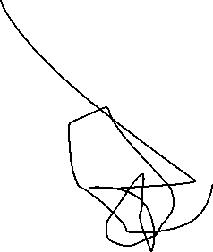

Introduction



Anne Frank was a Jewish person who in 1942 hid from the nazis during the occupation of the Netherlands. She is most famous for her diary in which she wrote in the secret annex which was where she lived in.



Birth and family

Anne Frank was born on the 12th of June 1929 in Germany Otto and Edith Frank were her parents and Margot Frank was her sister.



Life in the annex

Anne Frank lived in the secret annex for 2 years, it was normally quite hard because there were eight people living in the small apartment. The small group lived in constant fear of being found and since the nazis were there they couldn’t go outside



Hobbies

Anne Frank had many hobbies and she liked reading, writing, researching about family trees, Greek and Roman mythology, film stars and family photos



Death

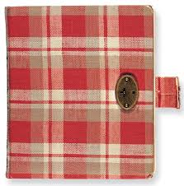When Anne Franke lived in the annex she only lived there for 2 years and sadly on the second year she was found and abducted she was taken to Bergen-Belsen concentration camp and that was where she died