**Emotions Wheel**

**(Emotional Granularity)**

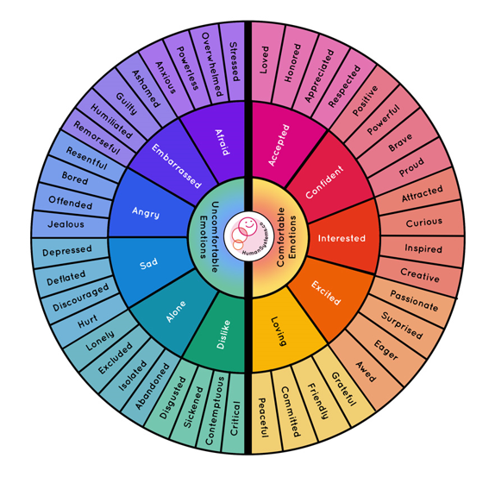

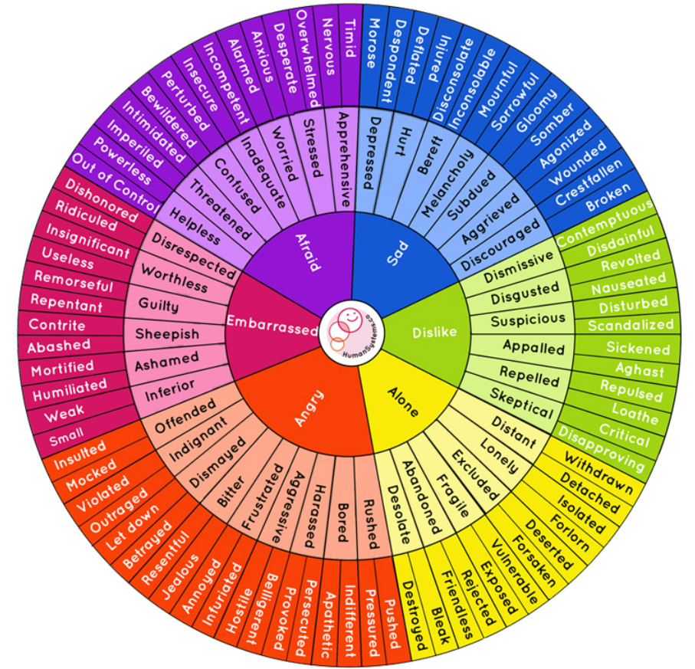

**Uncomfortable Emotions**

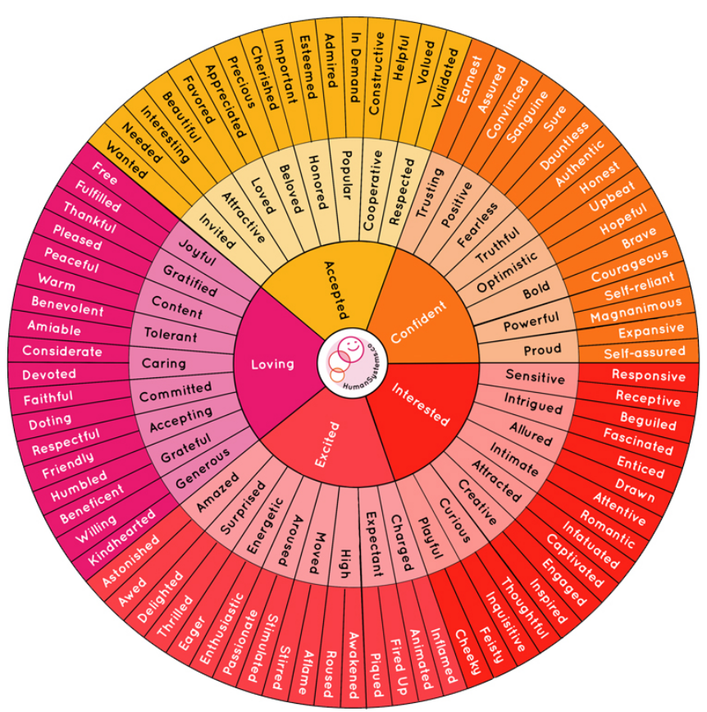

**Comfortable Emotions**