Shreck goes on RAMPAGE!!
-Reporter: Elizabath 31\8\23 august-

Shrek’s abduction of Fiona’s parents was committed 2 years ago.
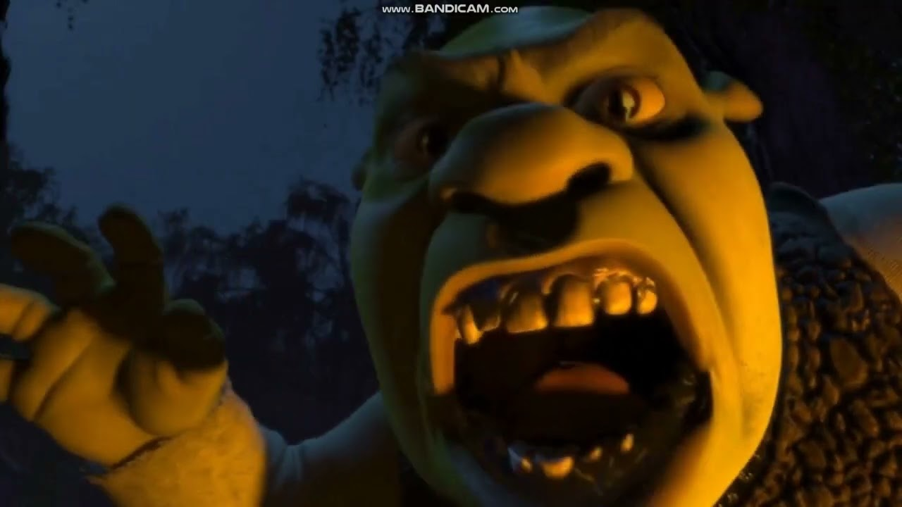
Fiona’s parents were found on august the 31st, Fiona’s mum say’s he came in the Cassel and put them in bags. Shrek claims he did its case 2 weeks after the honey moon the parents demanded a divorce.

Shrek the green swamp monster had rushed in the Cassel and put the in a big potato sack. Shrek says he found them in the bag and took him back so his swamp so he could get them out. The eye-witness puss in boots said ‘I sore him running out with a big bag kicking and screaming’. Donkey said ‘when I was walking past Shrek’s place, he sore through the window someone screaming HELP.

The dad said when donkey came by was when he lock them up in his room and chained them to the bed and left them there so they could starve to death.

Some people may ask how did they find them did hey make it out ok. Well, the answer is no they say after 2 hours they made it out they when on a run. So, the mystery still remains on Fiona’s parents.

Some people say they died there. Some think their spirits haunting Shrek’s swamp. Most people believe there on the run case of Shrek. But people ask will Shrek survive jail.

But the main question is where was Fiona in all this is he doing all this to her. Is she gone for good?

Continue on page 5

2 minutes after court found guilty

