“Off Your Back” Appeal 2021!
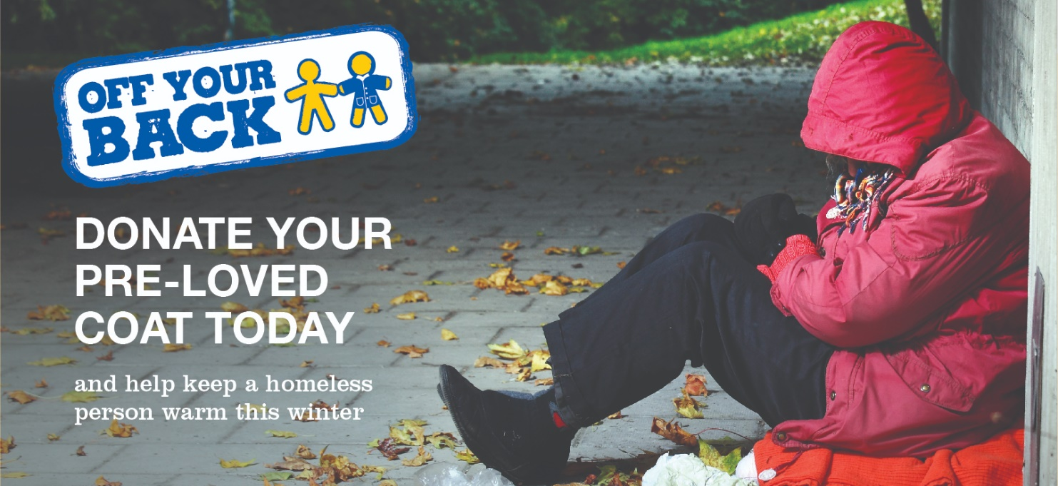

Donate your pre-loved coats and jackets today and help a homeless person!
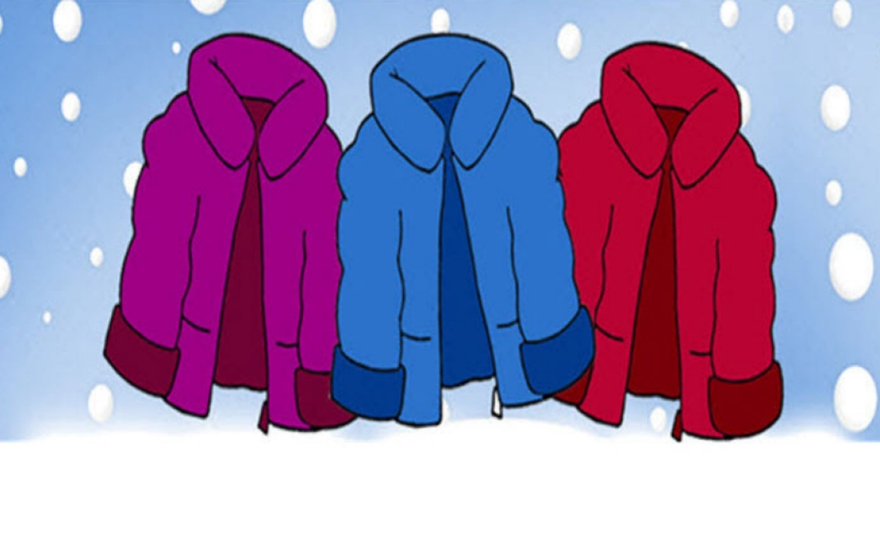
Donations can be brought to School until
Friday 27 August 2021!

