
LEVEL NEWSLETTER
2026  Term One |  |   BIRTHDAYS  January: Isaac Tran, Chiara Raucci  February: Alizé Jean-Pierre, Thomas Beayni, Amelia Chan, Leo Huynh, Annabelle Pham,  March: Eliza Mekhael, Mason Russell
Staff Contact |  | Please remember to only email staff between the hours of 8 am & 4 pm (Mon-Fri)  Amanda Marvelli - amarvelli@hfmw.catholic.edu.au  Eithne King - eking@hfmw.catholic.edu.au  Kate Buffham - kbuffham@hfmw.catholic.edu.au  All communication must be emailed.
Specialist Classes | MONDAY | STEM - with Mrs Katrina Davis
Specialist Classes | TUESDAY | 2B LIBRARY - Books must be returned on this day  2MK are to bring their library bags
Specialist Classes | WEDNESDAY | 2B PE – with Mrs Susan Michelsson  2MK Performing Arts - with Miss Rebecca Rawlins  2MK LIBRARY - Books must be returned on this day  2MK are to bring their library bags
Specialist Classes | THURSDAY | ART - with Miss Laura  AUSLAN - Ms Herrmann  2B - PERFORMING ARTS - with Miss Rebecca Rawlins  2MK - PE - with Mrs Susan Michelsson
Specialist Classes | FRIDAY | LEVEL SPORT  Year 2s to wear Sports Uniform
RELIGION   | TOPIC: ‘Caring for our Common Home’  This term in Religion, our Grade 2 students are learning about forgiveness and why it is important to be kind and caring to others. We talk about what we can say when we are sorry and how we can ask for forgiveness, just as Jesus Christ teaches us. Students share ideas about times they might need forgiveness, helping them understand that everyone makes mistakes and can learn from them. We also enjoy quiet prayer time together, sitting in a circle and sharing something they would like to be forgiven for. Students then write their own simple prayers to express their thoughts and feelings. Alongside this, children are learning about the season of Lent and how it is a special time to reflect, pray, and make good choices. Through these activities, students are developing empathy, responsibility, and an understanding of God’s loving forgiveness.
SPELLING    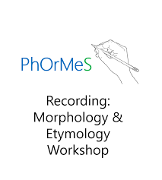 | This term in spelling students will revise sounds introduced to them in Year One as well as become exposed to a range of new sounds. These are the sounds that we will be looking at:  - Short A Review, Short I Review, Short O Review  - FLSZ Rule (ff, ll, ss, zz)  - -all, -oll, -ull  - vowel, constant, vowel (e_e)  - -es  - -ed  - -ing  - Closed and open syllables  - Closed and closed syllables  - Diagraph review
LITERACY  (Reading/Writing)   | This term in Literacy, students are building their reading and writing skills through our Geography inquiry and shared stories. We begin by learning about Australia and what makes it a special place, including its land, people, and cultures. Students explore how people live in different ways and why it’s important to care for our country and respect everyone who calls it home. We will also be starting two exciting novel studies: Possum Magic and The Magic Faraway Tree. Through these texts, students will practise comprehension, learn new vocabulary, and share ideas through speaking and writing.
MATHEMATICS  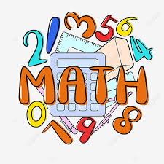 | This term in Mathematics, students will be learning about Place Value, Time, and Addition and Subtraction. Year 2 students will use hands-on materials to help build their understanding of these concepts and will practise different ways to solve problems. Through engaging activities, they will develop confidence with numbers and learn new strategies to support their thinking and problem-solving strategies.
KNOWLEDGE BASED/  INQUIRY   | Our focus in Inquiry this term is Geography. Students will be developing their understanding of Australia and the wider world. They will learn to identify continents, Australian states and territories, capital cities, neighbouring countries, and major natural landmarks such as rivers, deserts, mountains and reefs. Students will explore how people use and care for different environments, compare life in cities, towns and rural areas, and learn about Australia’s First Nations peoples as both an ancient and living culture. They will also investigate why Australia is home to people from many different countries and cultures. This unit encourages curiosity, discussion, mapping skills and a deeper appreciation of our diverse communities and landscapes.
BEHAVIOUR CURRICULUM  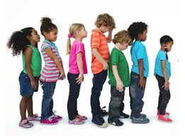 | Routines  - Lining up and sitting down after break times  - Calm entrance/exit routine  - Walking in roll order quietly  - Walking around the school with a partner quietly  - Understanding our classroom routine

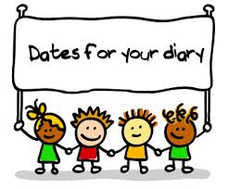 | Term One Important Dates (refer to our Google Calendar as well)  FEBRUARY  Wed 4 Prep Rest Day  Fri 6 Parent Welcome Event  Sun 8 Prep/New Family Welcome Mass (10am)  Mon 9 Children’s Mental Health Week (Wear an outfit that makes you feel confident and comfortable)  Tues 10 Safer Internet Day  P&F Meeting (6:30pm)  Meet the Teacher (Prep-Year 6)  Wed 11 Prep Rest Day  Meet the Teacher (Prep-Year 6)  Thur 12 District Swimming  Fri 13 Whole School Mass (9:15am)  FIRE Carrier Induction (10am)  Tues 17 Shrove Tuesday  Wed 18 Ash Wednesday (12pm Mass)  Prep Rest Day  Fri 20 Interschool Sport (1)  Mini Vinnies Soccer Event  Play Group commences (9:30am)  World Day of Social Justice  Wed 25 SAC Meeting (5:30pm)  Wed 25 Prep Rest Day  Fri 27 Interschool Sport (2)  MARCH  Wed 4 Prep Rest Day  Division Swimming  P&F Meeting (6:30pm)  Thur 5 Twilight Sports Day  Fri 6 School Closure Day (Vision for Engagement)  Sun 8 International Women’s Day (Give To Gain)  Mon 9 Labour Day Public Holiday (School Closed)  Wed 11 NAPLAN commences  Year 4 Reconciliation/Eucharist Info Night  Fri 13 Year 3-6 Athletic Trials  Sun 15 Catholic Education Week (Christ Beside Me-Walking in the Footsteps of St Patrick)  Tues 17 St Patrick’s Day  Wed 18 Open Day (all day) Everyone Welcome  Fri 20 Community Colour Run (Major Fundraiser)  Mass of St Patrick (St Patrick’s Cathedral)  Sat 21 Harmony Day  World Down Syndrome Day  Tues 24 Sacrament of Reconciliation (5pm)  Fri 27 Halogen Young Leaders Day  Summer Sport Gala Day (TBC)  Tues 31 EMR Swimming  APRIL  Thur 2 End of Term 1 (1pm finish)  Holy Thursday  Fri 3 Good Friday  Sun 5 Easter Sunday

