COMPASS  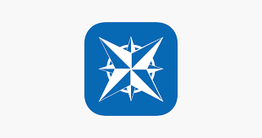 | SCHOOL WEBSITE  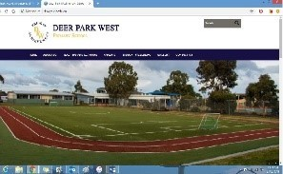 | QKR! | SEESAW  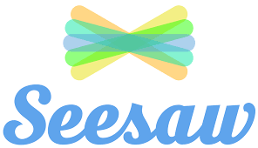 | MATHLETICS  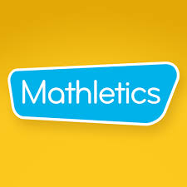 | READING EGGS
Purpose: Compass is a web based school software which allows us to manage school operations efficiently and communicate with our school community. | Purpose: Our school website is  often the first contact that people have with the school.  It gives us an opportunity to showcase the wonderful learning opportunities provided by our school.  It is also a way to keep our school community up to date with what is happening at Deer Park West PS. | Purpose: the Qkr! App allows you to order and pay for lunch orders from the school canteen online. | Purpose: Seesaw is an online resource that allows students “show what they know” using photos, videos, drawings, text, PDFs, and links.  The students learning is kept as a digital portfolio and is shared with families, and nothing is shared without teacher approval. | Purpose: Mathletics is an online, interactive, e-learning resource that allows the students to practice skills at their own level and their own pace.  Mathletics challenges students in all areas of math through a ‘game environment’ and allows them to access the appropriate level of challenge that best meets their learning needs. | Purpose: Reading eggs is an online, interactive, e-learning resource that allows the students to practice skills at their own level and their own pace.  Reading eggs challenges students in all areas of English through an environment that allows them to select the level of difficulty of the tasks.
Family Use:  - Advise school of your child’s absence  - Book your mid-year Parent/Teacher conferences across the year  - Access your child’s school semester reports. | Family Use:  - Keeping up with upcoming school events  - Accessing school newsletters  - Accessing school notes  - Getting information about school services, policies and programs | Family Use:  - Complete lunch orders the night before  - Pre-order and pay for lunches (later in the week or every Friday for example) | Family Use:  - See what your child is learning in school  - Give feedback to your child in the form of comments  - Receive information from your child’s teacher  - Leave messages directly with your child’s teacher | Family Use:  - Practice of the learning that is happening in the classroom  - Complete assign tasks as set by the classroom teacher  - Work towards achieving points and reward certificates  - Opportunities for ‘game play’ through mathematical concepts | Family Use:  - Provides practice of the learning that is happening in the classroom  - Complete assigned tasks as set by the classroom teacher  - Work towards achieving points and reward certificates
How to access:  - Link provided on school devices or download the free App  - Select Deer Park West Primary School  - Login in using your unique login codes for your family which are provided by the school | How to access:  - Web address:  http://dpwps.vic.edu.au | How to access:  - Download the free App  - Search and select Deer Park West Primary School  - Add your child’s name and class details in the Profile  - Add your payment card details  TIP: Remember to include a paper bag with each order so the lunch can be delivered | How to access:  - Download the free ‘Family’ App  - Select ‘Create Family Account’  - Scan the unique QR code provided by your child’s teacher | How to access:  - Web Address  www.mathletics.com.au  Download the free mathletics App  Your child can login using their individual username and password.  This is provided by the classroom teacher to your child | How to access:  - Web Address  https://readingeggs.com.au/  Download the free reading eggs App  Your child can login using their individual username and password.  This is provided to students from the classroom teacher

