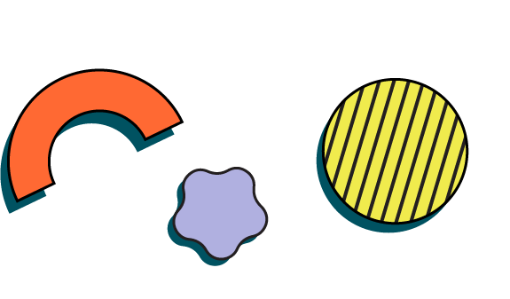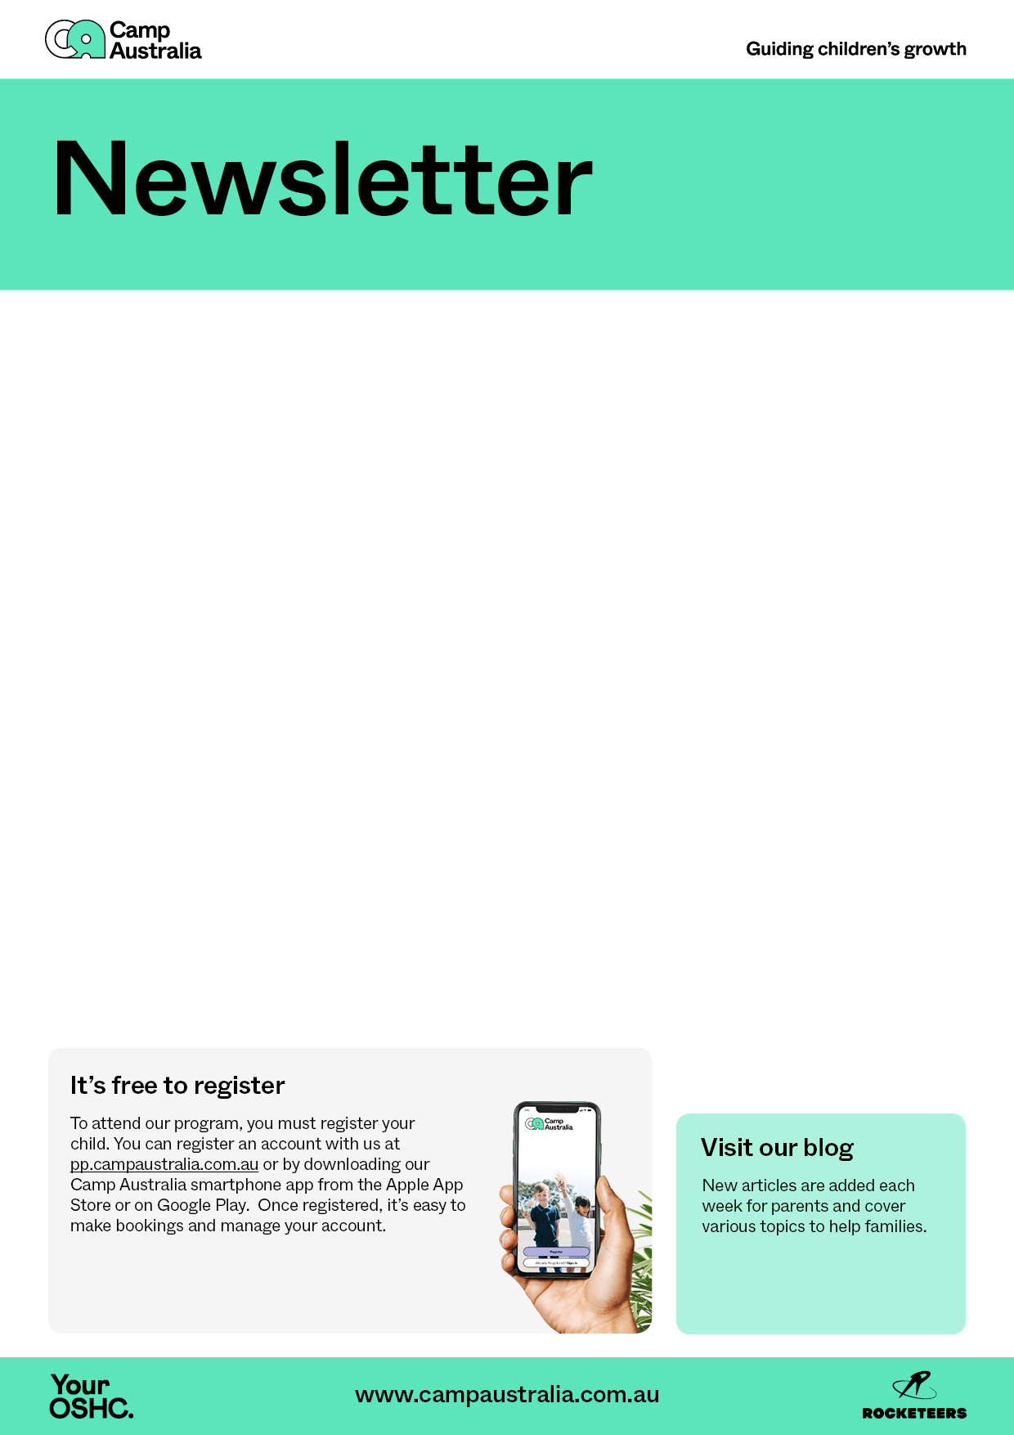

[](https://campaustralia.com.au/rocketeers)[](https://play.google.com/store/apps/details?id=au.com.campaustralia.parent)[](https://apps.apple.com/app/apple-store/id1529575453?pt=120333103&ct=edmbookings&mt=8)[](https://www.campaustralia.com.au/blog)

* Fruits and veggie platters
* Rice paper rolls
* Friday- Banana pan cake

A message from your Coordinator

This week the children are making creative things to show how much they love their dads to celebrate Father’s Day!

They can engage build with a challenge activities. Yummy cooking activities are also in the program.

* Building challenge
* Father’s Day gift ideas
* String art

What’s on the menu

Activities coming up

New articles are added each week for parents and cover various topics to help families.

Visit our blog