**

Instructors are:

* Government Screened
* First Aide Trained
* Senior Instructors are Internationally Accredited
* Nationally Accredited Black Belts
* Trained in Special Needs Instruction
* Trained in Traditional Japanese Judo
* Nationally Accredited Referees

**GOSHIN JUDO KAN**

Judo and Self Defense School

Established in 1988, Goshin Judo Kan has been a leader in the teaching and promotion of traditional Kodokan Judo in South Australia. Suitable for all ages (from 5yrs on wards). Goshin Judo Kan is an incorporated body that offers fun, fitness, friendship as well as the opportunity to enter regular competitions what learning self confidence and self discipline in a safe environment.

0416115195

Email: goshinjudokan@gmail.com

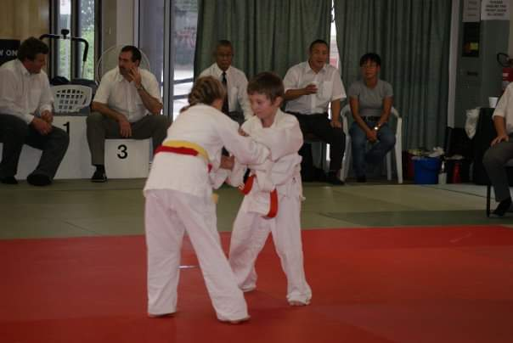

Qualified Japanese Graded Instructors

Trained in Special Needs Instruction

First Aide Trained

Government Screened

**FIRST 2 LESSONS FREE-**

**COME & TRY**

Goshin Judo Kan

917a South Road,

Clarence Gardens

South Australia, 5039.

Hours of Operation

Tuesday 6pm-7pm. Juniors

7pm-8.30pm Seniors

Thursday 6pm-7pm. Juniors

7pm-8.30pm Seniors

technology

consulting

**5432 Any Street West, Townsville, State 54321**

**Tel 555.543.5432 Fax 555.543.5431**

**WWW.YOURWEBSITEHERE.COM**

consulting