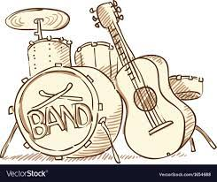

GUITAR AND DRUM LESSONS

AT MENZIES CREEK PRIMARY SCHOOL

Guitar and drum kit lessons are now available at Menzies Creek Primary with experienced musician and teacher Jed Rowe.

Jed has performed across Australia and overseas and loves passing his expertise on to the next generation of musicians. Lessons take place during school hours and are open to all students for guitar (grades 2-6) or drums (Foundation-grade 6).

Please ask for an enrolment form at the school office if you are interested.

Thanks, Jed.

