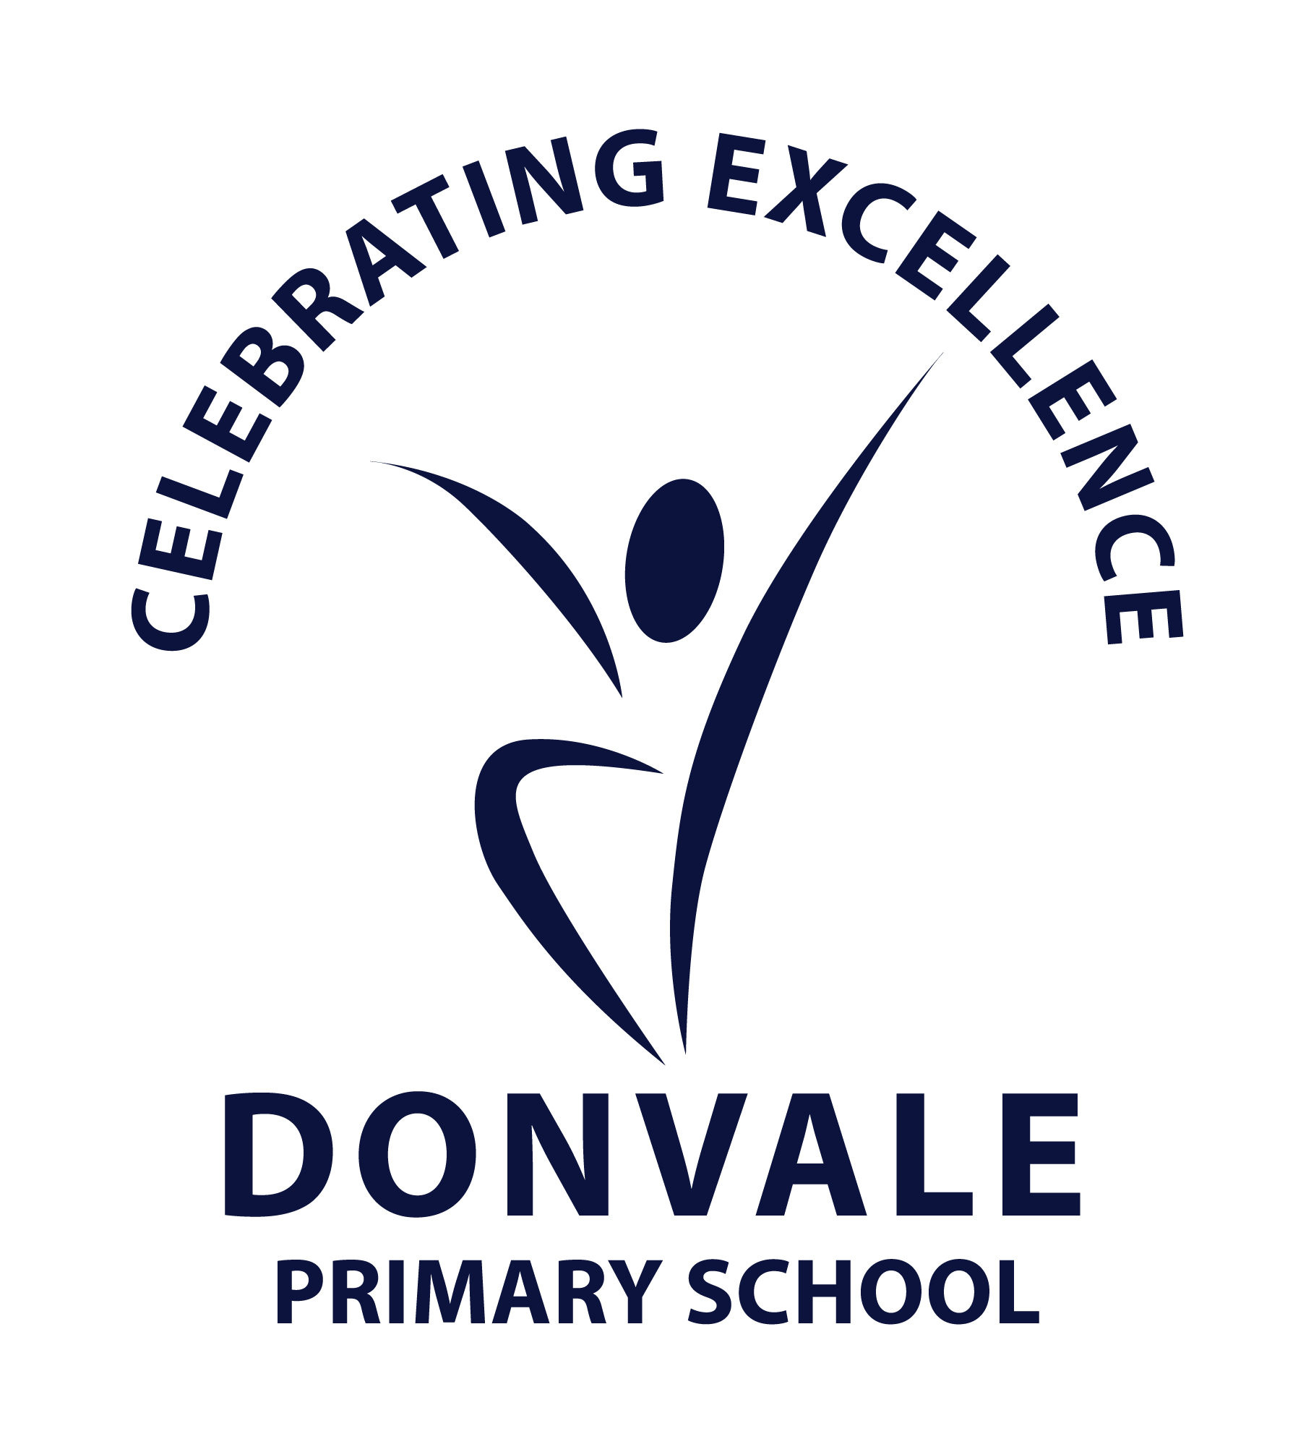

STUDENT DRESS CODE POLICY

Help for non-English speakers
If you need help to understand the information in this policy please contact the Principal 03 9842 3373

Purpose
The purpose of the Student Dress Code is to outline Donvale Primary School’s requirements for student dress and appearance and to provide information about uniform purchase and support, dress code implementation and exemption processes
This dress code has been developed by Donvale Primary School’s School Council in close consultation with our school community to ensure that it respects the rights of individual students whilst reflecting the values and interests of our community.

The Student Dress Code aims to:
- promote a sense of identity and pride, cohesion and good order in the school
- allow all students to feel equal
- prevent bullying and competition on the basis of clothing
- ensure students’ appearance reflects the expectations of their school community
- enhance the profile and identity of the school and its students within the wider community
- strengthen the spirit of community within the school
- enhance individual student safety and group security
- ensure all students are dressed safely and appropriately for school activities

Scope

Students are expected to comply with this Student Dress Code while traveling to and from school, during school hours and when attending school activities.

uniform and appearance
Students can wear any uniform item regardless of gender.

General appearance

While at school, travelling to or from school or participating in school activities, students must comply with the following:

- Uniforms must be clean and in good repair
- Uniforms should be clearly marked with the owner’s name
- Additional layers of clothing may be worn underneath the uniform, provided these undergarments are in school colours if visible
- Studs, sleepers and watches are the only acceptable jewellery. If the watch is a Smartwatch then the Mobile Phones and other mobile devices policy needs to be adhered to.
- Any make up or nail polish must be neutral tones only

Health and safety

Students with shoulder length or longer hair are encouraged to tie back their hair to help restrict the spread of lice and for student safety.

Jewellery, nails, hair accessories, hat cords and similar items that interfere with students’ ability to engage with school activities safely and fully are not permitted.

School uniform hats must be worn outside from mid-August (15th August) to 30 April and on any other day prescribed by the school. School uniform hats may also be worn outside of this time period, by parent/carer or student choice.

Hats are not to be worn inside.

Students are permitted to wear sunglasses during outdoor activities. Sunglasses should be close-fitting, wrap-around that meet the Australian Standards 1067 and cover as much of the eye area as possible.

PURCHASE OF UNIFORMS
Uniform items can be purchased from Spartan School World Ringwood – Unit 12/100 New Street, Ringwood. Permitted non-branded uniform items can also be purchased from department stores, such as Kmart, Big W, Target, etc.

Second-hand uniform items are available at school. Please come to the office and someone can assist you. There is also the WhatsApp group

The School Council has consulted with the school community and worked to ensure the student uniform is affordable. However, if you are facing difficulty meeting uniform costs the Help with school costs and fees page provides advice on support offered by the Victorian Government. If your child is starting prep or year 7 and is eligible to receive support via the Camps, Sports and Excursions Fund, you may be eligible to access the Affordable School Uniform program through State Schools' Relief.
Please contact the principal or office staff to discuss support that we may be able to provide.

IMPLEMENTATION
Donvale Primary School will ensure that this Student Dress Code and uniform item list is communicated to all families and students through our website, school newsletter and Compass. We will assist students who may be experiencing difficulties complying with this policy where possible.

If a student is out of school uniform or otherwise breaches the Student Dress Code on a recurring basis, a note will be provided to the student and parents/carers by the classroom teacher. If non-compliance with the student dress code becomes a continued occurrence, the principal will be informed and a phone call home may be required. In this event, the school will continue to work with the student and family to support compliance.

Measures taken by Donvale Primary School to address concerns about student non-compliance with the Student Dress Code will also be addressed in accordance with our Student Wellbeing and Engagement Policy.

EXEMPTIONS TO STUDENT DRESS CODE
We acknowledge that the enforcement of this Student Dress Code may impact students differently.
Students and their parents or carers may apply either in writing or in person to the principal for an exemption to this Student Dress Code if:
- an aspect of the code:
  - prevents students from being able to attend school or participate in school activities on the same terms as other students because of the personal characteristics referred to in human rights and anti-discrimination requirements
  - offends a religious belief held by the student or parents/carers
  - prevents students from complying with a requirement of their religious, ethnic or cultural background
- the student has a particular disability or health condition that requires a departure from the dress code
- the student or the parents/carers can demonstrate financial hardship that prevents them from complying with the dress code.

When the principal receives a request for an exemption, they will:
- consider the grounds for the exemption request
- explain the process to the student and/or their parents/carer
- guarantee that issues of a personal nature revealed to substantiate the request will be strictly confidential
- encourage the student and/or their parents/carers to support their application with evidence.
The principal or delegate will then try to negotiate a resolution that is acceptable to all parties, including providing advice about support with meeting uniform costs. If an exemption is not allowed, then written reasons will be provided to the student and/or their parents/carers.
CONCERNS ABOUT THIS STUDENT DRESS CODE

Donvale Primary School welcomes feedback from the school community in relation to this Student Dress Code. If you have a concern or complaint about the Student Dress Code, further information about raising a concern or complaint is available in our school’s Complaint Policy, available on our website.

COMMUNICATION
This policy will be communicated to our school community in the following ways:

- available publicly on our school’s website
- other online parent/carer/student communication method
- reminders in our school newsletter
- discussed in student forums
- included in staff handbook/manual
- discussed at staff briefings/meetings as required
- included in transition and enrolment packs
- discussed at parent information nights/sessions
- hard copy available from school administration upon request.

Views on our student dress code have been invited from the whole school community including:
- parent/carers
- teachers and other school staff
- students
The school community consultation invited feedback about uniform cost and affordability. This feedback has been recorded, carefully considered and incorporated into the student dress code policy where appropriate.

Further information and resources
- Donvale Primary School’s Sun Protection Policy
- Donvale Primary School’s Complaint Policy
- Donvale Primary School’s Student Wellbeing and Engagement Policy
- Donvale Primary School’s Inclusion and Diversity Policy
- Department of Education Student Dress Code
- Department of Education Student Engagement

POLICY REVIEW AND APPROVAL

For future reviews of this Student Dress Code, we will consult with our school community through the following mechanisms:
- letters, emails and social media messages to parents/carers
- surveys
- information in newsletters
- information on our website
The community will be given advance notice of the consultation process and timelines. The consultation will be open for at least 2 weeks.

Consultation materials will be translated into community languages.

Policy last reviewed | 28/10/2025
Approved by | School Council
Next scheduled review date | October 2028

APPENDIX A: DONVALE PRIMARY SCHOOL UNIFORM ITEMS

- Approved commemorative uniform items such as the year 6 top are accepted as part of the uniform.

COMPLUSORY UNIFORM ITEMS
Navy backpack with school logo*
Navy broadbrim hat with logo (terms 1 and 4)*
Navy short and/or long sleeve polos with school logo*
Bomber jacket or windcheater with school logo*
Summer dress* and/or culotte (navy)* and/or skort (navy)*
Winter Tunic* and/or navy bootleg pants*
Melange grey school shorts*
Grey trousers*
Sports polo*
Sport shorts (navy)*
Sports pants (navy)*
Grey socks (worn with grey shorts/trousers)
White socks (worn with navy bottoms/dress/tunic)
White sports socks

OPTIONAL UNIFORM ITEMS
Stadium jacket with school logo*
Raincoat (navy)
Navy beanie with school logo*
House t-shirt with logo*
House t-shirt (plain red, blue, yellow, green)
Navy blue tights
Navy blue/gold head bands, hair ribbons, “scrunchies”*
Headwear worn as part of cultural/religious beliefs

FOOTWEAR
Appropriate footwear is to be worn including:
- black school shoes or runners (academic uniform)
- runners (any colour for PE)
No thongs or open-toed sandals or boots are permitted.

*These items are available from Spartan School World.

Items without the school branding can also be purchased from other retailers.

