**Boroondara Park Primary School** 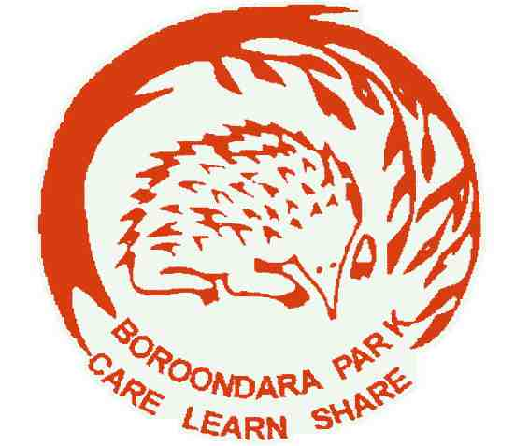

**Specialist Team Classroom Open Session 2024**

**Specialist Team Staff**

| **French**  **PE**  **Performing Arts**  **Visual Arts**  **EAL** | Marylou Higgins  Phil Wickham  Zoe Tsai  Lisa Trevorrow  Sujatha Chaturvedi |
| --- | --- |
|  |  |
|  |  |
|  |  |

**Learning Support Teachers**

**Tutor Program** Jen Coombs (term 1), Bridget Grundy (terms 2, 3 and 4)

**French**

French is taught at B.P.P.S. from Foundation to Grade 6 with the aim to foster an understanding of being a citizen of the world, exploring the linguistic connection and impact French language and culture has on English and the rest of the world.

Learning French starts with simple songs and rhymes at Foundation level branching through to Grade 6 with translation, pronunciation, conversation, memorisation and creation of digital bilingual books. French vocabulary used often relates to Integrated Studies topics such as Emotions, Community, Weather, Time and many others.

The school’s Seesaw app is used for communication and posting oral and written work as evidence of progress, achievement and assessment.

Students can access Duolingo and Languagenut which are fun and educational iPad apps used to consolidate vocabulary and grammar acquisition.

The French National day (Bastille Day) is celebrated with a French Day and a French Incursion showcasing French culture, music and history. On this day, students are encouraged to wear French themed costumes and buy a French meal from the canteen.

The whole school participates in a French Poetry Recitation Competition, encouraging students to memorise a French poem to present to their peers. Class winners compete in an overall final to then decide level winners. Class and Level winners are awarded CL&S (Care, Learn and Share) awards and French book prizes.

French classes run for 60 minutes on a weekly basis.

**PE and Sport**

At Boroondara Park Primary School we offer a comprehensive Physical Education and Sport program, with the aim of improving the Physical Literacy of each of our students. In the junior years, the PE program at BPPS has a strong emphasis upon developing each of the core Fundamental Motor Skills. These motor skills include locomotor actions such as running, jumping, and hopping, as well as more technical skills like catching, throwing, striking and kicking. As students progress through the school, the focus of their learning in the later years shifts to more game-based scenarios. These scenarios encompass invasion games, striking and fielding games, wall and net games and target games, promoting the continued development of the Fundamental Motor Skills, while also activating learning around game sense, decision making and strategic thinking. Across all year levels, student learning is underpinned by our core PE Values of Safety, Fairness, Teamwork, Positivity and Effort. As well as weekly PE lessons, all students at BPPS participate in an additional sport session each week within their specific cohort. These sessions begin in Foundation and continue through to the end of Year 6, supporting and building upon prior learning that has taken place in PE classes.

Outside of the classroom, BPPS also has a range of sporting opportunities for our students to participate in. These initiatives include:

* Junior School Athletics Carnival (F-2)
* Senior School Athletics Carnival (Years 3-6)
* School Cross Country Carnival (F-6)
* School Swimming Trials (Years 3-6)
* Perceptual Motor Program (Foundation - Year 2)
* Interschool Sport Program (Years 5-6)
* Hoop Time Basketball (Years 3-6)
* School Swimming Program (F-6)
* School Fitness Club (F-6)
* Gymnastics Program (F-6)
* Bike Education Program (Years 3-4)

**Performing Arts**

Boroondara Park has a thriving and exciting Performing Arts program, which gives our students ample opportunities to become involved in the many dance, drama and musical activities that we offer.

All students from Foundation to Grade 6 have a 60 minute session of Performing Arts each week, providing a well-rounded curriculum exploring dance, drama and music. We have two well-equipped Performing Arts rooms, and a range of ICT is incorporated throughout our Performing Arts program. Year levels will specialise and focus on one Performing Arts stream each term, then rotate through the rest in the year.

Junior school is starting the year off with Dance. Skills and activities they will practise in lessons includes:

* Improvising and making dance movements based off prompts
* Creating a dance diary about their observations of dance in their daily lives.
* Learning and performing a dance routine
* Building safe dance practices

Middle school will start off with Drama. Skills and activities they will practise in lessons includes:

* Observing and performing the styles of drama from different cultures/time periods.
* Utilising the elements of drama to create a dramatic play
* Drama improvisation

Senior school is learning Music the first term. Skills and activities they will practise in lessons includes:

* Using the elements of Music to create sound effects for a short animated film
* Exploring how ICT can be used to create Music
* Playing percussion instruments individually, and in an ensemble.

Outside of the classroom Music, Boroondara Park provides students with an opportunity to perform on the stage. We host a Carols night every year, and a whole school production is hosted every second year. Students who have an interest in the technical aspects of theatre are also able to work backstage or in the bio box to foster their interest.

**Visual Arts**

At Boroondara Park Primary School we offer an exciting, extensive and varied Visual Arts program. Our purpose built Art room allows us to offer ceramics, in addition to a full range of Art genres. All students from F – 6 experience a range of Visual Arts opportunities to explore different media, allowing them to continually develop their skills and understandings.  
  
Our aim is to link these skills with the whole school concepts and to respond to Art events in the wider community. Short and ongoing projects are undertaken and our students are encouraged to reflect on their own completed artworks.  
  
The Visual Arts includes exposing students to the works of renowned artists and requires students to respond to a variety of styles from a range of times in history.

The Visual Arts encourage all students to think creatively and produce high quality art works.  
  
Art works are displayed in the school corridors and classrooms and the students derive immense pride and pleasure from the experience of having their work exhibited to the school community. Some children are selected to be the Artist of the Week, with their work put in the newsletter. Opportunities are sought whereby children’s artworks can be exhibited to the wider community. Grade 5 and 6 students produce a permanent Art installation for the school every second year that leaves a lasting contribution to the art culture of the school.

# English as an Additional Language (EAL)

BPPS offers an enriching and supporting program for students learning English as an additional language from Grade Foundation (F) to 6. The program focus is to develop listening, speaking, reading and writing skills in students. Students follow a program that is suited to their English language level which allows for advancement as their knowledge and skills develop. The EAL program compliments the work of the classroom teacher by providing intensive instruction and revision for new English language learners. Students are provided with opportunities to learn, rehearse, practise new vocabulary, phrases and pronunciation in small groups. EAL students' progress is evaluated and reported against the stages of the EAL standards outlined in Victorian Curriculum F-10 EAL, rather than levels of the English standard. Translations and communications by the staff at BPPS, to all non-English speaking parents are facilitated through the use of interpreters from VITS Interpreting and Translating Services.

**Tutor Program**

Students who are selected for the BPPS tutoring program are working on the fundamental skills required to be successful readers, writers and mathematicians. Depending on their current learning goals, the students participate in 2-4 one-hour sessions during the week (Tuesdays and Wednesdays in 2024). We endeavour to complete literacy and numeracy tutoring at the same time that their class is covering the same subjects, so they do not miss out on class activities.

The literacy skills we are focussing on include:

* understanding phonics
* spelling strategies of simple, common and difficult words
* the structure of narrative and persuasive texts
* reading exemplary texts in narrative and persuasive genres
* planning and writing narrative and persuasive texts
* reading aloud for fluency
* reading texts for comprehension, identifying the main idea, finding evidence to support answers, predicting and summarising.

The numeracy skills we are focussing on include:

* addition and subtraction facts and fluency
* multiplication and division facts and fluency
* place value
* the four operations (addition, subtraction, multiplication and division)
* chance and data
* measurement and geometry
* problem solving and worded problems

All these activities take place in a small and supportive environment, where each student gets specialised attention from an experienced teacher. We play lots of word and number games to help students develop a love of learning in both literacy and numeracy.